Your journey to a successful first year in 4-H!



Larimer County CSU Extension Office
1525 Blue Spruce Dr. Fort Collins, CO 80524
(970)498-6000
http://larimer.extension.colostate.edu/
Facebook: Larimer County Extension

Welcome 4
Supportive Adults are encouraged to: 4
What is 4-H? 5
How is 4-H Administered? 5
How old do you have to be to join 4-H? 5
Enrollment and Choosing a Club 6
How do members enroll in 4-H? 6
How do families choose a 4-H Club? 6
Projects 7
4-H Projects: 7
4-H Project Costs: 7
Demonstrations: 7
Choosing a 4-H Project: 7
Learning about your 4-H Project: 7
Exhibiting your project: 7
Record Books 8
E-Record Books: 8
Where to find E-Record Books and Supplements: 8
What is a Supplement in an E-Record Book? 8
Tips and helpful information for a successful e-record book: 8
Activities and Contests 9
4-H Activities: 9
4-H Contests: 9
How to get involved: 9
Clubs and Leadership 10
Definition of a 4-H Club: 10
What 4-H Club Meetings Entail: 10
4-H Clubs meeting times and location: 10
4-H Club Meeting Attendance Policy: 10
Optional Leadership Opportunities: 10
Conferences and Exchange Programs 11
State Leadership Conferences: 11
National Leadership Conferences: 12
State and International Exchanges: 12
County Fair 12
County Fair and 4-H: 12
Exhibiting your project at County Fair: 12
Tasks to do before County Fair: 13
Display Boards: 13
Stand Alone (General Projects): 13
Deadlines and Dates for the 4-H Year: 13
Important Forms that need to be completed each year: 14
How to successfully complete your 4-H year: 14
Incomplete Projects: 14
Extension Staff & 4-H Leaders 14
Extension Agents: 14
4-H Support Staff: 15
4-H Leaders: 15
Club (Organizational) Leader: 15
Resource Leader: 15
Project Leaders: 15
Activity Leaders: 15
Top Ten Tips for Navigating 4-H 16
Frequently Asked Questions 17
What do 4-H Clubs do? 17
What Happens at a 4-H Meeting? 17
What is the 4-H Emblem? 18
What is the 4-H Pledge? 18
What do the 4-H’s stand for? 18
What is the 4-H Slogan? 18
What is the 4-H Motto? 18
What are the 4-H Colors? 18
What is the Colorado 4-H Vision? 18
What is the Colorado 4-H Mission? 18
What do youth gain from 4-H? 19
Facts about 4-H 19
4-H Financing: 19
What is the Larimer County 4-H Foundation? 19
How does the Foundation raise money to support 4-H participants? 20
Contact Your Larimer County 4-H Extension Staff: 20

Welcome
The purpose of this booklet is to help you learn more about 4-H and how to have a positive experience in 4-H. Use this booklet as a tool to familiarize yourself with the 4-H Youth Development Program.

As you go through the 4-H year, you may find that you have questions about specific activities, events, projects and expectations. Please be sure to keep the lines of communication open with your 4-H Organizational Club Leader(s).

You will get out of 4-H what you are willing to put into it!

Supportive Adults: We use the term parent to refer to the adult(s) supporting a child's participation in 4-H. This could include mother, father, grandparents, guardians or other caring adults.

Supportive Adults are encouraged to:
- Take the time to learn about 4-H, what it stands for, and how it operates.
- Help the 4-H member select a project of interest that fits their abilities, interests and financial capabilities.
- Show interest and enthusiasm for the 4-H member’s projects and club work. Plan work throughout the year rather than waiting.
- Help the member participate in club, county, regional, state, and national events.
- Help establish file and record keeping skills.
- Keep the purpose of 4-H in mind. The project is a teaching tool that provides a learning experience. Youth, with help from parents, interested adults, and older youth leaders, grow personally as they develop skills for living.
- Celebrate the 4-H member’s success and support learning from mistakes.

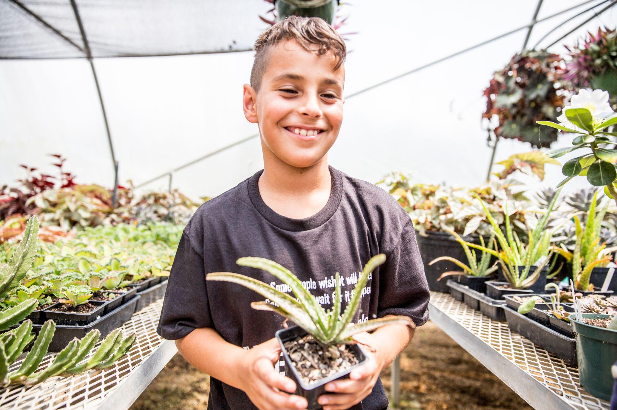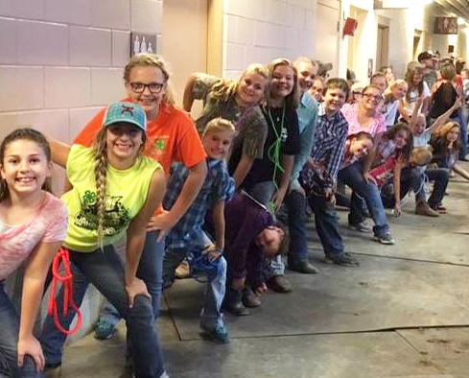

What is 4-H?
4-H stands for Head, Heart, Hands and Health. The four H’s are the four values that members work on through fun and engaging project areas. 4-H is a community of more than 6.5 million young people across America learning leadership, citizenship, and life skills. The 4-H community also includes 3,500 staff, 538,000 volunteers, and 60 million alumni.

4-Hers participate in fun, hands-on learning activities supported by the latest research of land-grant universities that are focused on three areas: healthy living, citizenship, and science. Youth can experience 4-H by becoming a member of a 4-H club, attending 4-H activities, or through school based or after-school 4-H programs. 4-Her’s can compete in contests at the local, state, regional, or national levels and also attend conferences and events.

How is 4-H Administered?
The Cooperative Extension Service (CES) was established when the U.S. Congress passed the Smith-Lever Act in 1917. CES is educational programs are centered in the land-grant university in each state. Major program areas are agriculture, family and consumer science, natural resources, community development and 4-H youth development. Colorado State University (CSU) is the land grant university responsible for the administration of the Extension Program in Colorado. Funding for Larimer County Extension is provided by federal, state, and county sources.

How old do you have to be to join 4-H?
Youth ages 5-18 are eligible to be in the 4-H program.

- Cloverbud members are children ages 5 to 7 years old. This program is a non-competitive membership opportunity
- Traditional 4-H members are youth between the ages of 8 to 18. The 4-H age is determined by what age the child is as of December 31st of the current year
- The 4-H year runs from October 1st to September 30th. Traditional members are broken out by age as Juniors (8-10), Intermediates (11-13) and Seniors (14-18)
- There is also a program called collegiate 4-H for youth in their college years
- Adult leaders also enroll in the 4-H program

Enrollment and Choosing a Club

How do members enroll in 4-H?

Step 1: Select a club
Step 2: Select your project(s)
Step 3: Enroll online
Step 4: Pay enrollment fees

Enrollment is done electronically at co.4honline.com Follow the step by step instructions to enroll through 4-H online. Print and sign the member enrollment form, the permission/code of conduct form, and the animal care and housing form (if applicable). Give the completed forms and enrollment fees to your organizational club leader who will submit it to the Extension Office. This form only registers youth to become an active 4-H member and does not include registration for youth for activities, camps, or the county fair.

Enrollment fees cover the cost of enrolling in the 4-H program, project literature and liability insurance for your child at any 4-H activity or event. The county enrollment fee is $50. Scholarship opportunities are available.
Some projects have additional fees. Other forms may need to be turned in throughout the year. Please check with your organizational leader, our website, or the newsletter for the most updated information.

How do families choose a 4-H Club?

Larimer County 4-H has 4-H clubs located throughout the county. You may obtain the phone number and email address of the 4-H club leader along with meeting locations by calling our office at (970) 498-6000. We will refer you to clubs near you and you will be invited to visit a club meeting. The leader of the club you choose will help you to enroll in 4-H.

Projects

4-H Projects:
A list of available projects (over 50) is on the website under “Projects.” Each 4-H member is required to take at least one project. Projects are a fun way to learn life skills, such as communication, decision making, and responsibility.

4-H Project Costs:
4-H project costs vary. Some projects use supplies and equipment from around the house and incur no additional expenses, while others may cost hundreds or even thousands of dollars, such as large animal projects.

Demonstrations:
What is a 4-H Demonstration? A demonstration is an opportunity to put together a presentation for your 4-H project (it can be anything) and present it to your 4-H club. This is a great way to learn about public speaking and helping others learn something you already know.

Choosing a 4-H Project:
- Pick something you are interested in, want to learn about and think would be fun.
- Make sure you know what the costs and time requirements are (review the Clover Guide; it can be found on the website).
- Ask for advice! Ask your leader or another friend who’s in 4-H.
- Reach out to your agents.

Learning about your 4-H Project:
Learn through your project manual, project leader/ meetings, fellow 4-Her taking the same project, and any other resources you may find related to your project. Attending project clinics and workshops advertised through email and the Clover Connections is also a great way to learn!

Exhibiting your project:
4-Her’s do have to exhibit their project to someone other than family; club meetings are a great place. You don't have to exhibit at County Fair, but it’s encouraged.

Record Books

E-Record Books:
An e-record book helps you keep track of your 4-H project and is a requirement to complete your 4-H year. It includes setting goals, record keeping, pictures, and a story. Sometimes referred to as an e-Record.

Where to find E-Record Books and Supplements:
- Go to http://larimer.extension.colostate.edu/
- Click on Programs
- Click on 4-H
- Click on the Project that you need an e-record book for
- Scroll down to find E-Record Books/Supplement information

What is a Supplement in an E-Record Book?
A supplement is needed in addition to the e-record book for some projects. If a supplement is needed, the link to the supplement will be just beneath the link to the e-record book.

Tips and helpful information for a successful e-record book:
- Use the checklist sheet for the Horse, Livestock and Companion Animal Projects
- Use the “Tip Sheets” for the Family and Consumer Science and General Projects
- Use the Study Guides for the Companion Animal project
- View the “Score Sheet” to see what judges look for
- Ask your club leader
- Call the Extension Office
- Get an early start; begin right away when you enroll in your project
- Keep a calendar, recording everything related to your project
- Save all receipts

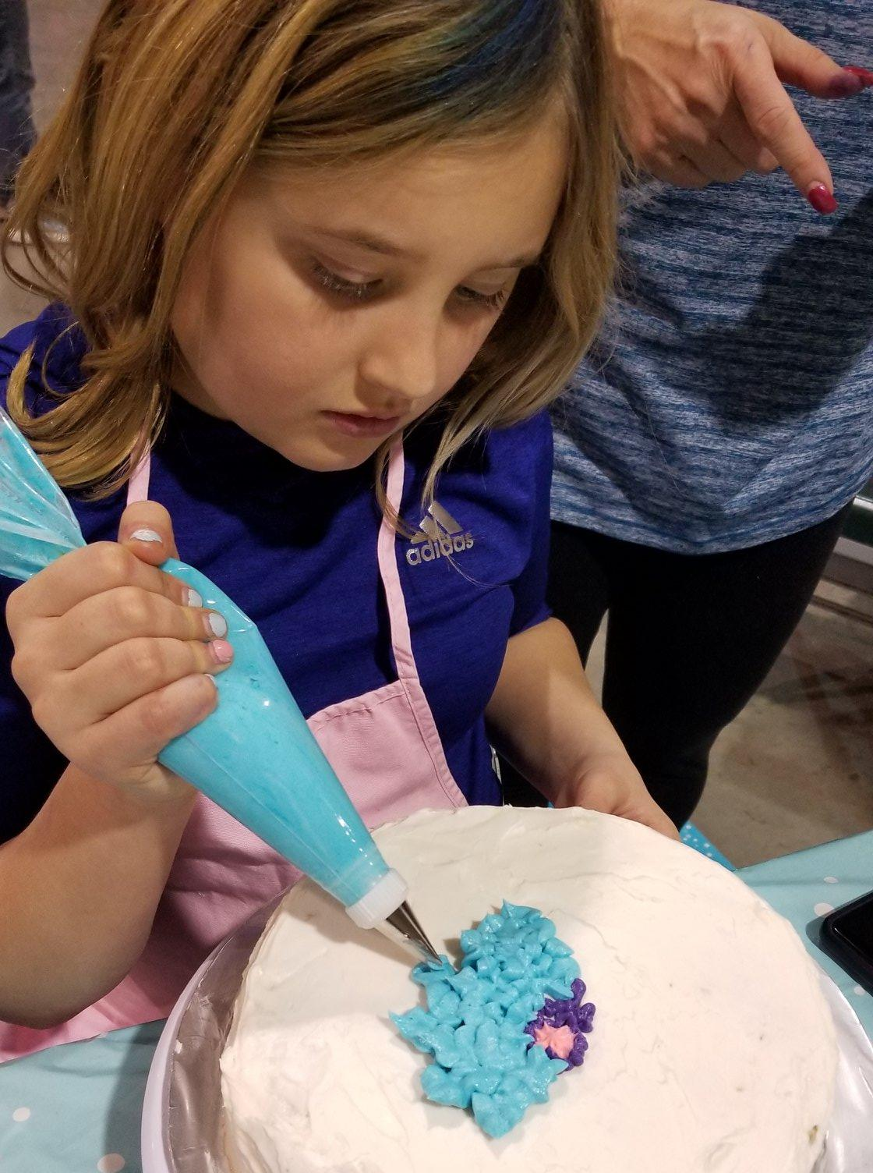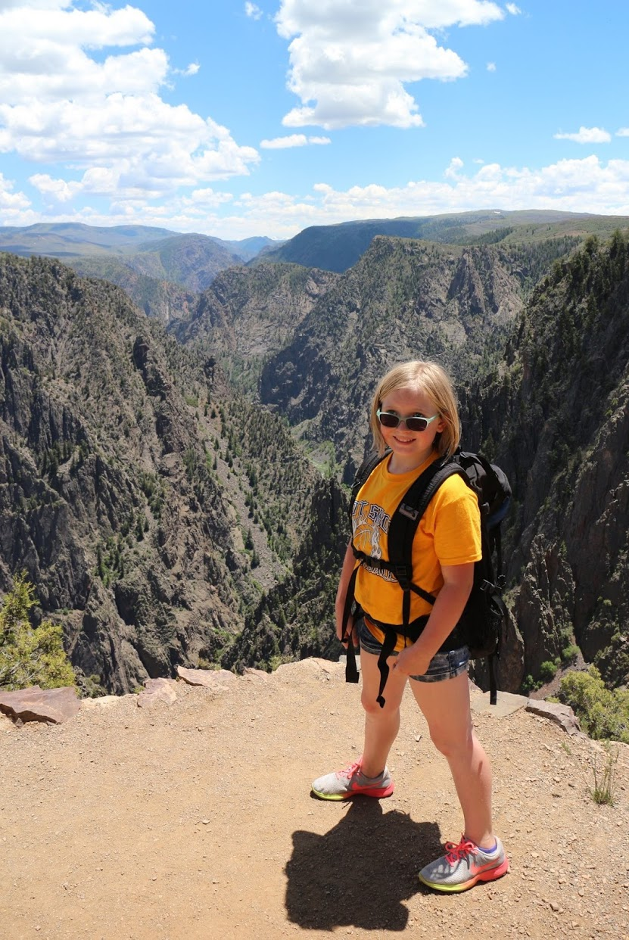

Activities and Contests

4-H Activities:
4-H Activities are an optional opportunity for 4-H youth. Included are Cloverbud Camp, Exchange Club, Achievement Night, and many leadership conferences/camps.

4-H Contests:
Contests are not required, but are optional competitive opportunities. Many contests coincide with particular 4-H projects, such as Fashion Revue. However, you might not have to be enrolled in a related project to participate in the contest. Some examples are judging teams, Creative Cooks, and Cake Decorating.

How to get involved:
- Read the monthly Clover Connections; most activities are advertised there
- Complete the correct paperwork when required (i.e. application form, registration form)
- Attend any orientation meeting or workshops (where applicable)
- Ask for advice! Ask your leader or another friend who’s been in 4-H before.
- Reach out to your agents.



Clubs and Leadership

Definition of a 4-H Club:
A group of youth and their parents, along with 4-H leaders, who trek through the 4-H year together as a group.

What 4-H Club Meetings Entail:
Usually a business meeting, community service projects(s), project meetings, demonstrations, fun activities, and friendship!

4-H Clubs meeting times and location:
Usually once a month for most months of the year, but it depends on the club. Locations and times of monthly meetings vary depending on the 4-H club selected. For a list of clubs, where they meet, and what time they meet visit: http://larimer.extension.colostate.edu/
Click on Programs, 4-H, 4-H Club Resources (right hand side) and then click on the “2019-2020 Club Directory.”

4-H Club Meeting Attendance Policy:
Each club may have their own attendance policy. Attendance is the best way to stay in the loop. Since 4-H is a family focused, club leaders ask that parents be involved and attend all club meetings with their child. If you miss a 4-H club meeting it is your responsibility to call your club leader to see what you missed.

Optional Leadership Opportunities:
- Junior Leadership Club: Meets separate from regular 4-H club and allows for additional development of leadership skills for 13-18 year olds.
- District II Senate: Comprised of Boulder, Larimer and Weld county senators from Junior Leadership Club and those interested in the “district” level of leadership participation. They plan a leadership event for younger members, called Junior Jam.
- 4-H State Officers: The president of the District II, serves as a 4-H State Officer and can run for an officer position, such as President that helps plan many of the events listed under State Leadership below.
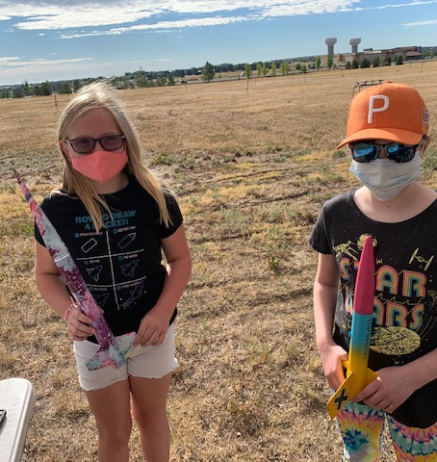

Conferences and Exchange Programs

Regional Leadership Conferences:
- Junior Jamboree: Typically held in late spring or early summer at The Ranch in Loveland for youth ages 8-12. This fun and educational event is planned and hosted by District 2 Senior Senators, who represent Larimer, Boulder, & Weld Counties. The purpose of this camp is to provide an opportunity for youth to learn teamwork, leadership, communication, and citizenship skills through a variety of workshops.

State Leadership Conferences:
- Junior Colorado Leadership Conference: Typically held in November in Glenwood Springs for youth grades 6 - 9 (roughly ages 11-14). The purpose of this camp is to provide an opportunity for youth to learn teamwork, leadership, communication, and citizenship skills through a variety of workshops.
- Leadership Development Conference: Typically held late January in Denver at the State Capital for youth 14-18. The conference focuses on government and civic involvement. It is followed by Colorado 4-H Day at the State Capital.
- Youth Fest: Typically held early February in Larkspur for youth ages 8 - 13. This is a three-day camp where 4-H'ers discover what self-esteem and leadership are all about.
- State Conference: Typically held late June for 14-18 year olds. This is a four day conference where 4-H teens:
  - (1) compete in state contests including consumer choices judging, horse contests, livestock judging, and public speaking contests
  - (2) attend workshops and tours; and
  - (3) participate in social activities and dances.

National Leadership Conferences:
- National Congress: Colorado delegates are selected from State Fair Senior Grand Champion recipients in certain project areas. This five day event is held in Atlanta, Georgia. Participants engage in leadership, citizenship, global awareness, and inclusion.
- National Conference: Applications are accepted for Senior aged youth. Typically, we are able to award two participants annually with the opportunity to attend where they learn about civic engagement, connection and impact to local communities, nation and world.
- Citizenship Washington Focus: Held near Washington D.C. (Chevy Chase, Maryland). Participants learn how to be citizen leaders and make a difference in their local communities

State and International Exchanges:
- State Exchange: Larimer County currently has a State Exchange program, that functions as a separate club to your main club. It is a two year commitment, hosting one year and traveling the next. Youth learn about another culture, county and state in the country.
- International Exchange: Colorado 4-H has an International Exchange program through our state office.

County Fair

County Fair and 4-H:
County Fair is the annual county event held each July/August at the Larimer County Fairgrounds, which showcases the culmination of a year of hard work for every 4-Her who chooses to exhibit their project.

Exhibiting your project at County Fair:
You do not have to exhibit your project at the County Fair, but you do have to exhibit your project to someone other than family in order for the project to be completed. Club meetings are a great place to do this! If you are interested in exhibiting at the fair you must be an active 4-H member enrolled in the project that you would like to exhibit in before the enrollment deadline. You must also complete and turn-in a fair entry form to the Larimer County Fair 4-H Extension Office at the beginning of July.

Tasks to do before County Fair:
- Complete your project (some require you to create a “display board”)
- Complete your e-record book (animal projects only have to be up-to-date by fair time)
- Complete any specific project requirements (i.e. Meat Quality Assurance for livestock projects)
- Review the County Fair “Premium Book” (available online in late spring)
- Register for the fair by the fair entry deadline
- Sign up for “Interview Judging” (excluding animal projects)
- Bring your projects and e-record books to the appropriate time/place

Display Boards:
A display board is required for many Family Consumer Science & General/ Natural Resource 4-H projects. A display board should include; pictures, titles and text to showcase what you have learned by completing your 4-H project.

Stand Alone (General Projects):
A stand alone is an exhibit that is a functional item that supports your project of interest. Examples include: bow stand (archery project), fishing rod (sportfishing project), robot (robotics project).

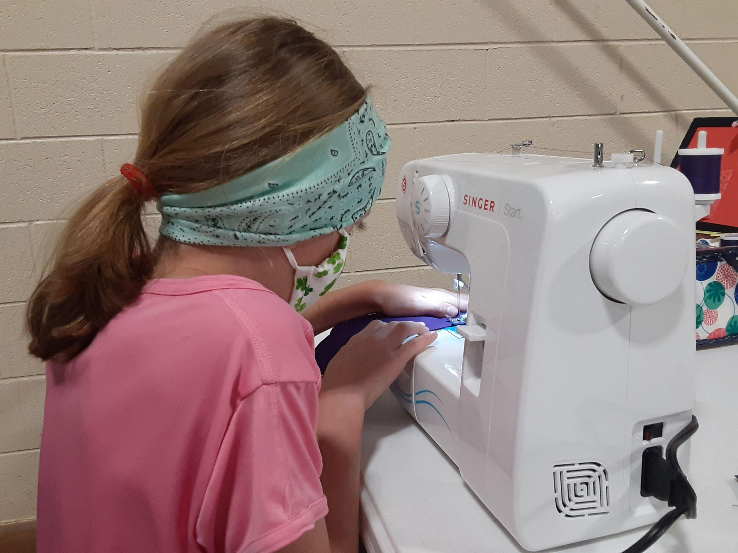

Deadlines and Dates for the 4-H Year:
To keep track of all dates and deadlines, read the Clover Connections Master Calendar (found on the website under “current 4-H members”).

Keeping up with deadlines and dates can be tricky, so we suggest having a family 4-H Calendar. Mark it in January with all pertinent dates for this year. Review the Clover Connections Calendar each month for updates/changes which are emphasized in BOLD.

Important Forms that need to be completed each year:
- Enrollment form (4honline.com)
- Medical forms (This is not required unless you are attending an activity that requires it. We often will collect updated forms prior to the event.)
- Animal care and housing form- if applicable
  - If your animals are not cared for at your home, please fill out this form and turn in a hard copy to the Extension Office or club leader.
  - If your animals are cared for at your home please fill out the form at 4honline.com
- Shooting Sports waiver- if applicable
  - A paper copy needs to be turned into the Extension office
- Your club leader will let you know if there are other required forms .

How to successfully complete your 4-H year:
- Learn about and exhibit at least one of your projects.
- Complete an e-record book (e-record).
- Do a demonstration or participate in a judging activity.
- Participate in a community service activity with your club.

Incomplete Projects:
While we encourage you to complete all of them, only one project is required. You can try again next year if you are not able to complete them all.

Extension Staff & 4-H Leaders

Extension Agents:
An Extension Agent is an employee of CSU Extension and Larimer County. Extension Agents oversee the direction and daily management of the 4-H program and its volunteers.

4-H Support Staff:
The county provides additional funding to support the county program needs.

4-H Leaders:
Someone who volunteers their time in service to 4-H. They must go through a background check and application process.

Club (Organizational) Leader:
The overall leader of a 4-H club; there are about 50 clubs in Larimer County 4-H (see Club Directory on the website).

Resource Leader:
A county-wide leader who has agreed to help 4-H kids from any club with project questions (see web list).

Project Leaders:
A leader within your 4-H club who will help you with a specific project.

Activity Leaders:
A county-wide leader such as a team coach who leads a specific county-wide activity (judging, dance, etc.)

Top Ten Tips for Navigating 4-H

- Go to your 4-H Club Meetings

- Start your e-record book as soon as you enroll in 4-H

- Read the Clover Connections and all e-mails/letters from the Extension Office & your club leader

- Visit the website often at http://larimer.extension.colostate.edu/

- Observe and write down deadlines

- Take advantage of workshops and clinics

- Do your demonstration and community service

- Ask questions

- Make friends with other 4-Hers & help each other

- Have fun!!!!

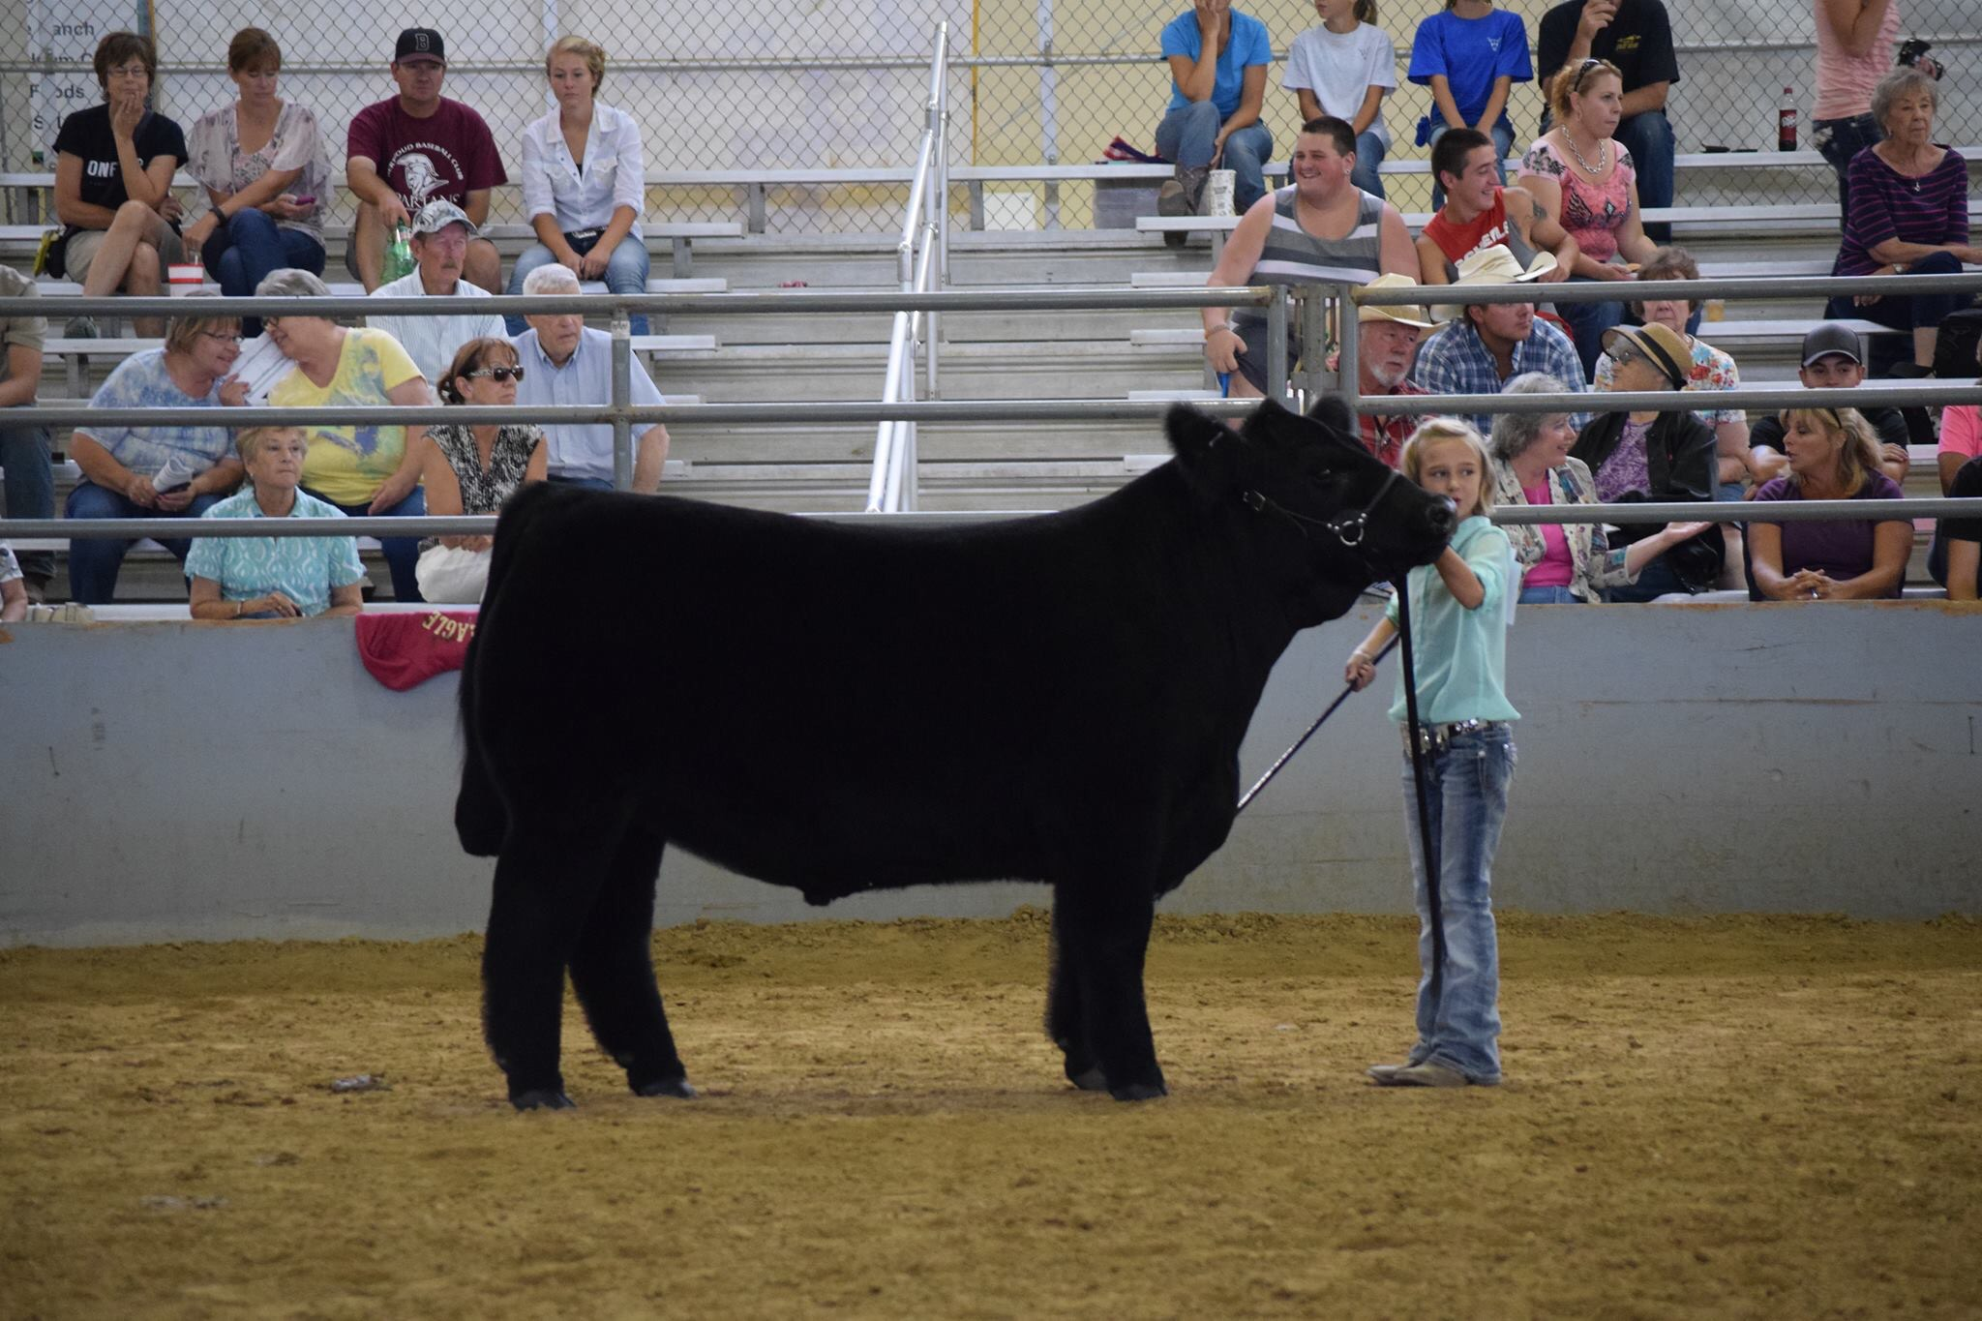

Frequently Asked Questions

What do 4-H Clubs do?
4-H Clubs are an informal, practical, fun environment for youth to learn public speaking and leadership skills as they gain knowledge in project areas of their choice. 4-H Clubs are led by the youth with assistance of a volunteer organizational club leader. They meet in various locations from individual homes, to libraries, to community centers, or schools. 4-H provides research based, developmentally appropriate curriculum for adults to teach youth specific projects and life skills such as citizenship, communication skills, public speaking, leadership, teamwork, and responsibility.

4-H teaches skills that will help youth throughout their life. Club participation, projects, and friendships are other memorable parts of the 4-H program. Youth will have the opportunity to give demonstrations, do community service, attend activities and camps with other youth, and develop the basic life skills that 4-H hopes to instill in its 4-H members.

Research shows that Colorado 4-H members:
- Have a positive self-concept that gives them confidence in life
- Are more socially competent and have the practical skills needed to become successful and contributing adults
- Are more likely to view the future and their role in the community positively
- Are more likely to develop a deep sense of compassion and caring for others

What Happens at a 4-H Meeting?
Most clubs meet once a month for most months of the year. Volunteer leaders, parents and 4-H members meet together for a 4-H club business meeting where decisions are made concerning community service projects, fundraising activities, and upcoming plans for participating in contests and events. The 4-H members also can share their project demonstration with the rest of the club at these meetings. The 4-H members of the clubs elect officers and these officers are responsible to run the meetings. Parents and leaders may make suggestions. However, they may not vote.

The 4-H member attends a project meeting where they learn about the project area they are taking. This is the time to learn the project skills, practice, and work on e-records. The time is limited so individual projects generally are not worked on at this meeting but rather at home with the guidance of parents.

What is the 4-H Emblem?
The 4-H emblem is federally protected under section 18 US Code 707 and belongs to the Congress of the United States. The official emblem is green with white H’s. Only 4-H clubs, enrolled 4-H members, and leaders may use the 4-H name and emblem.

What is the 4-H Pledge?
I Pledge my Head to clearer thinking,
my Heart to greater loyalty,
my Hands to larger service,
and my Health to better living,
For my club, my community, my county, and my world.

What do the 4-H’s stand for?
Head, Heart, Hands and Health are the four H’s in 4-H and they are the four values members work on through fun and engaging programs.

Head: Managing, thinking
Heart: relating, caring
Hands: giving, serving
Health: being, living

What is the 4-H Slogan?
“Learn by doing”

What is the 4-H Motto?
“To make the best better”
The intent of the motto is to inspire young people to continue to learn and grow, to make their best efforts better through participating in educational experiences where they gain knowledge, values, and skills.

What are the 4-H Colors?
Green and White. The white symbolizes purity and the green is nature's most common color in the great outdoors and is the color of springtime, growing, life, and youth.

What is the Colorado 4-H Vision?
A world in which youth and adults learn, grow and work together.

What is the Colorado 4-H Mission?
4-H empowers youth to reach their full potential by working and learning in partnership with caring adults.

What do youth gain from 4-H?
Kids build life skills by leading hands-on projects in areas like science, health, agriculture and civic engagement – helping them to grow confidence, independence, resilience, and compassion. Adult mentors provide a positive environment where they learn by doing. This 4‑H experience is delivered by a community of more than 100 public universities across the nation.

Facts about 4-H

4-H Financing:

What is the Larimer County 4-H Foundation?

The Larimer County 4-H Youth Foundation is a 501(C)3 Non-Profit Organization that was established in 1953. Governed by a Board of Trustees, the Foundation is an arm of the Colorado State University/Larimer County Extension Service and acts upon recommendations from the Larimer County Extension Service and its advisory groups to create and sustain positive youth development. The primary purpose of the Foundation is to help provide financial support for educational opportunities for the approximately 400 volunteer adult leaders and 1,000 youth, ages 5 through 18, who participate directly in the Larimer County, Colorado, 4-H Program. Educational opportunities include but are not limited to:
- Youth and adult leadership and citizenry skills conferences and workshops
- Project workshops and competitions
- Camp experiences
- Counselor training
- Livestock and non-livestock events
- Post-secondary education

How does the Foundation raise money to support 4-H participants?
The Foundation coordinates the Carnival. This event happens in March every year. Clubs are encouraged to participate in the event providing a fun experience for youth and families in the community to participate in games for a chance to win prizes. Youth enrolled in 4-H are expected to sell tickets that can be used that the Carnival. This ensures a successful fundraiser and increases the number of programs the program can offer at free or reduced prices By meeting your required quota, your child will be eligible for funds that will help finance a large percentage of state and national opportunities through 4-H.

Contact Your Larimer County 4-H Extension Staff:

Larimer County Extension Office:
Phone: 970-498-6000
Fax: 970-498-6025
Address: 1525 Blue Spruce Drive, Fort Collins, CO 80524-2004

County Director:
- Kerri Rollins
  - krollins@larimer.org

4-H Youth Development & Leadership Agent
- Katie Daywalker
  - kdaywalker@larimer.org

4-H Youth Development & Livestock Agent
- Bailey Schilling
  - schillbw@co.larimer.co.us

4-H Program Coordinator:
- Diane Kern
  - dkern@larimer.org

4-H Administrative Assistant:
- Pam Heeney
  - pheeney@larimer.org

