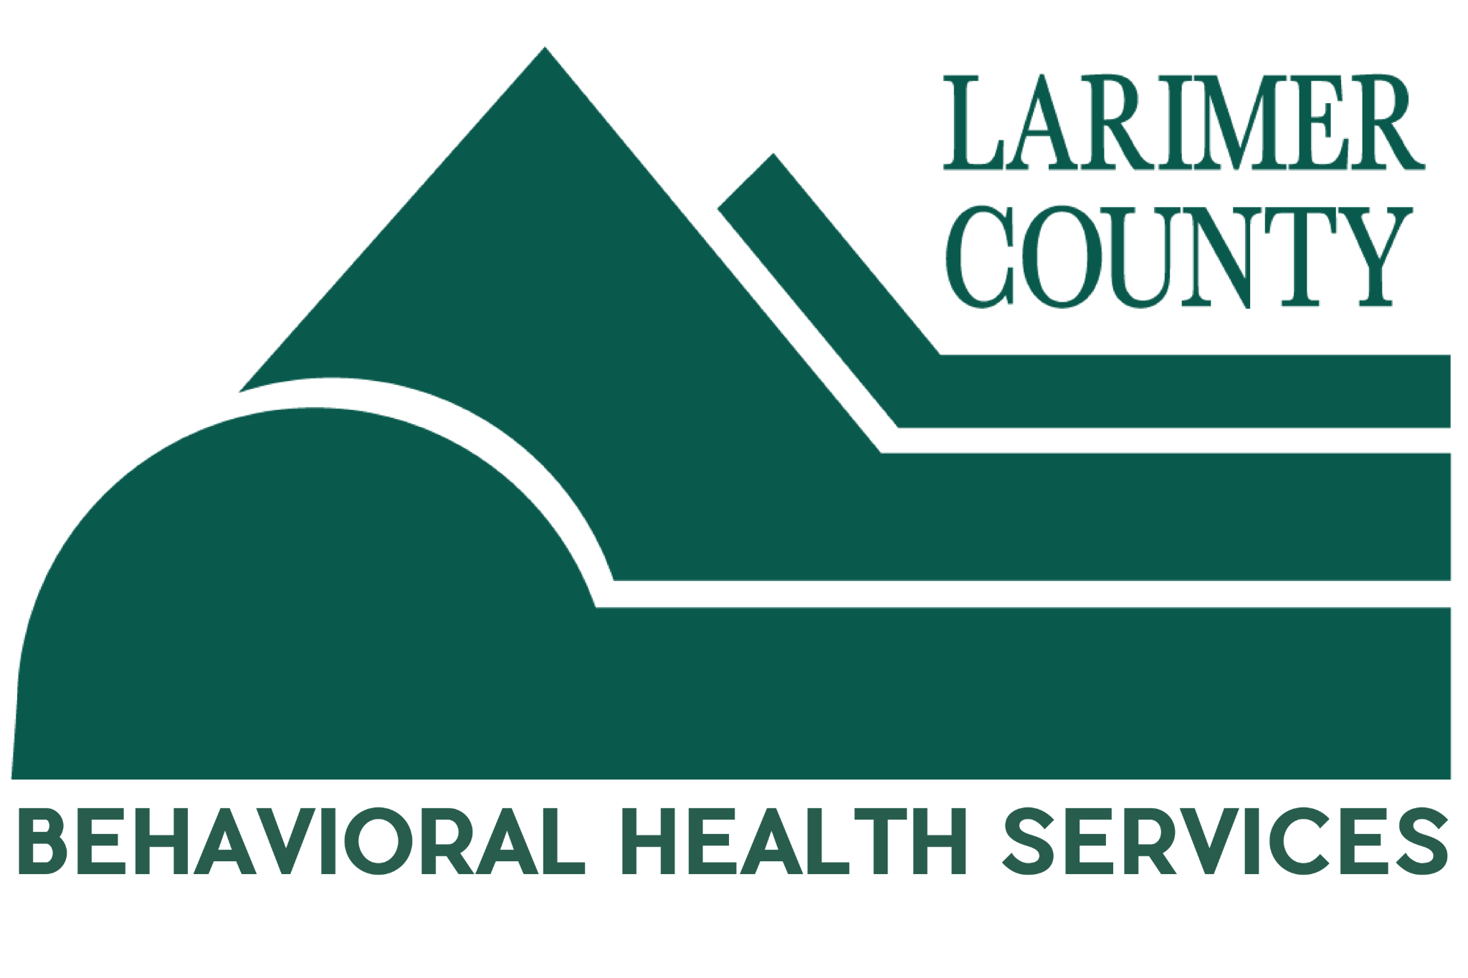

Larimer County Behavioral Health Services Sponsorship Agreement

1. The Partnership
This agreement is between Larimer County Behavioral Health Services (“BHS”) and [Recipient’s Name] (the "Recipient"). By entering this agreement, BHS agrees to sponsor Recipient in the amount stated in this Agreement, and the Recipient agrees to comply with this Agreement for the [Name of Event/Program] held on [Date].

2. Sponsorship Investment
BHS agrees to provide a total contribution of $[Amount], payable by [Due Date].

3. Recipient Obligations
To ensure high-quality representation, Recipient agrees to:
- Logo Usage: BHS logos must appear on all promotional materials. You must get pre-approval from the BHS Communications Coordinator before using the logo or any County slogans.
- Reporting: Organizations must submit a brief Post-Event Report within 30 days of the event detailing community impact. Such report must contain, at a minimum: the name of event, date/time/location, description of event and how it aligned with ballot language/strategic priorities, total number of attendees, any outcomes of note.

4. Public Benefit and Compliance with Ballot Language
- Ballot language: Recipient agrees that all sponsorship funds provided by BHS will be used solely on a program, service or event that complies with the 2018 ballot language.
- Claw-back: Recipient agrees that if BHS determines, in its sole discretion, that sponsorship funds provided by BHS were not used on a program, service or event that complies with the 2018 ballot language, Recipient is obligated to return all funds to BHS. Recipient waives any further notice or right to cure, and Larimer County is authorized to use this agreement as the sole basis to seek a judgment in a court of competent jurisdiction for the full amount of all sponsorship funds.

5. Key Terms & Conditions
- Professional Conduct: Both parties agree to act in a way that protects the reputation of the other. BHS reserves the right to terminate the agreement if the Sponsor’s actions conflict with BHS core values, posted on the “About Behavioral Health Services” web page.
- Fund Availability: Pursuant to C.R.S. § 30-25-103 financial obligations of the County payable after the current fiscal year are contingent upon funds for that purpose being appropriated, budgeted, and otherwise made available. If funds are not appropriated, budgeted, or made available, this Agreement shall immediately terminate without further County obligation.
- Governmental Immunity: Liability for claims for injuries to persons or property arising from negligence of the County, including without limitation its employees, departments, boards, offices, and officials shall be controlled and limited by the provisions of the Colorado Governmental Immunity Act, C.R.S. § 24-10-101 et seq., as applicable now or hereafter amended. No term or condition of this Agreement shall be construed or interpreted as a waiver, express or implied, of any of the immunities, rights, benefits, protections, or other provisions contained in these statutes.
- Independent Contractor: Recipient shall perform its duties hereunder as an independent contractor and not as an employee. Neither Recipient nor any employee of Recipient shall be deemed to be an employee or agent of the County. Recipient and its employees are not entitled to unemployment insurance or workers compensation benefits through the County and the County shall not pay for or otherwise provide such coverage. Recipient shall be responsible for all employment taxes, income taxes or other taxes incurred in performing this Agreement. Recipient shall provide and keep in force workers’ compensation and unemployment compensation insurance in the amounts required by law, and provide proof thereof when requested, and to be solely responsible for its acts and those of its employees and agents.
- Compliance With Law: Recipient shall strictly comply with all applicable federal and state laws, rules, and regulations in effect or hereafter established, including, without limitation, Title II of the Americans with Disabilities Act of 1990, as amended, as well as laws applicable to discrimination and unfair employment practices.
- Choice of Law, Jurisdiction, and Venue: Colorado law shall be applied in the interpretation, execution, and enforcement of this Agreement. Any provision included or incorporated herein which conflicts with said laws shall be null and void. All suits or actions related to this Agreement shall be filed and proceedings held in the State of Colorado and venue shall be in Larimer County, Colorado, or Colorado Federal District Court.
- Prohibited Terms: Any term included in the Agreement that requires Larimer County to indemnify or hold Recipient or any other party harmless; requires Larimer County to agree to binding arbitration; limits Recipient’s liability for damages to anything other than actual and direct damages; or that conflicts with this provision in any way shall be void ab initio. Any provision rendered null and void by this provision shall not invalidate the remainder of the Agreement.

6. Signatures
Both parties agree to the terms listed above:
For BHS: Name/Title: ___________________________
Signature: ___________________________
Date: _______________
For the Sponsor: Name/Title: ___________________________
Signature: ___________________________
Date: _______________

