Larimer County Economic & Workforce Development
Workforce Innovation and Opportunity Act (WIOA) Local Plan

Program Year 2024 – 2027

Larimer County Economic and Workforce Development
Local Plan for Program Year 2024 – 2027

Provide an analysis of the workforce development activities (including education and training) in the local area, including an analysis of the strengths and weaknesses of such services, and the capacity to provide such services, to address the identified education and skill needs of the workforce and the employment needs of employers in the local area.
Labor Market Analysis: Larimer County Economic and Workforce Development
- Provide an analysis of the regional economic conditions overall, as well as for each area included in this planning region, including:
- Existing and emerging in-demand industry sectors and occupations; and
- The employment needs of employers in those industry sectors and occupations.
Economic Overview
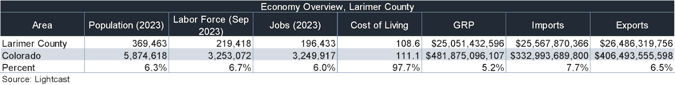
Historical Trends
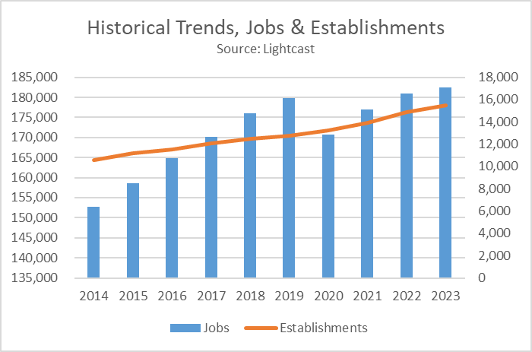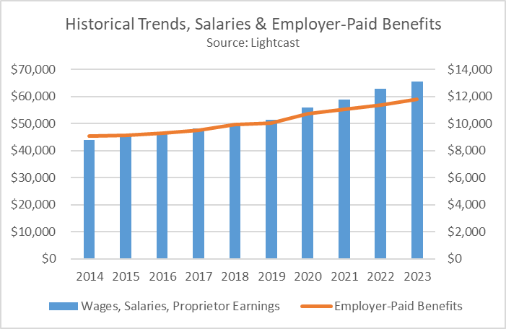
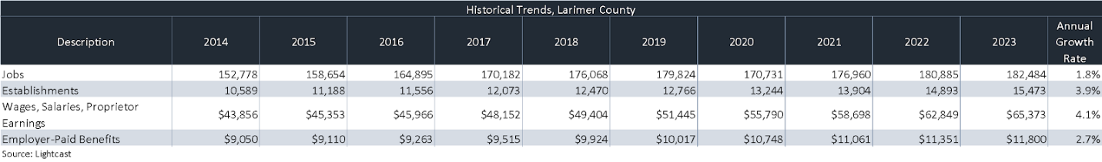

Projected Growth by Sector
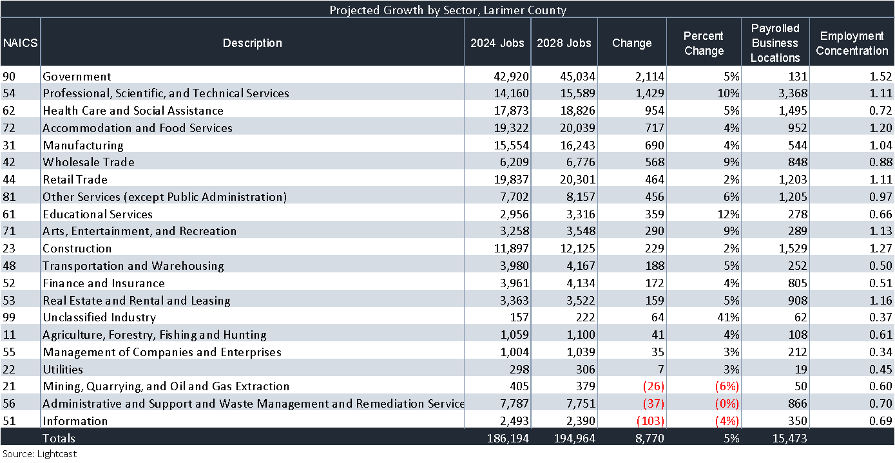

Projected Growth by Occupation Family
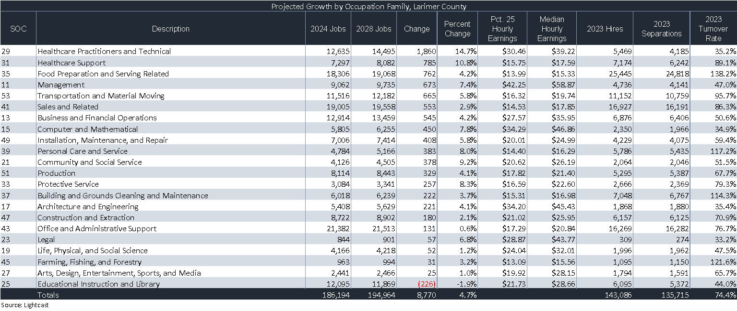
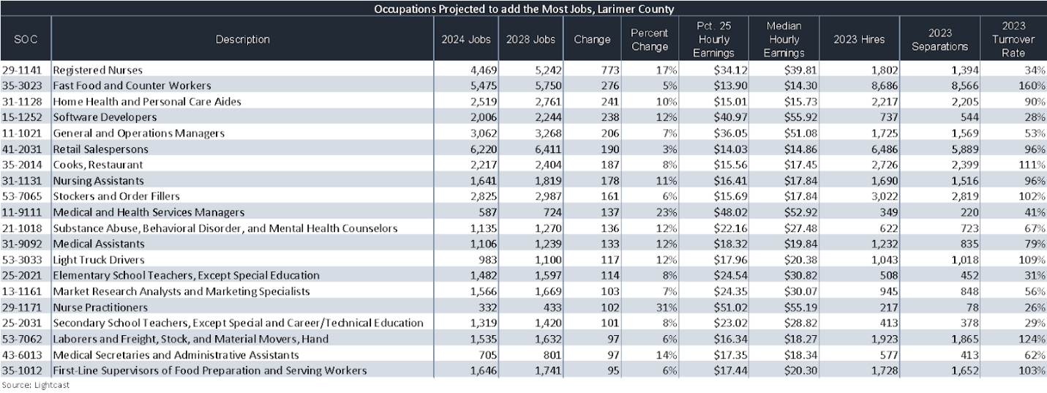
Takeaways (Lightcast)
- As of 2023 the region's population increased by 5.2% since 2018, growing by 18,418. Population is expected to increase by 3.0% between 2023 and 2028, adding 11,221.
- From 2018 to 2023, jobs increased by 3.9% in Larimer County from 189,136 to 196,433. This change outpaced the national growth rate of 3.6% by 0.3%. As the number of jobs increased, the labor force participation rate increased from 70.6% to 71.0% between 2018 and 2023.
- Concerning educational attainment, 29.9% of Larimer County residents possess a Bachelor's Degree (8.8% above the national average), and 9.3% hold an Associate's Degree (0.3% above the national average).
- The top three industries in 2023 are Education and Hospitals (State Government), Restaurants and Other Eating Places, and Education and Hospitals (Local Government).
- Larimer County has 78,119 millennials (ages 25-39). The national average for an area this size is 74,579.
- Retirement risk is about average in Larimer County. The national average for an area this size is 109,917 people 55 or older, while there are 105,549 here.
- Racial diversity is low in Larimer County. The national average for an area this size is 150,834 racially diverse people, while there are 70,080 here.
- Larimer County has 19,797 veterans. The national average for an area this size is 19,042.
- Larimer County has 2.64 violent crimes per 1,000 people. The national rate is 2.41 per 1,000 people.
- Larimer County has 17.74 property crimes per 1,000 people. The national rate is 12.12 per 1,000 people.
- Provide an analysis of the knowledge and skills needed to meet the employment needs of the employers in the region, as well as for each area included in this planning region, including employment needs in in-demand industry sectors and occupations.
In calendar 2023, Larimer County employers posted an average of 9,431 unique jobs per month. The average posted wage through 2023 was $24.13 per hour.

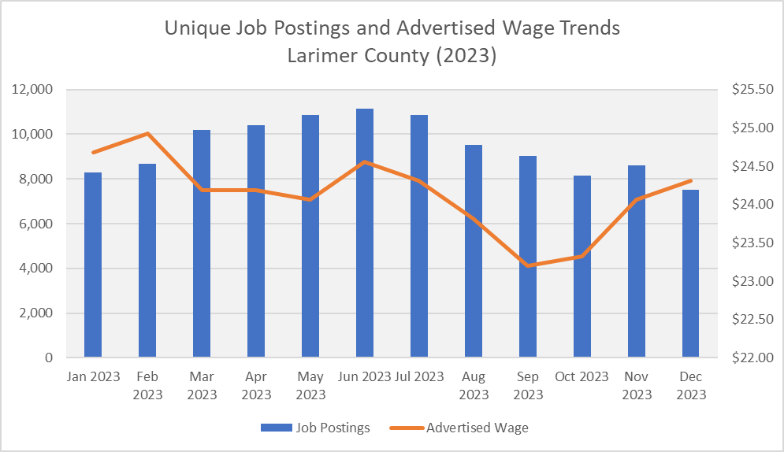

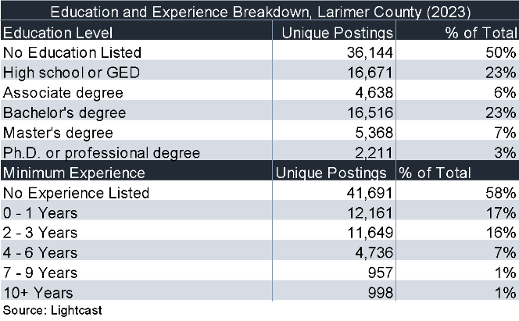

This table shows the education and experience requirements of unique jobs posted in Boulder County in the calendar year 2023.

The structurally scarce labor market has encouraged skill-based rather than education-based hiring, as can be seen in the top portion of the table. However, nearly 40% of the jobs posted required a bachelor’s degree or higher.
Top Jobs Posted
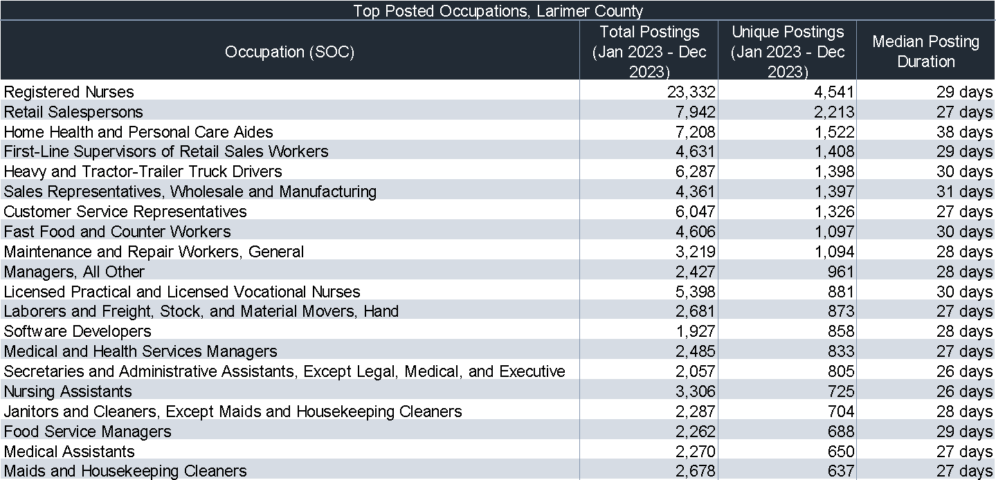

Job Postings: Skills Breakdown, Credentials in Demand
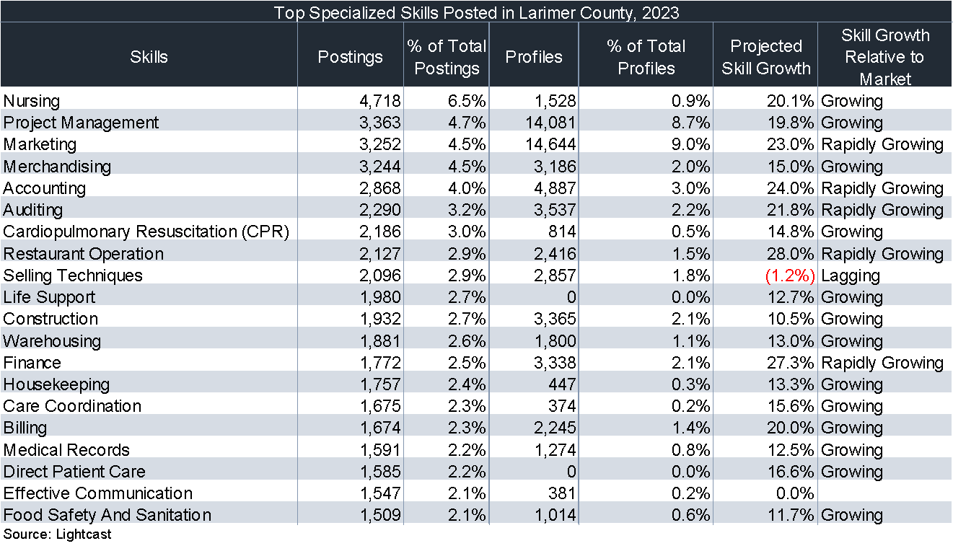

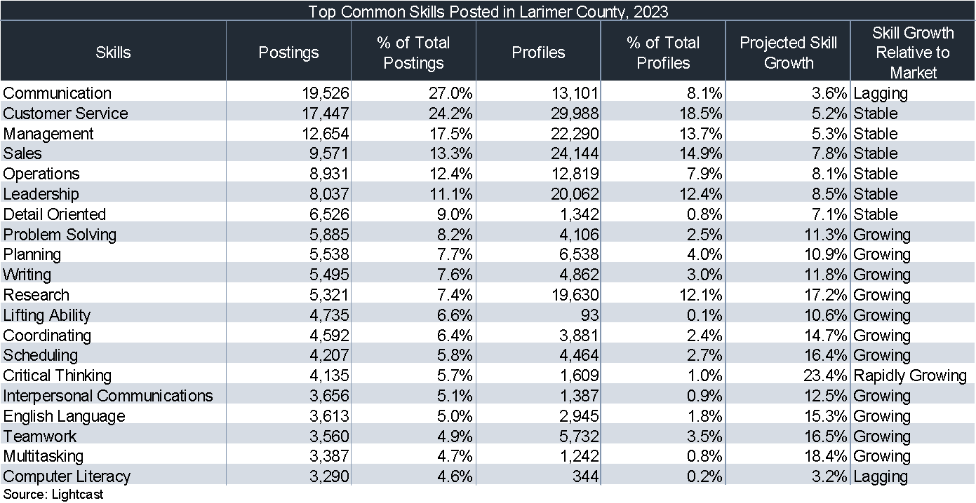

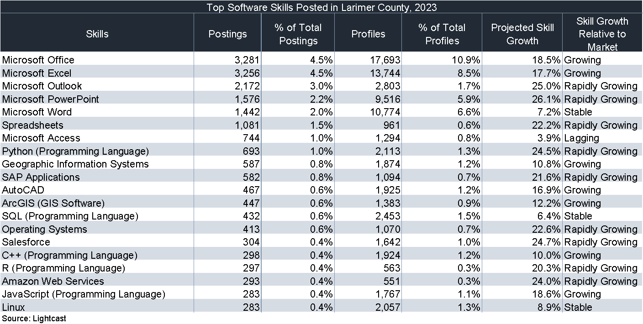
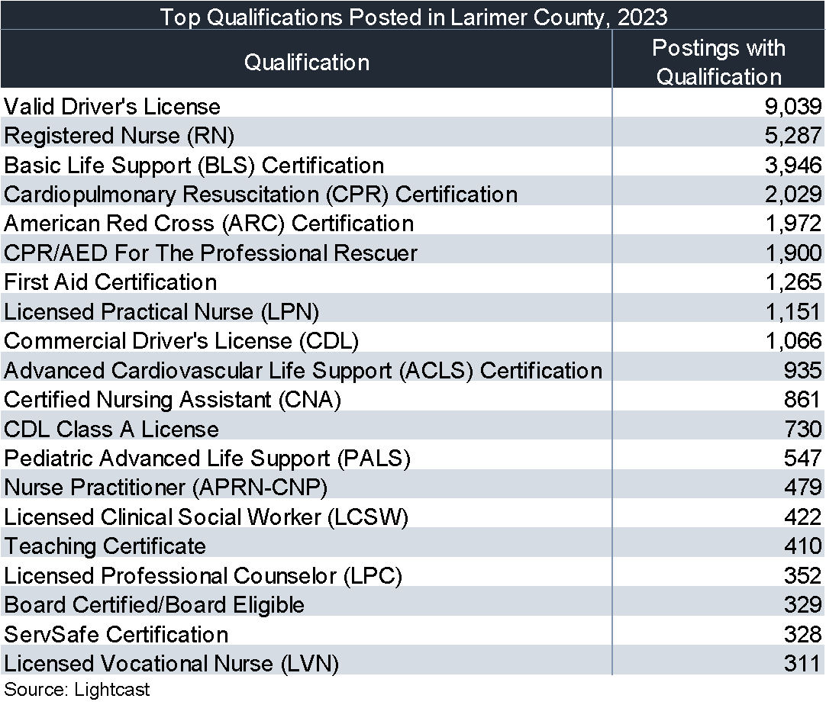
- Provide an analysis of the workforce in the region, as well as for each area included in this planning region, including current labor force employment and unemployment data, and information on labor market trends, and the educational and skill levels of the workforce in the region, including individuals with barriers to employment, New Americans (defined as Coloradans who arrived in the U.S. as immigrants or their children) and veterans.
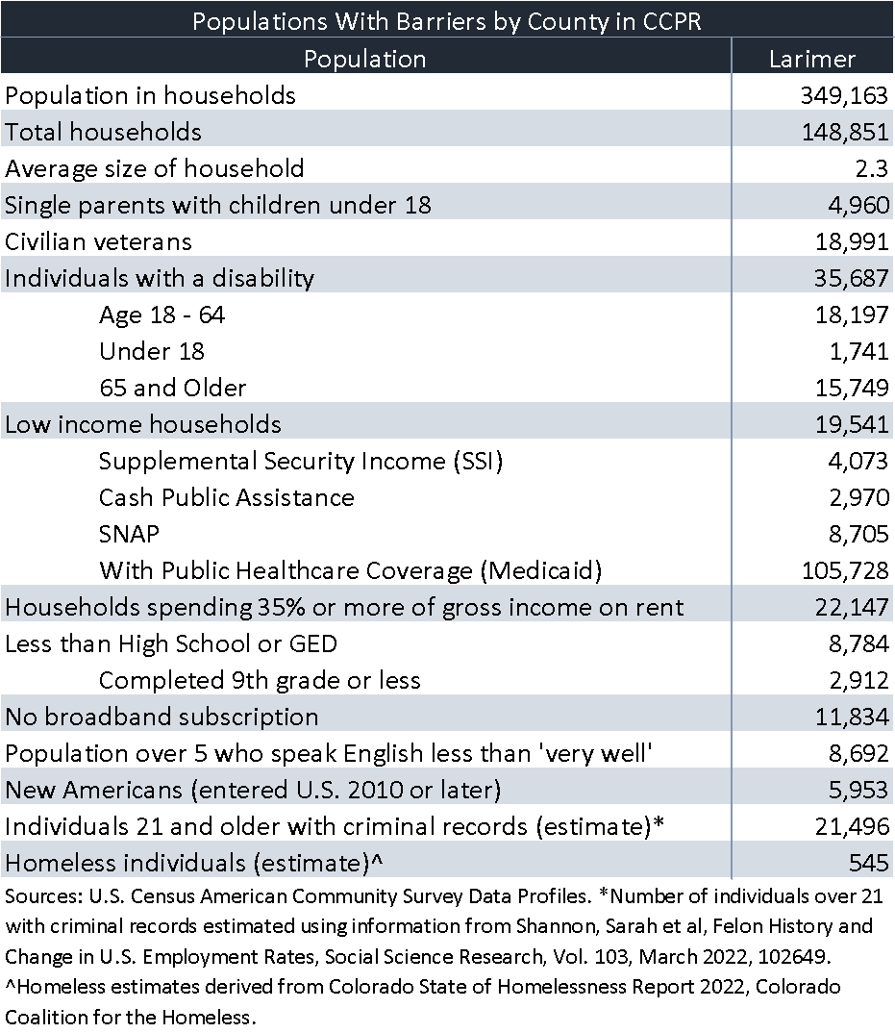

This data is important for each local region because workforce centers are uniquely positioned to increase labor force participation by helping these individuals surmount their barriers using braided funding strategies to provide supportive services, and upskilling, reskilling and new-skilling them so they can successfully engage in work.

This vital role played by workforce centers and their partners can make a critical difference in maintaining the competitiveness of Colorado employers in a global economy.
Kitchen Table Concerns for Workers
Wages have not kept up with inflation, so workers are finding they are spending more money for less product across the board. While the inflation rate has gone down, it is important to realize how to read this graph correctly. Prices in November 2023 were 3.1% higher than they were the previous November 2022. What this means is that if we go back to November 2020, we find that prices have actually gone up 17%.
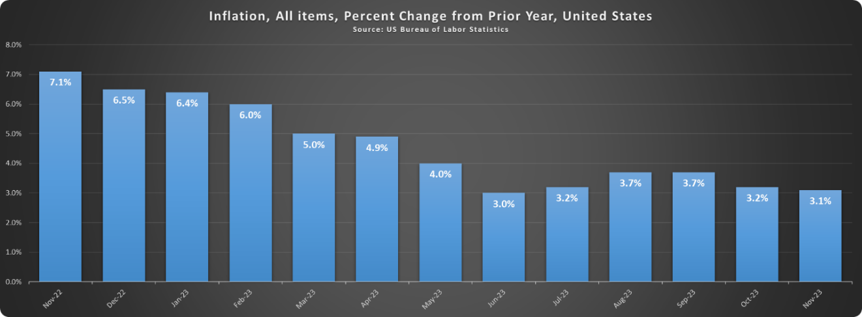
The high costs of insuring and repairing motor vehicles is also a concern, which is one reason hybrid and remote work schedules have become more popular since the pandemic.
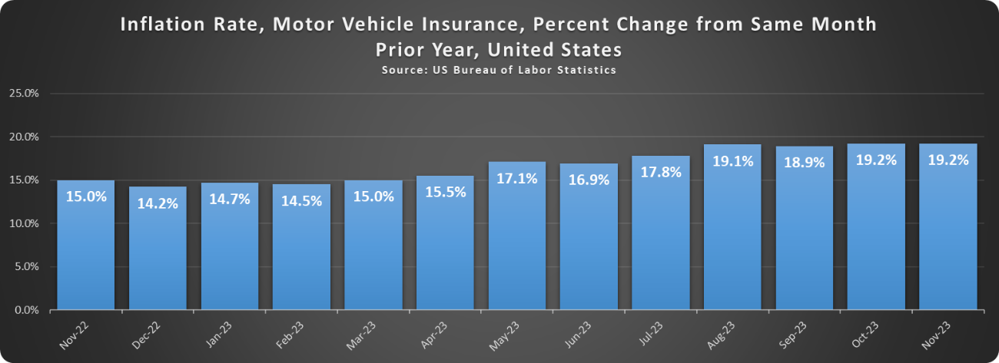
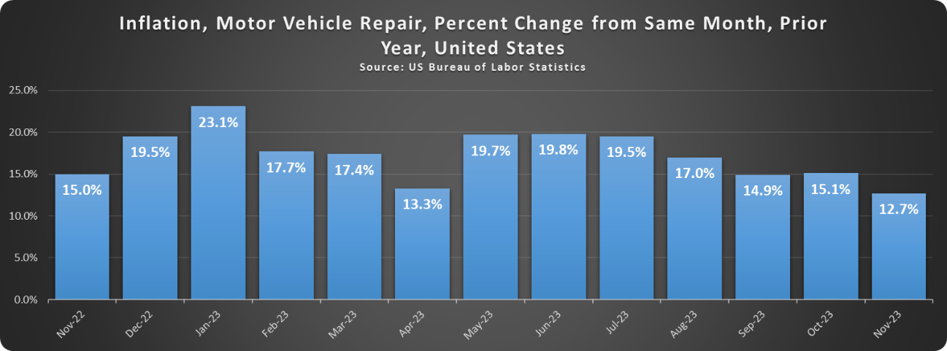
Rents also remain high. According to the U.S. Census Bureau American Community Survey, 22,147 (44.5%) of the renters in Larimer County are paying 35% or more of their gross rent as a percentage of household income.
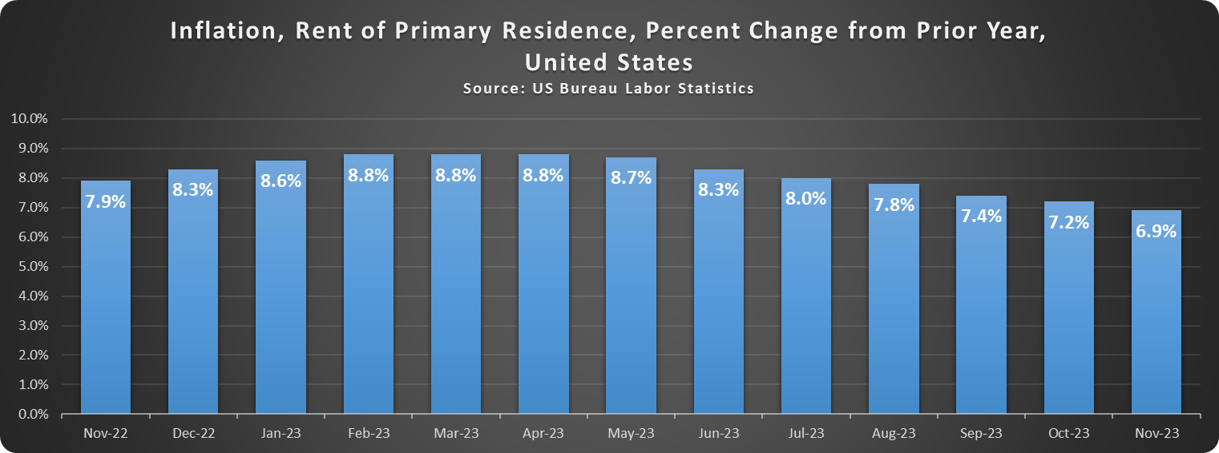

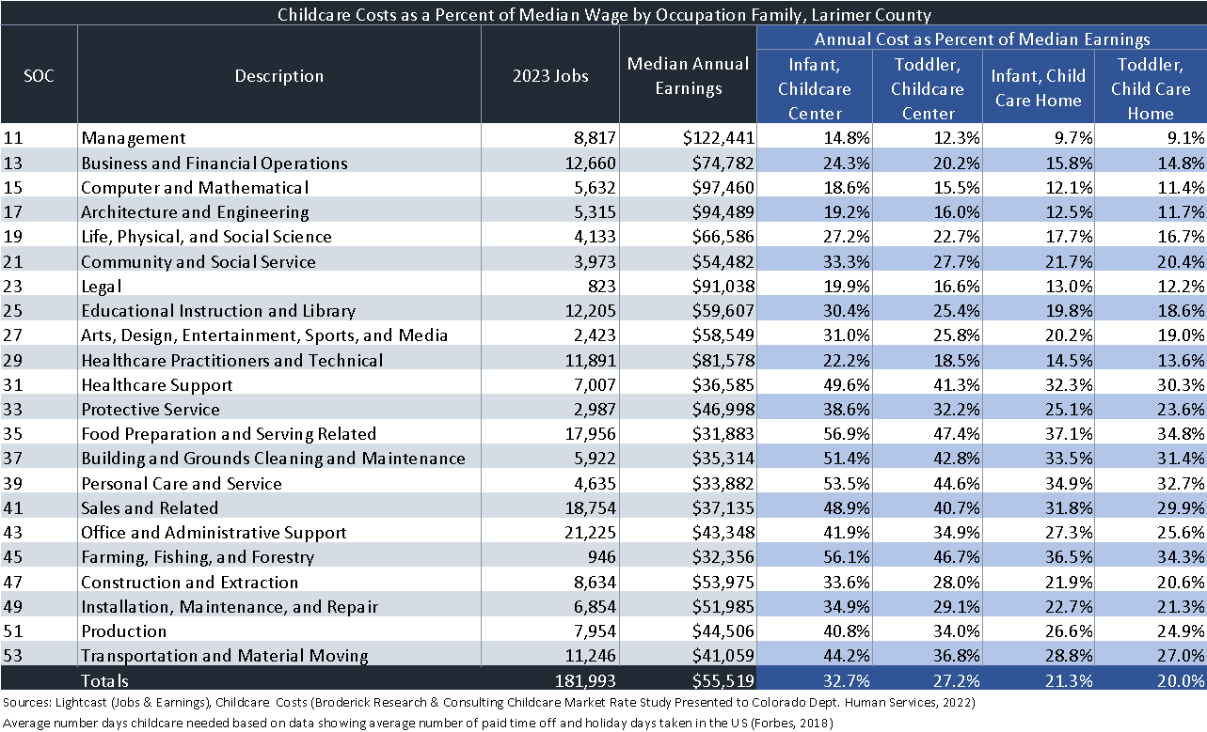
Figures from this table are from Lightcast and the 2022 Colorado Childcare Market Rate Study, which is required for each state every two years. For example, a housekeeper with an infant may be paying over half of their gross income for childcare.

If they are also paying 35% for rent, this leaves only 15% of their entire gross to pay for everything else they need.

Employment and Unemployment Data
The following information was taken from the U.S. Bureau of Labor Statistics Local Area Unemployment Data. Note that the labor force in Larimer County went up by 17,418 between January 2019 and December 2023, an increase of 8.7%. This reflects the entry into the labor force of a number of workers who lost jobs during the pandemic and were gradually reabsorbed over 2022. Larimer County Economic and Workforce Development has been steadily helping people with barriers to success in the labor market to surmount those barriers with supportive services while they reskill, upskill or new-skill.
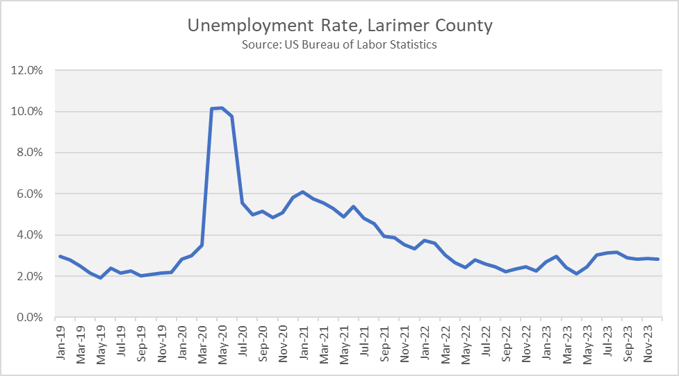
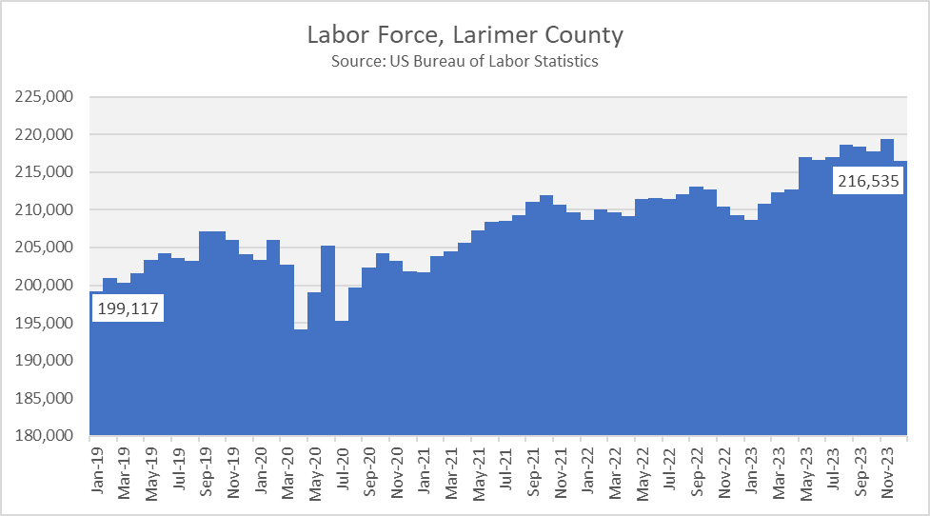
Larimer County Economic and Workforce Development (LCEWD) provides a variety of economic and workforce development activities, some of which include education and training, in the local Larimer County region. Portions of these workforce development activities are funded through the Workforce Innovation and Opportunity Act (WIOA) while others are funded through local, state, federal and other resource funds. All are geared towards supporting people within the labor market gaining access to the skills they need to fill the employment needs of employers within the region and the broader laborshed of northern Colorado.
As part of a regional analysis related to workforce development, it’s important to note the continued development of the northern Colorado strategic talent development initiative titled NoCo Works. Across Weld and Larimer County, Northern Colorado recognizes the importance of regionalism and the power of collaboration, specifically pertaining to talent and workforce. This is not just an idea or a grand goal, it’s the truth.
Growing from the success of previous strategic plans for the region such as the Talent 2.0 initiative, NoCo Works is composed of collaborators from across both Weld and Larimer counties. A facilitated process was held in spring 2022, where a guided discussion broke down complex workforce and talent issues into manageable chunks so the group could work strategically to implement motivating goals addressing workforce challenges.
In fall 2022, the next step was a thorough review of strategic plans and annual reports of 50-plus organizations and initiatives who are key contributors to economic and workforce development in the region. These reiterated an overwhelming acknowledgment of regionalism which extends from business to government to nonprofits to education.
Based upon the review of existing efforts and initiatives, as well as demonstrated needs and commitment to action from key stakeholders, NoCo Works was formed. A steering committee provides oversight and support to six subcommittees that move the work forward pertaining to regional talent and workforce development encompassing the Northern Colorado ecosystem. The LCEWD’s Workforce Development Board has adopted these themes as monthly board meeting topics for the 2024 calendar year, convening subject matter experts in these topics to share valuable insight.
Six Key Themes:
Economic Inclusion: All community members have equal access and opportunity to utilize workforce and talent services, Digital literacy, bilingual and monolingual Spanish upskilling and reskilling. These include but are not limited to under-represented and minority populations.
External Barriers: Advocacy and policy reform to address Transportation, Childcare, and Housing which affect access to job opportunities and limit how people can thrive in the community.
Business Resources: Provide a one-stop shop with resources, tangible services, and information to help local businesses accomplish necessary business goals.
Training and Development: Create regional access for businesses to provide training and development opportunities for Northern Colorado’s labor force (incumbent employees and job seekers). This includes upskilling and reskilling through access to certifications and credentials as well as customized soft skills and technical skills training.
Talent Pipeline: Holistic strategy for attracting and retaining the future workforce, with the goal to increase labor pool and positively contribute to the local economy. The aim is to generate career pathways and sector career pathway models.
Work-based Learning: Regional commitment to expanding internships, pre-apprenticeships, apprenticeships, on-site career learning opportunities, and more.
The Larimer County Economic and Workforce Development department is a critical partner in the workforce development environment. In 2023, the public workforce system celebrated 90 years of the Wagner-Peyser legislation that formed the labor exchange system in the country. Over time, the public workforce system has adapted services and priorities based on the changing priorities of our nation. In 2024, LCEWD is proud to remain a key partner within our region by administering the existing legislation of the Workforce Innovation and Opportunity Act (WIOA) Title I and Title III services and offers workforce development services through the following ways:
The Workforce Connections Team (WCT) provides all Workforce Innovation and Opportunity Act (WIOA) Title III Wagner-Peyser job seeker and business services. This includes business services such as supporting employers to post their open vacancies in Connecting Colorado, hosting hiring events, providing skill assessments for employers, consulting related to skills-based hiring, providing labor market data for employer decision making, and aiding in the review and modification of modernizing job descriptions to attract talent. Job seeker services include conducting an effective and modern job search, career pathway identification and job search skill workshops, providing core services to job seekers such as resume assistance, cover letter development, and developing interviewing skills, assessing individual needs and making intentional referrals to internal and external partners of the department, responding to general questions about Unemployment Insurance (UI) benefits, and providing opportunities for employers to connect with job seekers actively searching for employment. Job seeker and business services are provided in-person, on the phone, in remote and virtual environments, and in some cases through self-directed use.
The WCT provides an updated website that offers job search related information and videos, career assessments, and current labor market information designed to provide updated and relevant information related to the northern Colorado and state-wide needs of business. The WCT conducts outreach activities utilizing job search related email notifications and a job seeker newsletter, as well as providing onsite job search workshops and related activities within community organizations and events, including public libraries, non-profits, post-secondary institutions, and other places to stretch our service reach to those who have job search related needs in Larimer County. The WCT serves as an internal expert for Connecting Colorado and Unemployment Insurance (UI).
A primary strength of the WCT job seeker services is the ability to assist large numbers of job seekers in a way that’s most convenient for their situational access. This includes in-person, on the phone, in remote and virtual environments, and in some cases through self-directed use. LCEWD deploys multiple staff, some of whom are multi-lingual, into the community to improve our access footprint. By building these relationships with talent populations in their neighborhoods and community partner agencies, we’ve increased our capacity to serve talent pools who are desperately needed to fill the vacancies that our business community demands.
Another strength of the WCT job seeker services is the ability to assist Unemployment Insurance (UI) claimants with the claim process. As the volume of UI claimants ebbs and flows with labor market conditions, WCT staff are able to assist customers with filing a claim, escalate a concern about their claim to the UI staff, and connect the claimant directly to UI. A limitation of the UI process that connects directly to LCEWD is the lack of public awareness regarding Connecting Colorado as a viable job search tool. Additionally, the continued partnership with the Colorado Department of Labor and Employment (CDLE) Reemployment Services and Eligibility Assessment (RESEA) service provides our public workforce system an opportunity to support individuals who have lost their employment, through no fault of their own, access re-employment supports to improve their connection to the wide variety of services offered at LCEWD, ultimately aiding them in returning to the labor market. The goal is to reduce the duration of the participants' UI participation time, improve their employment outcomes, and create alignment with the vision of the Workforce Innovation and Opportunity Act (WIOA).
A significant strength of the WCT has been their adaptability to the changing needs of our job-seeking customers. As the pandemic has ended, job seekers increased their interests within our office to seek new career pathways, scale up within their existing career path, or are choosing to re-enter the labor market after spending time away. This has provided new services to respond to the growing needs of our workforce region; specifically, digital literacy to assist the job seeker with technology skills to conduct an effective job search, engaging in broader outreach to communities that are not accessing services within our One-Stop physical location, and the development of short-term training support access to improve the marketability of our residents’ skills through the Reskill, Upskill, Next Skill (RUN) service.
Digital Roots has become an award winning, keystone workforce development service that has improved our technology access offering to the public. Through Digital Roots, WCT staff provide one-on-one assistance, at a location that is convenient for the customer, and work regularly with that customer for a 3-month period to build their confidence and competence with technology and computer use. At the end of that time duration, if the customer chooses to, they may keep the computer device they used while learning about technology.

The Coaching Collaborative and additional resources aligned outside of the public workforce system, have provided an opportunity to further expand our outreach and connection to targeted populations that have not been familiar with LCEWD services. These activities have expanded our access to serve, and once participants are connected with our staff and have experienced the power of our partnerships and relationships, we find these groups continue accessing resources both in the community and within the physical structure of the One-Stop location. In addition to expanding access to serve, the bona fide professional career and employment counseling services accessed through bilingual LCEWD staff have increased our level of quality to continue promoting an equitable and accessible economy for all job seekers and the businesses seeking their talents.
The RUN short-term training service offers an expansion of skills training access for eligible populations to obtain the necessary training credentials to competitively enter or scale up their existing skills to enter the labor market, while ensuring our residents have access to affordable low-cost or no-cost training opportunities. Through these short-term credential programs, we have improved our ability to continue supporting WIOA Title I eligible populations, while also expanding training services for those that may not meet Title I eligibility or who lack the desire to commit to an in-depth case management program. This service expansion is an existing strength in our efforts to support education growth and skill attainment necessary for the workforce.
The LCEWD department provides Workforce Innovation and Opportunity Act (WIOA) Title I services, through a variety of subject matter expert service teams. The Career Transition and Training (CTT) Team is the unit primarily responsible for the delivery of WIOA Title I Adult, Dislocated Worker, Trade Adjustment Assistance (TAA), Trade Readjustment Allowance (TRA), and many of the other federal WIOA-related and non WIOA-related discretionary services that target adults seeking case management services within the region. The inCompass Team is the unit primarily responsible for the delivery of WIOA Title I Youth services, a vital component of the youth focused CareerRise team, responsible for the youth services footprint.
Both CTT and inCompass services have modernized their service delivery model as a result of new opportunities the pandemic provided, including an expansion to host virtual meetings, create more efficient compliance related electronic paperwork and processes, and simplified eligibility documentation and determination activities when allowable. This allowed existing participants and new participants to continue receiving services with increased efficiency and accessibility. WIOA Title I teams have the capacity to deliver these primary workforce development activities that support the employment needs of local employers within the Larimer County region and regional labor shed such as:
Intensive Job Search Assistance: This service is provided to all CTT and inCompass participants. Some participants benefit exclusively from this service, or they may use Intensive Job Search Assistance as a complement to other services outlined below. These services work diligently to recruit and enroll customers most likely to benefit from services; services that assist customers with the education, training, and the skills necessary to support their personal and professional economic growth and self-sufficiency.
As part of intensive job search assistance and skill acquisition processes, staff assist participants in understanding current workplace trends, labor market conditions for the present and projected for the future, and employer expectations, so that customers are prepared to secure and retain their employment and create further economic opportunity for themselves and their families.
The primary strength of this service is a customized Individual Employment Plan (IEP)/Individualized Service Strategy (ISS) developed in partnership with each participant. The IEP/ISS provides a map of agreed upon services, considering important life factors that include but are not limited to alternate resource access, barriers to employment, strengths and desires, workplace and individual values, and circumstances unique to the person, all of which may influence a job search and the type of employment the customer seeks to secure. Through the IEP/ISS, staff work diligently with participants to map out career pathways through the use of assessments, counseling, and case management services.
A drawback to the Intensive Job Search Assistance service is that it is customized, leading to an intensive amount of time and labor for both the counselor and the participant. For best results, the counselor and participant meet regularly to continually adjust and refine their job search strategy in real time. Counselors have consistently employed virtual technology to maintain regular, real-time contact with participants engaged in Intensive Job Search Assistance and training services.
Individual Training Accounts (ITAs): Eligible customers may apply for ITA scholarship funds for the development of in-demand work skills or credentials that lead to their identified career pathway. Eligible customers in the WIOA Adult and Dislocated Worker programs are provided financial investments in the form of tuition assistance, books and fees, and other expenses that aid in removing the financial barrier to accessing quality and affordable training. Funding for scholarships may include braiding multiple funding sources internally, or within partner agencies to further stretch resources to minimize financial barriers. Strong training vendor partnerships exist across a variety of public and for-profit training providers, all connected to the Eligible Training Provider List (ETPL). Additionally, the WIOA Youth program offers limited ITA opportunities when funding is accessible. Despite these strong local partnerships, the capacity to provide ITA scholarship assistance continues to remain a challenge, limited by fluctuating and declining funding investments to deliver these services.
Work Based Learning: Work-based learning (WBL) services are initiatives designed to provide eligible individuals with hands-on, experiential learning opportunities that directly relate to their career goals and interests. These services bridge the gap between classroom learning and real-world work environments allowing participants to develop practical skills, gain industry specific knowledge, and build professional networks to help them advance within their chosen career pathways. Successful services require industry relationships to act as host sites and employment linkages, providing these real-world learning opportunities. Examples of work-based learning services that the LCEWD department supports include experiences such as job shadowing and career exploration, career tours, subsidized work experience and internship matching, on-the-job training connection, and apprenticeship development. Please see a more descriptive example of these services further in the plan.
Supportive Services: Supportive Services are aimed at assisting eligible individuals in overcoming barriers to employment, accessing essential resources to help remove financial challenges to connect to workforce development activities. These services can become critical factors in removing barriers for the person to advance their training and employment goals. Services are customized to meet the specific needs of each unique job seeker and vary. Common supportive services include support related to transportation, childcare, utilities, and internet access among other areas. Please see more descriptive examples of supportive service use further in the plan.
High School Equivalency (HSE) and Adult Basic Education Services: High School Equivalency services are a cornerstone to the WIOA Title I Youth service delivery model, focusing on serving out-of-school youth. Partnerships with our local Adult Education and Family Literacy Act (AEFLA) Title II service provider, The Learning Source, provide a referral relationship for youth and adults to engage in a classroom learning environment to improve their basic education skills to prepare them for HSE testing. Furthermore, The Learning Source is a key referral partner in participants' pursuit of English acquisition skills as they seek to enter the labor market as an English as a second language participant. For those who desire an alternate service from the classroom environment, LCWED deploys an individual tutoring service, providing wrap-around support from adult tutors who help the person create a customized learning plan to improve their basic education skills in preparation for HSE testing. These academic supports have proven to lead young adults to their high school diploma, as they pursue their education goals as part of a broader career pathway vision.
The Larimer County Economic and Workforce Development (LCEWD) department is excited to explore emerging opportunities as they relate to addressing the identified education and skill needs of the workforce and the employment needs of employers in the local area. These opportunities have the potential to further advance access, quality, affordability, and equity. First, Learning Employment Records (LER) hold significant potential to enhance the effectiveness and efficiency of the talent development system by providing a comprehensive and dynamic repository of individuals' learning and employment experiences, housed in a single digital wallet. The Larimer County Economic and Workforce Development department has been part of learning labs hosted through the National Association of Workforce Development Boards (NAWB), convening leaders across the country in an effort to advance this technology potential. Opportunities that a Learning Employment Record could offer to our community, that we intend to continue discussing include:
  - Comprehensive Skills Assessment: A LER can serve as a comprehensive skills assessment tool, capturing not only formal education and training achievements but also informal learning experiences, certifications, and on-the-job skills development. This holistic view of individuals' skills and competencies can help workforce professionals better understand their abilities and match them with suitable employment opportunities.
  - Tailored Career Pathways: By aggregating data on individuals' educational achievements, work experiences, and career goals, a LER can facilitate the development of tailored career pathways and training plans. Workforce professionals can use this information to provide personalized guidance and support to individuals seeking to advance their careers or transition into new industries or occupations.
  - Improved Job Matching: With access to comprehensive information about individuals' skills, qualifications, and preferences, the public workforce system can improve job matching and placement services. Workforce professionals can leverage LER data to identify suitable job opportunities, apprenticeships, or training programs that align with individuals' interests and abilities, leading to better employment outcomes.
  - Enhanced Training and Education Planning: A LER can support better decision-making around training and education investments by providing insights into the effectiveness of different programs and interventions. Workforce agencies can analyze LER data to identify trends, gaps, and areas of opportunity in the education and training landscape, informing strategic investments in workforce development initiatives.
  - Credential Transparency and Recognition: The use of a standardized LER format can promote credential transparency and recognition, allowing individuals to easily showcase their skills and qualifications to employers, educators, and other stakeholders. This can reduce barriers to employment and education by providing a clear and verifiable record of individuals' learning and employment achievements.
  - Data-Driven Policy and Program Development: Aggregated LER data can inform data-driven policy and program development efforts within the public workforce system. By analyzing trends and patterns in LER data, policymakers and program administrators can identify areas of need, evaluate program effectiveness, and make evidence-based decisions to improve workforce development outcomes.
  - Lifetime Learning and Skills Development: A LER can encourage and support lifelong learning and skills development by capturing individuals' learning experiences and achievements over time. As individuals acquire new skills and credentials throughout their careers, their LERs can be continuously updated and expanded to reflect their evolving capabilities and aspirations.
Overall, a Learning Employment Record has the potential to transform how the public workforce system supports individuals in navigating their career pathways, accessing education, and training opportunities, and securing meaningful employment. By leveraging LER data effectively, in partnership with industry leaders who are able to make hiring decisions, talent development systems could improve service delivery, enhance job matching, and promote economic mobility for individuals and communities alike.
Another emerging opportunity involves Colorado Department of Labor and Employment’s (CDLE) active work to pursue a technological advancement that would transform the public workforce systems existing labor exchange and staff reporting system. Modernizing Connecting Colorado technology offers significant benefits to both businesses and job seekers, facilitating more efficient and effective labor market matching and improving overall workforce outcomes. Through improved elements that would increase the system's access to artificial intelligence (AI), unlocking the opportunities would hold significant potential to advance the public workforce system by enabling more efficient, effective, and personalized service delivery for job seekers, employers, and workforce development professionals. Some key advantages for businesses could be access to a larger talent pool of candidates, improved recruitment efficiency for their organization, customized talent matching, and access to labor market insights in a more efficient and effective manner. Some key benefits for job seekers could be expanded job opportunities and matching, enhanced visibility to employers, access to training and supportive services, and real-time job alerts with notifications. Advancing the labor exchange technology in the public workforce system is closer to reality in the coming year.
- Describe the local board’s strategic vision and goals for preparing an educated and skilled workforce (including youth, individuals with barriers to employment, and New Americans), including goals relating to the performance accountability measures based on primary indicators of performance described in WIOA section 116(b)(2)(A) in order to support economic growth and economic self-sufficiency.
Over the past few months, all local areas across the state of Colorado have engaged in strategic planning to ensure alignment with state, regional and local needs. As a workforce system, each local workforce development board continues to ensure that populations that have traditionally found barriers to education and employment are at the forefront of our efforts to ensure seamless service delivery. Over the last four years, we have worked to incorporate newly identified strategic populations into models and will continue to do so as we move into the implementation of the 2024-2027 plans.
The socio-economic realities in Larimer County continue to undergo shifts in an ever-changing environment. The local Workforce Development Board (WDB) is working to understand the imminent changes and develop strategies to address them with key community partners. The overall vision and mission of the WDB are:
- Vision: Cultivate a well-trained, productive, and competitive workforce in our region.
- Mission: Connect community, government, business and education to shape a robust, talented and sustainable workforce.
The local WDB prioritized three functions to support the mission and vision. Those priorities are:
- Act as a convener: Convening, brokering, and leveraging with local workforce development system stakeholders to address local workforce issues and to identify expertise and resources to leverage support for workforce development activities.
- Local and Regional Planning: In partnership with the chief elected official for Larimer County, the WDB will develop a comprehensive 4-year local plan and collaborate with other WDBs, Workforce Centers, and partners within the region to identify partner opportunities to strengthen the workforce system.
- Lead efforts to engage with a diverse range of employers and entities: The WDB will lead efforts in Larimer County to engage with a diverse range of employers and partners to identify, promote, and disseminate strategies and initiatives to meet the needs of employers and workers.
In addition to the priorities highlighted above, the WDB is also setting strategic goals to:
- Act and coordinate meaningful follow-up to the regular board meetings.
- Build awareness of the WDB and conduct greater outreach and marketing for the WDB and the LCEWD with the goal of creating more community engagement.
- Support the regional Memorandum of Understanding related to regional partnership with Weld County.
- Support the regional NoCo Works talent development initiative.
LCEWD will meet or exceed the goals related to the WIOA performance accountability measures for WIOA-funded programs, as outlined in the local plan and/or as negotiated with, or guided by, the Colorado Department of Labor and Employment (CDLE), based on primary indicators of performance to support economic growth and economic self-sufficiency:
- Employment Rate – Second Quarter After Exit
- Employment Rate – Fourth Quarter After Exit
- Median Earnings – Second Quarter After Exit
- Credential Attainment
- Measurable Skill Gains
- Effectiveness in Serving Employers- Recently adopted by United States Department of Labor (USDOL)
Employment-related data is an absolute strength of the public workforce system, connecting participant outcomes to Unemployment Insurance (UI) employer wage records. Additionally, the use of supplemental methods for performance reporting purposes will be utilized when Colorado UI records are not confirmed. These are initiated in examples such as out-of-state employment, independent contractor work etc. LCEWD will adhere to guidance provided by CDLE on the obtainment, reporting, and documenting of all performance accountability measures.
New Americans: Per the Colorado Department of Labor and Employment’s Office of New Americans website portal, New American communities have long played a vital cultural and economic role in Colorado, contributing to shared prosperity and wellbeing through their hard work, dedication, and love for our state. The community is growing and diversifying; today, one in ten Coloradans is an immigrant. In addition, over 600,000 Colorado residents (11% of the total) are native-born Americans with at least one immigrant parent. Almost a full quarter of individuals living in Colorado are, or live with, an immigrant, which makes Colorado a state prosperous thanks to immigrants’ experiences and skills. LCEWD embraces efforts to ensure meaningful inclusion of New Americans into the social and economic fabric of our community. To this end, the LCEWD deploys community navigators to specifically engage in this work outside of our four walled One Stop Center. These positions are funded through varying sources including a grant through the US Economic Development Administration (EDA) in addition to other resource investments. The community navigator conducts outreach to dozens of organizations that serve New Americans or underserved populations in our community. LCEWD staff assist Spanish-speaking and other non-English speaking job seekers. LCEWD has also contracted with two different language lines, CyrcCom (formerly Voiance) and Language Link. Staff has been trained on how to access each and to under the benefits that each offers.
Individuals with Barriers to Employment: LCEWD embraces efforts to ensure universal access for all job seekers, including those with barriers to employment. In addition to partnerships with WIOA-mandated programs, LCEWD engages with local community based organizations as a way to promote employment services that are offered in the community. Some of these partners include the United Way, local justice involved transition programs, organizations serving persons experiencing housing insecurity or near homelessness, and community partners serving populations experiencing low-income situations. An additional example of partnership includes an active agreement with the Larimer County Department of Human Services (LCDHS), providing workforce system navigation services and access to work-based learning programming for Colorado Works participants. LCEWD continues to invest staffing expertise in the development of our ADA and EO responsibilities by convening an internal group that meets quarterly to review access of continuous improvement, with action plans that prompt improvement.
WIOA Title I programs (i.e., Youth, Adult, and Dislocated Worker) continue to cultivate referral partnerships with a wide variety of internal and external partners that serve customers with barriers to employment. The Youth program has historically served youth who are unattached to secondary or post-secondary education, demonstrating LCEWD’s commitment to the most disconnected youth in Larimer County. For those not disconnected from school, the youth team continues to offer in-school participants nearing high school graduation with a transition service grounded in career counseling, work-based learning, wrap-around supportive services, and employment counseling upon the completion of the summer field learning. These in-school youth services focus on young adults with barriers to employment who would benefit from a staff supported post-high school transition plan. The Adult program continues to focus services on WIOA mandated populations, including veterans who are disabled or qualify as low-income. When funding permits, the Adult program widens the enrollment opportunity for Larimer County residents who qualify as low-income and/or have other barriers to employment defined by WIOA federal law.
LCEWD continues to strengthen our partnership with our local Adult Education and Family Literacy (AEFLA), WIOA Title II provider, that regularly serves youth and others with barriers to employment. The variety of literacy services including English as a Second Language (ESL) classes offered helps to address the language barriers some populations have when trying to enter the labor market.
- Describe the strategies and services that will be utilized to facilitate engagement of employers, including small employers and employers in in-demand industry sectors and occupations, in workforce development programs. Specifically:
  - What outreach activities are planned to increase business engagement in your local area?
  - How will the Business Services Team be utilized for this purpose?
  - How will the members (particularly business members) of the LWDB and Youth Council/committee support these efforts?
  - How will sector partnerships be utilized for this purpose?
  - What are your objectives and goals for these activities?
The Colorado Workforce Development System has strong Business Services Teams rooted in the ten local Workforce Development Areas and the eleven core business services designed to engage and provide a framework for services. Additionally, each local area utilizes Labor Market information designed to ensure that services, engagement, and other activities with business, industry, and sectors to ensure success. This work is not able to be completed in a vacuum, and requires the collaboration with our partners, members of the Local Workforce Development Boards/Youth Committees, Sector Partners and other thought leaders.
The Larimer County Economic and Workforce Development (LCEWD) department’s business engagement and outreach initiatives are strategically centered on sectors with high demand and small-scale employers. These initiatives leverage partnerships with organizations that serve the business community across Northern Colorado. This collaborative approach enhances our comprehension of the business landscape and better directs the scope of our services. To enhance business engagement within Larimer County, the following outreach activities are systematically executed:
- Weekly Business Newsletter: Distribution of a curated newsletter to an extensive network of approximately 2,400 employers and business partners, providing valuable insights and updates.
- Online Presence: Maintenance of a dedicated business section on the larimer.gov/ewd website, complemented by active engagement on various social media platforms.
- Data-Driven Engagement: Utilization of ‘Connecting Colorado Job and Employer Query’ reports to pinpoint businesses actively seeking talent. Subsequent dissemination of weekly communications detailing the array of recruitment services available, encompassing 11 core services.
- Tailored Support: Commitment to delivering personalized support to each business that seeks assistance, emphasizing quality interactions over quantity.
The Business Services Team (BST) is configured to provide excellent services to the business community. The BST markets the state-defined 11-core services to ensure local businesses, as well as regional and national businesses, have access to the same menu of services. Specifically, the BST engages with employers and business partners via a weekly newsletter that presents a united message from Larimer County and regional economic and workforce development partners to approximately 2,400 businesses. This collaborative effort includes updates and resources from partners within the cities/towns of Loveland, Fort Collins, Estes Park, Berthoud, Windsor, Greeley, members of our Small Business Development Centers, Chambers of Commerce in both Fort Collins and Loveland, and staff from Larimer County Economic and Workforce Development.
The BST generates daily reports of businesses posting open positions to Connecting Colorado and shares these reports with the job-seeking public. Businesses receive a regular email that explains the recruitment tools available through the LCEWD department. These talent recruitment services include invitations to participate in virtual hiring events, multi-business virtual job fairs, job posting assistance/creation within Connecting Colorado (including the ability to review current job posts for clarity and effectiveness), employer workshops, and access to occupational labor market data.
Additional services designed to increase business engagement include:
- NoCo Works: To support the development of a regional talent program LCEWD created the NoCo Works Coordinator position to lead NoCo Works. NoCo Works is a collaborative initiative focused on building an effective and efficient regional talent and workforce ecosystem across Northern Colorado. This work is done by aligning the efforts of workforce, business, economic development, education (K-University), nonprofits and many other key organizations to lead efforts in six themes; economic inclusion, external barriers, business resources, training and development, talent pipelines, and work-based learning. The NoCo Works Program Coordinator is a three year grant funded position through the federal Economic Development Administration (EDA).
- Statewide Job Fairs: Colorado Department of Labor and Employment and all local Colorado Workforce Center regions consistently collaborate to present virtual job fairs to all Colorado residents. These events combine efforts throughout the state to reach as many businesses and people as possible. These collaborative events allow businesses to access talent and talent to access businesses from across Colorado.
- Hire Me. Connect my Partner: In partnership with the Fort Collins Chamber of Commerce and NoCo Works, “Hire Me. Connect My Partner” actively supports employers in finding, attracting, and retaining talent, specifically, by assisting a candidate’s spouse/partner in connecting to job opportunities. LCEWD includes information on this unique and valuable program within the weekly outreach emails to local employers regarding this service and provides individualized and customized employment services to the spouse/partner of an employer’s potential job candidate or recently hired employee.
- Enterprise Zone: Every municipality within Larimer County has an Enterprise Zone designated area. Although state tax credits are only available to businesses within the zone, LCEWD commits to educating new and existing businesses within the zone on how to access the benefits and provides technical support to businesses.
- Rapid Response/Layoff Aversion: LCEWD adapts Rapid Response services to meet the access needs of businesses and affected employees. Commonly, a 1-hour workshop, “Managing a Layoff”, is offered to affected employees. The workshop explains how to navigate the Unemployment Insurance system, information on healthcare options available after being laid off, and a forum for questions. This session also introduces affected employees to additional available job-seeker resources at LCEWD, including access to one-on-one appointments with a Career Consultant.
- Workforce Symposium: Each September, LCEWD partners with Employment Services of Weld County to host the annual Workforce Symposium. The Workforce Development Boards (WDB) of each County also support this event. Northern Colorado business professionals interested in learning about state and local workforce issues, hearing best practices from businesses that have effective solutions to workforce challenges, and receiving training on how they can institute solutions to workforce challenges in their own businesses are invited to attend. WDB members help plan the event and facilitate conversations about a variety of workforce management strategies throughout the day. The Workforce Symposium also provides an opportunity to highlight the work of the NoCo sector partnerships.
- Work-Based Learning Alliance: Starting in 2023, the Work-Based Learning Alliance (WBLA) was incorporated into NoCo Works, where it continues to convene a wide variety of public partners to support the development and implementation of a local work-based learning infrastructure. The WBLA has representation from the following partners: Thompson, Estes, and Poudre School Districts, Front Range Community College, Aims Community College, Colorado State University, School to Work Alliance Program (SWAP), Division of Vocational Rehabilitation (DVR), CareerWise Colorado, Project Self-Sufficiency, each NoCo sector partnership, Employment Services of Weld County and Larimer County Economic and Workforce Development. Newly joined is Colorado Early College, Poudre River Public Library District, Loveland Public Library, and Fort Collins Chamber of Commerce. Work-based learning opportunities provide a solution to address issues related to current and projected struggles in the talent pipeline. Outcomes of the WBLA include adoption of a common work-based learning framework, agreement on activity definitions for both the talent and business viewpoints, inventory of work-based learning activities occurring within each respective system, a strengths self-review, best practice sharing, and a single point of contact for businesses within each unique system. The WBLA has launched the NoCo Inspire website portal in partnership with Weld County GEARS2, the Weld WBL Alliance collaboration. The portal provides one access point for businesses to learn about work-based learning, identify which public partners in the region support work-based learning services, and navigation to specific representatives within each respective partner system to immediately assist the employer partner. Businesses can also request a workforce development consultation with a Larimer or Weld Work-Based Learning Navigator for an individualized approach to talent outreach through WBL activities. The WBLA also hosts numerous events that support diversity, equity and inclusion throughout the region as well as talent development solutions for businesses.
LCEWD employer engagement and outreach activities focus on in-demand industries and our regional sector partnerships provide an opportunity to focus outreach on these specific industries. LCEWD staff are represented on the convener teams of the NoCo Manufacturing, Health, Construction, Nonprofit, and Hospitality Sector Partnerships as well as play a key role in advancing the workforce initiatives of each partnership. This deep engagement provides an in-depth understanding of business needs and challenges in each industry and the connections to effectively deploy interventions throughout the industries. Also, existing collaborations with the Larimer County Small Business Development Center, the local Chambers of Commerce, higher education, K-12 and a variety of business associations, greatly amplify LCEWD’s ability to understand the needs of businesses in these industries and take effective action to address those needs. For example, through LCEWD’s role in the Healthcare Sector Partnerships it was discovered the establishment of a Nurse Shortage Program Manager was a necessity for the region’s healthcare talent needs. LCEWD pursued an EDA grant to support the creation and hiring of this position.
LCEWD has three overall business outreach and engagement goals. First, understand the needs of businesses through deliberate and strategic activities such as participation and support of local sector partnerships, discussions facilitated through the Workforce Development Board, and collaborative efforts among employer, community, and regional partnerships. Second, LCEWD will work diligently with economic and workforce development partners to develop action plans and services to meet the needs of local and regional employers. Finally, LCEWD will leverage relationships with businesses and regional partnerships to address community-wide challenges.
- Discuss the implementation of initiatives designed to meet the needs of employers in the local area that support the local board’s strategy, including:
  - Work-Based Learning Programs: Explain how you will utilize and promote, incumbent worker training programs, on-the-job training programs, customized training programs, internships, or other activities for PY24 and PY25, and identify targets for work-based learning activities for your youth, adults/dislocated workers, transitional jobs, and incumbent workers.
  - Apprenticeships: USDOL and CDLE are emphasizing the importance of apprenticeships. Please provide a detailed response which includes the steps you will take to increase apprenticeship opportunities for your customers during the next program year.
  - Sector Partnerships Participation: Explain how you will utilize the relationships built by your Business Services Team to enhance or expand participation in Sector Partnerships and also expand business services efforts. Indicate PY24 and PY25 specific planned objectives and measurable outcomes.
  - Sector Partnerships - Status and Objectives: In your local area or with partner local areas, what sector partnerships are you engaged in or do you plan to engage in during PY24 and PY25? Indicate the current status of your partnerships, (active, emerging, or exploring), plus PY24 and PY25 planned objectives and measurable outcomes. Note: For Sector Partnership Information, please visit: https://www.colorado.gov/cwdc/sector-partnerships
  - Career Pathways: Explain how you will utilize information gathered through your Business Services Team to provide a baseline for consideration of new or enhanced Sector Partnerships, and how this information will be used to inform changes to or development of Career Pathways in your Local Area. Indicate specific PY24 and PY25 planned objectives and measurable outcomes.
  - Skills Based Hiring: Explain what services are offered to employers to implement skills-based hiring practices, which could include assistance with job postings, interview procedures, onboarding mechanisms, or referrals to outside training resources on this topic.
Local Area Workforce Development Boards utilize tactics to ensure that services that benefit both business and career seeking customers are mutually beneficial and lead toward success. Models from across Colorado include provision of engagement in Work Based Learning, Apprenticeships, Skills Based Hiring, Leading and Participation in Sector Partnerships and Career Pathway Development. These relationships in many cases are not limited to only Local Board areas, but also regional areas to address labor sheds that naturally occur due to a number of factors within a geographical region.

Initiatives designed to meet the needs of employers in Larimer County include:
Work-Based Learning
LCEWD implements work-based learning programs, most notably subsidized internships, and registered apprenticeships. Work-based learning includes various skill development opportunities that are designed to engage both interns and employers in hands-on, real-world learning and skill development opportunities.
Through the lens of a common mission, LCEWD committed staffing resources to organize an internal, cross-functional team of staff titled the Work-Based Learning Team (WBLT). While the WBLT falls under the larger umbrella of Workforce Development, this team serves as the primary source of work-based learning expertise, particularly as it relates to employer development and internship coordination, for all staff within the LCEWD infrastructure. WBLT’s mission is to implement a variety of work-based learning services including internships, apprenticeships, and on-the-job training (OJT) for customers from all LCEWD programs. Combining this expertise across local/state/federal funds allows this integrated team to work with industry partners in a concerted effort, resulting in less duplicated business contact combined with staff trained to address workforce needs, regardless of the funding stream or targeted populations.
LCEWD continues to support a broad base of work-based learning services within the model noted above, focusing most notably on internships and work experiences, as funding and staffing permits. LCEWD delivers these services across youth, adults, dislocated workers, and other talent populations based on eligibility and funding. Centralizing internship coordination into one team concentrates their expertise and maximizes employer development by reducing redundancies and/or duplications of business outreach, resulting in higher levels of creative internship site development and richer employer relationships.
As funding permits, LCEWD will continue to prioritize Work-Based Learning primarily through the continuation of paid internships, delivered by way of the model described in the previous paragraphs. While WIOA Adults, Dislocated Workers, and Youth will continue to be the prioritized groups in receiving Work-Based learning services, other populations may also be served by the WBLT when additional funding sources are available. For example, LCEWD has upheld an inter-agency agreement with the Larimer County Department of Human Services (LCDHS) that supports the provision of internship placement services specifically for local Colorado Works participants. Since the origination of the agreement in June 2021, both LCEWD and LCDHS have seen fluctuations in funding that have challenged the departments to think creatively and strategically about co-enrolling individuals to braid WIOA Title I funds, National Emergency Grant (NEG) funds, and local dollars, ensuring the uninterrupted continuation of this important work that supports some of Larimer County’s most at-risk and in need individuals and families.
Apprenticeships:
The approach to increase apprenticeship opportunities in Larimer County remains focused on expanding expertise and knowledge around apprenticeships. In 2023, LCEWD continues a partnership with the Colorado Department of Labor and Employment (CDLE), and our regional workforce partner Arapahoe/Douglas Works! (ADWorks). The LCEWD department currently embeds a Statewide Apprenticeship Consultant, who serves as an industry lead and technical expert for outreach and technical assistance in the development and expansion of Registered Apprenticeship Programs (RAP) throughout the state. The consultant adds to the business services relationship established by LCEWD and brings the bandwidth and depth of resources to research, find “proof of concept” examples, and work with employers and organizations to effectively complete the USDOL registration process.

The Innovation, Diversity, and Equity in Apprenticeship (IDEA) grant builds strong collaborations between local regions and the state, with a focus on expanding apprenticeship opportunities by marketing directly to business and educating and assisting them with the creation of new and/or expanding Registered Apprenticeship Programs. IDEA has allowed CDLE to operate an Apprenticeship HUB, including the five (5) Apprenticeship Consultant positions. Each Consultant specializes in a local Colorado region. LCEWD continues to leverage an Apprenticeship Navigator position to effectively outreach to job-seekers and inform/educate them on local opportunities. This position is funded by the IDEA grant. Together, these positions collaborate to ensure a clear and consistent message is delivered to both business and job seekers with the goal of expanding apprenticeship opportunities throughout the state until December 2024.
LCEWD’s Apprenticeship Navigator and selected staff participate in statewide, monthly meetings to remain informed on trends, best practices, and updates to the IDEA grant. This grant provides resources to local areas to support the growth and expansion of apprenticeship throughout Colorado. IDEA allows local regions to treat apprenticeship as a separate, non-WIOA program. This increases participant eligibility and greatly impacts our ability to serve both business and job seekers.
To ensure that businesses receive the answers and help they need regarding apprenticeships, LCEWD’s Apprenticeship Navigator and the statewide Apprenticeship Consultants work to determine the overall workforce landscape and share potential resources/workforce solutions that best meet the needs of business. Once an apprenticeship has been identified, staff actively work with business partners to guide the employer toward registration with the federal registered apprenticeship partner. The Office of the Future of Work’s State Apprenticeship Agency (SAA) in Colorado is an important partner that is responsible for the oversight and registration of Registered Apprenticeship programs in Colorado. Our LCEWD team and work-based learning navigators work in partnership with the SAA office which is designed to serve as a primary point of contact with the United States Department of Labor’s Office of Apprenticeship, accelerating new program growth and overseeing the growing network of registered programs.
LCEWD’s Apprenticeship Navigator and the entire Business Services team take time to explain apprenticeships and existing program opportunities to interested job seekers, and to staff dedicated to serving job seekers, clarifying different kinds of programs, training requirements and expectations, and connecting them to programs and training resources when appropriate.
One local example is the Work-Based Learning Incentive Program (WBLIP), a state-funded and locally administered program by the Fort Collins Area Chamber of Commerce partner, offering financial reimbursements of up to $10,000 to businesses to create or expand high-quality work-based learning programs. When staff recognize an opportunity to create a connection, they provide the business with information to pursue this opportunity.
Currently, apprenticeships in the trades offer the most opportunities for job seekers, with strong hiring needs expected over the coming years. To expand apprenticeship opportunities, both in number and in reach, new programs need to be developed. To meet the high demand for labor in the healthcare field, LCEWD works with partners and the State to increase health care apprenticeships in Larimer County, including partnering with higher education partners around occupations such as Medical Assisting, Sterile Processing Technician, Ophthalmic Technician, and Pharmacy Technician.
Additionally, LCEWD continues to pursue development of programs in industries such as Education, IT, Manufacturing, Business, Automotive Services, and Transportation and to work with both secondary education, higher education, and community partners to help increase access and equity into these programs for job seekers.
Sector Partnerships Participation:
Moving into the eleventh year of operation, the Manufacturing and Health sector partnerships continue to serve as models for engaging private sector and public partners in beneficial business service efforts. With significant wins accomplished, sector partnerships are attracting more businesses and helping the LCEWD grow deeper relationships with long-standing members. Moreover, LCEWD continues to facilitate more crossovers between sector partnerships and the local WDB, creating synergy between the two and facilitating stronger relationships between the private sector and workforce system.
Over the last few years, LCEWD also helped to convene the Construction, nonprofit and Hospitality Sector Partnerships for Region 2. Currently, these partnerships are focused on many of the same career pathways activities as the Health and Manufacturing partnerships.
LCEWD staff are heavily involved in our sector partnerships, filling seats on convener teams, supporting committees, and administering sector-led programs. For example, LCEWD’s CareerRise Team coordinates the Summer Internship Program and Career Tours for the partnerships, exposing young adults to careers and opportunities in the field within the industries (see below). This effort also opens the door for LCEWD to offer additional services to businesses within the partnerships.
Sector Partnerships:
Status and Objectives: LCEWD is actively engaged in five regional sector partnerships: (1) Manufacturing, (2) Health and (3) Construction (4) Hospitality (5) Nonprofit. In conjunction with these Partnerships, LCEWD coordinates with other public partners to enact business focused programs, including efforts to increase the number of work-based learning opportunities available to students/job seekers and industry partners.
Manufacturing Sector Partnership: LCEWD is actively engaged with the NoCo Manufacturing Partnership. One of the primary activities of the manufacturing sector partnership is Workforce.
The Workforce Committee connects future workforce (particularly students and young adults) to manufacturing careers, via Career Tours of local manufacturers, and by working with educators to provide manufacturing presentations, internships, and scholarship opportunities.
Activities:
- NoCo Manufacturing works in conjunction to offer Career Tours of regional businesses to high school and middle school students.
- The partnership also works with regional schools to organize the Parent’s Manufacturing, Design & Engineering Night, which exposes students and parents to career opportunities in the industry.
- In conjunction with LCEWD, the NoCo Manufacturing Sector Partnership funded 22 interns through the Summer Internship Program in 2023 and is actively supporting future programs.
Additionally, the NoCo Manufacturing Sector Partnership continued its work to uncover actionable information on key skills gaps in manufacturing. The partnership uses labor market data and qualitative input from NoCo manufacturing employers and employees to understand the knowledge, skills, and abilities needed for employees to be successful in a set of six critical occupations: Machinists, Welders, Assemblers, Technical Sales Representatives, Engineers, and Production Managers. In addition to providing detailed profiles of each of these critical occupations, this process highlights foundational talent needs for the broader manufacturing workforce.
Northern Colorado Health Sector Partnership: LCEWD is actively engaged with the Northern Colorado Health Care Sector Partnership by serving on the regional convener team, participating on committees, and contributing to ad hoc work groups for specific projects. On the convener team, LCEWD plays an important role in aligning resources around industry priorities and to serve as a voice for workforce and economic development within the organization.
LCEWD is most involved in the Workforce Committee, whose overarching goal is to "bring health sector employers together with educators and workers to meet growing workforce needs.” LCEWD does this by introducing students and young people to local health care businesses through Career Tours and work-based learning experiences. While many young people are aware of the careers related to patient-facing occupations (e.g., doctor or nurse), far fewer are aware of the diversity of jobs available within health care (e.g., facilities management, nutrition, information technology).
In addition to promoting the health sector as a viable career option, the Health Sector Partnership also works on overcoming the systemic challenges that have contributed to the regional nursing shortage.
Activities:
- Working with Front Range Community College and Aims Community College to support scholarships in Medical Assistant programs. The scholarships cover the fees for the certification exam required to work as a medical assistant in Colorado. This removes one of the barriers for young people to move from the classroom to a clinical environment.
- Continuing to champion the Medical Assistant program at Front Range Community College.
- Sponsoring Health Care Career Panels for high school teachers and counselors. Panels included participants from many of the largest health care providers in Northern Colorado.
- Funding a Nurse Shortage Program Manager at LCEWD, who will help navigate workforce pipeline needs for the healthcare industry by engaging in conversations with regional, state, and federal leaders as it relates to healthcare workforce needs.
- Organizing the Nurses Conference to show appreciation for the hardworking nurses in NoCo.
- Hosting the annual Healthcare in Your Future Summit to offer interindustry networking opportunities and education of workforce trends.
Construction/Trades Partnership: LCEWD is actively engaged with the emerging Northern Colorado Construction/Trades Partnership. On the convener team, LCEWD plays an important role of aligning resources around industry priorities and serving as a voice for workforce and economic development.
This partnership is currently focused on industry education through their quarterly All Partnership meetings as well as expanding awareness of occupations in construction.
Activities:
- The NoCo Construction Sector Partnership continues to focus on creating meaningful work-based learning opportunities for students. Their efforts to train a corps of industry leaders to provide in-classroom learning experiences has grown with regional schools.
- Additionally, the partnership's annual Construction Con has been such a huge success that the student attendance has increased to over 750. During this event students are immersed in hands-on experiences showcasing a wide variety of career opportunities in the construction industry. They are also given the opportunity to apply for jobs and internships opportunities with participating businesses during this event.
- The partnership recently received a grant from the Colorado Workforce Development Council to offer expanded basic construction certification to regional students. Next steps for this partnership include launching the basic construction certification program, growing the scope of their school engagement, and growing financial support for the 2024 Construction Con.
Hospitality Sector Partnership: LCEWD is actively engaged with the Hospitality Partnership. On the convener team, LCEWD plays an important role of aligning resources around industry priorities and serving as a voice for workforce and economic development.
The NoCo Hospitality Sector Partnership includes industry leaders from hotels, food and beverage, and retail. The partnership has formed three working committees focused on customer experience, staffing and government regulations. The partnership has a stable Leadership Team with governance bylaws, officers, and established financial processes.
Activities:
- The Staffing committee has developed four career pathway outlines with different archetypes to show a variety of ways to make hospitality a viable career choice and is currently looking for ways to promote the opportunities they represent. They plan to use these pathways for recruitment and retention of staff.
- Additionally, the Staffing committee recently received a grant from the Colorado Workforce Development Council which they will use to provide professional development opportunities for industry workers.
- The Regulations committee is working to help industry understand certain government practices and requirements, as well as including the business voice on rules pertaining to dogs on patios, the impact of new health dept regulations, local building/zoning processes and plastic/Styrofoam restrictions.
- As a part of the Regulations committee, there has been considerable work with local governments and construction contractors to develop a community development roadmap for local municipalities.
NonProfit Sector Partnership: LCEWD is actively engaged with the Nonprofit Partnership. On the convener team, LCEWD plays an important role of aligning resources around industry priorities and serving as a voice for workforce and economic development.
The NoCo Nonprofit Sector Partnership is focusing effort on solidifying the role of their board and building the leadership that will operate the board. The partnership has formed 5 committees which are organized under two themes: Running Your Business and Program Excellence. Running Your Business is broken down into Workforce and Improving your Organization. Program Excellence is broken into Board Development, Sustainable Funding, Community Awareness. LCEWD Staff support the leadership group, Workforce and Improving Your Organization subcommittees. The Board has recognized the partnership may have too many subcommittees to effectively maintain, so they are working with each subcommittee to combine efforts.
Career Pathways:
Through support of Sector Partnerships, growth of work-based learning services, providing recruitment supports, and proactive economic development activities, LCEWD is well positioned to understand the need of the business community and adjust/build services that meet those needs. Most often, these services align with the career pathway activities outlined above (work-based learning, sector partnerships, etc) and can lead to the launch of new Sector Partnerships.
Almost all businesses were highly impacted by the pandemic. As they recovered, it became very apparent that many of their traditional workforce challenges have deepened. Working in conjunction with regional industry and public partners, LCWED has focused on some of these key workforce challenges and is currently supporting sector partnerships as they work to develop career pathway solutions.
Additionally, under NoCo Works there are regional efforts to create a Holistic strategy for attracting, retaining, and growing the future workforce, with the goal to increase the Northern Colorado labor pool and positively contribute to the local economy. The aim is to achieve this purpose through the generation of new career pathways, enhancement of existing pathways and engagement in sector career pathway models.
Skills Based Hiring:
Skills based hiring is a concept and practice that has been fully embraced by LCEWD. Focusing on a candidate’s practical skills rather than their educational attainment, work history, or credentials has many tangible benefits. Benefits include a wider, more diverse talent pool, less-time to onboard, and improved retention rates. Talent has never been so difficult to find and hire as it is right now. By embracing the Skills Based Hiring concept, businesses can remain competitive and solve many of their recruitment issues. LCEWD is committed to informing local businesses about these concepts and provides several services dedicated to reinforcing this practice within the business community.
One of the first and most easily implementable practices a business can perform to move towards skills-based hiring is to review their current job postings. LCEWD provides the Job Post Review tool, which allows a business to upload a job description and submit it for a review. Our trained staff will then review the job post and suggest changes in line with a skills-based hiring concept. Suggestions include removing requirements like having a specific degree or number of years direct experience from the “qualifications” of a job posting, and including statements that empower applicants to explain how and why they are qualified. This can include past work, transferable skills and lived experience. The Job Post Review tool is accessed from LCEWD’s website and is free to all employers.
LCEWD offers local businesses an opportunity to create awareness of their open jobs and their hiring practices by addressing job seekers through Hiring Events. These events give a stage to a single business at a time. They can communicate directly with interested candidates and inform them, not only about the open position, but also about what they look for in submitted applications. A business utilizing a skills-based hiring approach can inform candidates what skills they are looking for and can answer questions directly from candidates. Reducing the qualifications on the job post and addressing any candidate concerns directly results in many more diverse candidates feeling empowered to apply.
LCEWD also works with businesses to review their current onboarding practices. Another benefit of skills-based hiring is that it drastically reduces the time it takes to bring candidates on board. We remind businesses that it is more important than ever to move quickly from interview to offer. By removing the necessity to verify degrees/credentials a business is free to make offers to candidates before that candidate can accept a different offer from a competing business.
- Describe how the local board, working with the entities carrying out core programs, will expand access to employment, training, education, and supportive services for eligible individuals, particularly eligible individuals with barriers to employment, including how the local board will facilitate the development of career pathways and co-enrollment, as appropriate, in core programs, and improve access to activities leading to a recognized postsecondary credential (including a credential that is an industry-recognized certificate or certification, portable, and stackable);
The Colorado Workforce Ecosystems foundation is based upon providing program participants access to services centered around employment, training, education, work-based learning, apprenticeships, and supportive services designed for success. WIOA Title I programs have a variety of eligibility criteria set around traditional barriers, governor set priority populations and local board priorities to ensure that individuals have abilities to be successful.
Larimer County Economic and Workforce Development (LCEWD) works with several internal partners who share the common mission of increasing and expanding access to employment, training, education, and supportive services for individuals with barriers to employment. These service strategies which are critical to achieving this common mission, include co-enrollment practices, developing career pathways with and for customers, and improving access to recognized postsecondary credentials.
On-site internal partners at LCEWD include WIOA Title III (Wagner-Peyser), WIOA Title I (Adult, Dislocated Worker, and Youth), Trade Adjustment Assistance, Veterans to Career grant, Larimer County Work-Based Learning Funds, National Emergency Grants (QUEST), Technology Employment in Colorado Partnership (Tec-P), Colorado Works Subsidized Training and Employment Program (STEP), and Colorado Opportunity Scholarship Initiative (COSI). These diverse funding initiatives position LCEWD to maximize internal resources and expand access to employment and training activities for a wide range of individuals, particularly those individuals with one or more barriers to employment.
LCEWD actively utilizes co-enrollment across internal programs as a strategy to expand service options for eligible individuals. LCEWD managers and staff are trained and knowledgeable about the eligibility criteria, opportunities, and limitations of LCEWD’s current employment and training grants. This knowledge allows case managers to maximize service offerings for program participants wherever appropriate, ensuring that access to career pathway development and the support necessary to take action towards credential attainment is secured. Common examples of internal program co-enrollments include WIOA Dislocated Worker and National Emergency Grant (QUEST) co-enrollments, WIOA Adult and Veteran to Career, and WIOA Youth and Tec-P.
In addition to internal partnerships, LCEWD continually engages in meaningful conversations with off-site mandated partners which have resulted in the development of Memorandums of Understanding (MOU) with the local offices of the Division of Vocational Rehabilitation, Adult Basic Education, and the Department of Human Services: TANF/SNAP. Active service coordination and agreements are also commonly established with local school districts, libraries, and other community-based organizations. These partnerships further support the expansion and reach of employment and training opportunities to individuals who may be eligible to receive individualized career services from LCEWD.
Ongoing collaborations across external partners provide meaningful supplements to LCEWD’s internal strategies to serve individuals through the provision of employment and training services. These strong collaborations, referral processes, and established agreements, allow LCEWD to identify and serve many individuals who are most at-risk or most in need of employment and training service interventions.
One noteworthy example that demonstrates the commitment to partnership is the MOU between LCEWD and the local Department of Human Services (DHS). This MOU currently funds staffing at LCEWD to provide system navigation and internship coordination services for individuals receiving TANF. The navigator works with TANF referrals from DHS to connect them directly with an internship coordinator at LCEWD. This partnership allows TANF recipients fast-track access to paid internships and other employment and training services that may be necessary or appropriate for them to create career pathways that will result in quality employment and independence for them and their families. Further demonstration of the LCEWD and DHS collaboration includes yet a third contributing partner, Project Self-Sufficiency. Project Self-Sufficiency is a community-based organization whose mission is to ‘assist low-income, single parents in their efforts to achieve economic independence and become free from community and government assistance while building and maintaining strong, healthy families’. In 2024, LCEWD and DHS were dually honored by Project Self-Sufficiency to receive the 2024 Vision Maker award at the annual Bring the Power Social and Fundraiser. To quote Tracey Mead, Project Self-Sufficiency Executive Director, ‘Our work with your teams is an excellent example of high-impact alignment and collaboration toward the same desired outcomes for our single-parent families. Without the expertise and resources both teams bring to our work, we could never fully execute our mission’.
- Describe the strategy to work with adult education providers funded under Title II of WIOA and Vocational Rehabilitation to align resources available to the local area, to achieve the strategic vision and goals described in question 5.
All public workforce systems across Colorado work with WIOA Title II providers to ensure seamless service delivery for adult education and vocational rehabilitation as needed. Local areas have developed a memorandum of understanding with providers that qualify under this program and continue to monitor progress.
LCEWD has a long history of strategic engagement with the Adult Education and Family Literacy Act (AEFLA) and the Division of Vocational Rehabilitation (DVR) providers in Larimer County. These strategic partnerships have been in existence for years and customers served by both partner agencies have had opportunities to be co-enrolled in the full array of services offered among each entity.
LCEWD continues to coordinate service delivery with both partners. The goal is to reach local agreements regarding the One-Stop delivery system, identify the service strengths of each agency, and develop an improved cross-agency referral process and co-enrollment linkages. These agreements lead to the development and implementation of a Memorandum of Understanding (MOU). In situations where an MOU is developed at a state level, conversations will occur regarding operationalization of the state-derived agreements. The Adult Basic Education provider in the Larimer local area is The Learning Source. LCEWD works regularly with The Learning Source not only in connection to their Adult Basic Education offerings but also on their services available for our shared customers who are English Language Learners.
Through quarterly convenings hosted by the Larimer WIOA One-Stop Operator, WIOA partners can stay abreast of operational and/or service changes that affect our shared customers and schedule follow-up presentations to specific teams when appropriate. These follow-up sessions have served to foster stronger communication channels and staff connections between all WIOA partners.
With respect to LCEWD’s partnership with DVR, LCEWD hired a Disability Program Navigator (DPN) last year. Since that time, the DPN has developed a robust partnership with DVR staff. Recently, the DPN created a link to DVR personnel. When appropriate permissions are in place, the DPN and DVR personnel provide name and contact information of possible co-enrolled customers. At a regularly scheduled meeting, each staff member reviews the list and determines any actions that are needed to assist the shared customer thus reducing barriers and improving the customer’s experience.
- Describe the strategies and services that will be utilized to strengthen linkages between the one-stop delivery system and unemployment insurance programs.
During the 2020 Pandemic, several workforce areas in Colorado established call centers to assist job seekers in accessing the unemployment insurance system and other resources in the community. As the surge of calls has dropped to approximately pre-pandemic levels, workforce centers have continued to provide specific services to constituents of the workforce and unemployment insurance systems as needed. Additionally, the local areas continue to work with representatives from unemployment insurance, as well as CDLE Employment and Training Programs to outline areas that are pinch points to ensure customers have the best experience. Labor exchange services continue to be provided to customers throughout Colorado.
LCEWD has consistently maintained linkages with the Unemployment Insurance (UI) program over the decades. However, those linkages became critical and significant during the pandemic. At the height of the pandemic, the Workforce Connections Team (WCT) staff became knowledgeable in UI processes at a deeper level than previous years and continue to stay informed on UI changes. WCT staff regularly attend the scheduled UI webinars whenever possible. This ensures the WCT staff have the most current UI information.
WCT currently provides customers UI support through the following services:
- Providing triage services to UI claimants (most of them via the telephone and/or in-person).
- Coordinating access to the UI telephone approved telephone line via two cell phones which allows remote access to the UI office and ensures safety for both customers and staff when connecting customers to UI.
- Continuing to provide access to the UI approved telephone line onsite via a landline.
- Assistance in the computer lab when filing a UI claim.
- Providing timely updates via the job seeker newsletter when important changes are happening with the UI system.
- Assistance with the identity validation process that is now a component of all UI claims.
- Managing frustrated and desperate UI claimants and trying to facilitate connection to the UI system so that issues related to their claims can be resolved.
WCT no longer provides in-person or virtual UI chats for customers due to the amount of UI staff time involved. The WCT Manager will reach out via email to the UI Reemployment & Reemployment Services and Eligibility Assessment Grants (RESEA) Program Manager to assist if it is determined that the UI claimant has taken every possible step to remedy the issues associated with their UI claim and no resolution is apparent. WCT developed an online job seeker newsletter immediately prior to the pandemic. The newsletter became an important channel of communication with those impacted by the pandemic and continues to be utilized. At present, LCEWD has 15,000+ subscribers to the newsletter. Additionally, during the week (Monday - Friday), LCEWD offers job seekers a daily email with announcements of hiring events, job fairs, and current job postings. At last count, this email goes out to over 1,900+ subscribers, many of them receiving UI benefits.
LCEWD has been conducting the Reemployment Services and Eligibility Assessment (RESEA) program since April 2016. LCEWD staff work closely with the RESEA program staff. Since the inception of LCEWD providing RESEA services to UI claimants, LCEWD has often been asked to participate when strategic changes to the program are being developed. LCEWD was asked to participate in the training and testing of the new split service delivery model that began in 2023. In 2024, LCEWD was asked to participate in an audit of the RESEA program.
RESEA continues to be an effective enrollment strategy for serving WIOA Dislocated Workers. WCT provides referrals to the local Dislocated Worker program for those UI claimants that seek a more in-depth intensive job search and/or access to work-based learning and training related services. LCEWD values the ongoing partnership with the UI RESEA program.
- Describe how the local board will coordinate workforce investment activities carried out in the local area with economic development activities carried out in the planning region, and promote entrepreneurial skills training and microenterprise services;
The Larimer County Economic and Workforce Development (LCEWD) department administers Larimer County’s economic development activities and is integrated within the public workforce system. This uniquely positions the department to carry out economic development activities in concert with workforce investment activities. One example is the Northern Colorado Regional Economic Development Initiative (REDI), whose objective is to collaborate across Northern Colorado’s region to increase economic growth, resilience, and overall improve the business ecosystem. LCEWD is an active partner within the network, and is positioned to translate business attraction, retention, and expansion related opportunities to internal staff working within the workforce development system. This information helps guide talent seekers to employer opportunities, aiding in creating a more robust talent development pipeline of workers for existing and future business needs.
Our local Workforce Development Board (WDB) works closely with the region’s economic development efforts to create an ecosystem that encourages both business and job growth by assisting businesses of all sizes. Our core work is with primary employers, which are industries that produce more goods and services than can be consumed by the local economy, and therefore export from the region a significant portion of them. Due to the strong economy created through primary employers we have communities with robust downtown small business and retail centers which also find much support through our business services provided by our Business and Economic Development Team.
The local WDB recognizes and supports the idea that entrepreneurship and microenterprise services are a viable opportunity for job seekers looking for the next opportunity. Likewise, LCEWD recognizes small to medium-sized business support as a critical element in the suite of business services provided to the community. Our efforts encompass assisting companies in every life stage from startup and expansion to succession planning and owner transitions. The utilization of data and services to assist businesses with managing growth is necessary for proper planning and business success. LCEWD has specific programs to help entrepreneurs and small business owners scale their operations in Larimer County. LCEWD also supports the Larimer County Small Business Development Center, specifically the organizations reciprocate membership on each other’s boards and have a Memorandum of Understanding that outlines partnership agreements when it comes to entrepreneurial and small business support. These agreements avoid duplication of services and minimize customer confusion regarding the functions of each entity.
LCEWD also supports the City of Fort Collins Multicultural Entrepreneurship Center, Business Accelerator Services of Estes (BASE) Program, Business Accelerator the Warehouse in Loveland, and Innosphere Ventures/Incubator in Fort Collins.
Young Entrepreneurial Tournament (YET): Training and mentoring provided by veteran business leaders to build an actionable business model. Youth 18 and under compete against each other during a pitch event to local business/entrepreneurs to win prize money to be used to fund startup costs of their business. Fifteen (15) youth participated in the 2023 YET event.
- Provide a description of the workforce development system in the local area that identifies the programs that are included in that system. Also describe how you will partner with the required WIOA partners to increase awareness of career pathways and the critical role that workforce development plays in ensuring that all Coloradans have access to educational and career pathways that result in meaningful employment.
LCEWD has external partners required by the Workforce Innovation and Opportunity Act (WIOA) with Memorandums of Understanding (MOUs) that support and expand opportunities for individuals searching for and receiving workforce services. These partners include:
- Job Corps/Equus Workforce Solutions- Workforce Innovation and Opportunity Act Title I
- Denver Indian Center- Workforce Innovation and Opportunity Act Title I
- Community Services Block Grant- Larimer County Department of Human Services
- Division of Vocational Rehabilitation- Rehabilitation Act of 1973
- The Housing Catalyst- Department of Housing and Urban Development
- Jobs for Veterans State Grant Programs
- The Learning Source- Adult Education and Family Literacy Act
- SER Jobs for Progress National, Inc.- Older Americans Act of 1965
- Temporary Assistance for Needy Families- Larimer County Department of Human Services
- Unemployment Insurance
- Front Range Community College- Carl D. Perkins Career and Technical Education Act of 2006
LCEWD staff work closely with their WIOA partner teams to support shared customers on their career paths by providing access to all appropriate programs, services, and funding based on customer need and LCEWD capacity. On-going communication between LCEWD staff and WIOA partner teams acts as an informal method to increase awareness about career pathways through LCEWD as they work collaboratively with shared customers. As subject matter experts, LCEWD provides multiple opportunities for WIOA partners to become knowledgeable about current trends in the northern Colorado job market, and the tools and resources available through LCEWD that will ensure Coloradans have access to educational and career pathways that result in meaningful employment.
The LCEWD business services team offers an annual Northern Colorado Job Market Presentation to WIOA partners outlining national and local job market trends. The presentation covers the past and current economic outlook, demographic shifts, how work and workers are changing, and data on unemployment and labor force participation. This is paired with data regarding opportunities within local industries, the types of occupations needed along with the required education and potential wages associated with those occupations. LCEWD introduces partners to Lightcast’s Career Coach as part of the presentation through the website at no cost. Career Coach is an online service that helps workforce professionals guide job seekers to local labor market information and assists with customer career development. The LCEWD Business Services team makes themselves available to partners for additional presentations or one-on- one consultations and can provide up-to-date data regarding the Northern Colorado Job Market to partners as requested.
LCEWD offers up to three virtual training courses annually on workforce center resources and tools for partner teams. The virtual training includes LCEWD’s general and program services, and an introduction to career and job search tools that can be accessed on or through the LCEWD website such as Connecting Colorado, Career Coach, and My Career Compass. LCEWD staff are available at request from partner organizations to provide training regarding LCEWD resources and tools, on-site at partner locations, and virtually for their teams throughout the year.
- Describe the one-stop delivery system in the local area, in particular:
  - Identify the locations of the comprehensive physical one-stop centers (at least one) within your local area; also list the locations of your network of affiliate sites, both physical and electronically linked, such as libraries.
  - Identify your key strategies for integrating the core programs (WIOA Title I, II, III, and IV programs), as well as all required partner programs, within the local one-stop system of comprehensive and affiliate offices.
  - Describe the roles and resource contributions of each of the one-stop partners.
  - Describe how the local board will facilitate access to services provided through the one-stop delivery system, including in remote areas, through the use of technology and through other means; include your intended use of virtual job fairs, the upcoming virtual job shadowing capability, and other innovative strategies and initiatives to streamline and enhance services, as well as increase access.
  - Identify the types of assessments and assessment tools that will be utilized within the one-stop delivery system and how these assessments will be coordinated across participating programs to avoid duplication of effort and multiple assessments of customers being served by more than one partner program.
  - A description of how entities within the one-stop delivery system, including your centers, one-stop operators and the one-stop partners, will comply with section 188, if applicable, and applicable provisions of the Americans with Disabilities Act of 1990 (42 U.S.C. 12101 et seq.) regarding the physical and programmatic accessibility of facilities, programs and services, technology, and materials for individuals with disabilities, including providing staff training and support for addressing the needs of individuals with disabilities.
  - A description of how the local board will ensure the continuous improvement of eligible providers of services through the system and ensure that such providers meet the employment needs of local employers, and workers and jobseekers;
  - Provide a description of how training services under chapter 3 of subtitle B will be provided in accordance with WIOA section 134(c)(3)(G), including, if contracts for the training services will be used, how the use of such contracts will be coordinated with the use of individual training accounts under that chapter and how the local board will ensure informed customer choice in the selection of training programs regardless of how the training services are to be provided.
  - Outreach to Individuals with Barriers to Employment: Describe how you will engage your LWDB and Youth Council/committee to increase the awareness of the services offered to returning veterans, out-of-school youth, individuals with disabilities, long-term unemployed, and other targeted groups? What additional strategies will be utilized to reach out to these groups? What are your objectives and goals for this effort?
  - Describe your specific outreach strategies to eligible New Americans and your objectives for this effort. In addition, what strategies will you deploy to ensure your services and programs effectively serve eligible New Americans?

The comprehensive One-Stop center is located at:
Comprehensive One-Stop Office
Larimer County Economic and Workforce Development
Fort Collins, Colorado
200 W. Oak Street, Suite 5000
As a result of the pandemic, most of LCEWD’s services have been converted to allow for a virtual presence which has strengthened the department’s ability to serve job seekers and businesses throughout Larimer County. LCEWD has established a goal of migrating our workforce towards a hybrid-model approach, beginning in June of 2022 and it continues to this day. Our hope is to foster increased department integration which benefits all who we serve. Additionally, LCEWD has long-term, strong partnerships with libraries in cities and towns throughout Larimer County. In fact, LCEWD has regularly scheduled hours at the Loveland Public Library two afternoons per week. By providing multiple service locations and channels, this will allow those we serve more opportunities to choose from options that are accessible to them.
Separate from the presence of Wagner-Peyser staff twice per week, WIOA Title I Youth staff utilize the library as their primary meeting space when working with customers in southern Larimer County and use large rooms at the library to hold regularly scheduled workshops and special events. LCEWD coordinates with each library’s employment/business services personnel for training and services as needed. LCEWD staff are knowledgeable of the resources available to job seekers through the local libraries and inform customers of services and classes as beneficial to their job search. Larimer County libraries have been key partners in our digital literacy program, Digital Roots.
LCEWD communicates and shares information with WIOA partners through yearly MOU check in meetings, partner meetings, and cross-training. LCEWD staff communicate regularly with their counterparts in partner agencies when they are providing services to shared customers and have defined referral processes with partners to ensure customers are getting the services they need and LCEWD has staff availability to assist them.
LCEWD schedules an annual WIOA MOU Check In meeting with each of its partners to share program updates, emerging challenges, and ideas for furthering service coordination and collaboration. Check In meetings also allow partners to discuss what is working and what could be improved or needs to be addressed to more closely integrate services.
LCEWD coordinates WIOA partner meetings where partners can share information about their programs, connect with their peers across the workforce ecosystem in Larimer County, and identify trends or challenges that support a broader understanding of their participant and organizational needs. Partner meetings provide a forum for connecting partners that may not traditionally work with each other and that may be able to support each other in finding solutions that meet their organizational needs or those of their diverse participants. Partner meetings provide a foundation for creating a continuum of support for customers and integrating services across the ecosystem.
LCEWD facilitates cross-training across partner organizations to ensure that partners understand the programs and services offered throughout the entire workforce ecosystem and inspire cross-collaboration. LCEWD facilitated a cross-training for partner organizations presented by Front Range Community College (FRCC) in response to a partner survey regarding cross-training needs and interests. FRCC presented information about their certificate and degree programs and funding options for students, non-credit programs, and apprenticeship opportunities to support partners' knowledge and understanding about educational options that will support their participant’s career goals. LCEWD leveraged a cross-training with the Division of Vocational Rehabilitation (DVR) scheduled for LCEWD staff by opening it up and inviting WIOA partner teams to join them to learn more about DVR services and how to access them. Cross-training increases knowledge and understanding about programs, services, tools, and resources available to partner organization staff and participants supporting the integration of services throughout the ecosystem.
The Jobs for Veterans State (JVSG) Program is co-located with LCEWD. The Division of Unemployment Insurance (UI) provides hotline technology in the LCEWD office that directly connects UI representatives to LCEWD staff and customers that can assist them in real time.
Co-location or access to hotline technology are ways that LCEWD integrates partner program services within the comprehensive workforce center.
LCEWD staff regularly communicate with staff from partner organizations when serving shared customers from the referral process to accessing appropriate services so that customers have a cohesive and seamless experience. LCEWD partners are invited to attend the Larimer County Workforce Development Board monthly meeting. Additionally, LCEWD shares appropriate data regarding workforce accomplishments, as well as marketing and program materials to ensure partners are kept informed as programs, services, or funding changes.
LCEWD has ten external partners required by the Workforce Innovation and Opportunity ACT (WIOA) with Memorandums of Understanding (MOUs) that support and expand opportunities for individuals searching for and receiving workforce services. Each partner makes an in-kind contribution to the Larimer County Workforce ecosystem through their Infrastructure Funding Agreement (IFA). The IFA is based on each partner's direct costs to provide their programs services to Larimer County residents, or through their lease agreement with LCEWD when the partner is co-located.
LCEWD external partners provide information to customers about LCEWD programs and services. They screen for potential program eligibility and refer appropriate customers for potential WIOA services. Partners may also work in collaboration with LCEWD to develop outreach strategies ensuring customers needing services have knowledge of the various resources and program offerings available. Partners cross-train appropriate LCEWD staff and other external WIOA partners across the ecosystem on programs and services and provide marketing and informational materials on their current programs and resources.
More specifically each partner provides services to meet the needs of their target population and acts as subject matter experts for LCEWD and partners across the ecosystem.
- The Colorado Division of Vocational Rehabilitation (DVR) provides services to applicants and eligible individuals with disabilities to support them in preparing for, securing, retaining, or regaining employment.
- The Division of Unemployment Insurance (UI) Division provides individualized information to customers regarding aspects of unemployment, including filing a claim and eligibility requirements and how the requirements may relate to the individual’s circumstances.
- The Jobs for Veterans State Grant (JVSG) program provides an array of intensive services to eligible veterans and spouses through a case management framework through their DVOP specialists. The LVER staff provide services to businesses and build capacity within the workforce system.
- Front Range Community College (FRCC) provides career and technical education (CTE) and offers classes in-person, online and in a hybrid format. FRCC has Workforce Solutions partnerships providing apprenticeships, customized training, continuing education, and small business development services to address targeted workforce and business development needs. They also provide career exploration and employer networking opportunities and career services support. FRCC provides a wide array of financial assistance through federal funding, grant programs, and scholarships for students returning to college to complete their degree and for adult learners pursuing a career-related credential.
- The Housing Catalyst offers housing opportunities for northern Colorado residents earning below 60% of the area median income through affordable rentals, a voucher program and housing development.
- Larimer County Department of Human Services – TANF program, or Colorado Works provides financial support to eligible families along with case management, schooling, training, and job opportunities to support them in becoming self-sufficient.
- The Learning Source programs, activities, and services include, but may not be limited to, adult education, literacy, workplace adult education and literacy activities, family literacy activities, English language acquisition activities, or integrated education and training.
- SER National SCSEP is focused on fostering and promoting useful part-time opportunities in community service activities for persons with low incomes, who are unemployed, 55 years old or older, have poor employment prospects, and have the greatest economic need.
- Equus Workforce Solutions - Job Corps provides a residential career training and education program for low-income young adults ages 16 – 24.
- The Denver Indian Center, Inc. serves American Indian youth, elders, and families through education, advocacy, and cultural enrichment. The Denver Indian Center has a federally funded native workforce center and provides a full range of workforce services to support job seekers and to assist employers.
COVID-19 fast-tracked the onboarding of virtual service delivery strategies for LCEWD. All forms and types of services have been converted to a virtual format in addition to the traditional technological standbys: Connecting Colorado and the LCEWD website. Additionally, LCEWD worked with a local business to co-create a job seeker platform called My Career Compass. This platform is an interactive, online platform that provides job seekers with access to A-Z tools and resources to assist with career planning and/or job search goals. Job seekers can complete each step at their own pace while receiving virtual support from the department’s Career Consultants. This platform went live in 2020 and can be found in a customer’s “toolbox” on Connecting Colorado. Recent developments of the platform have occurred, expanding additional language opportunities outside of English and career-focused videos.
LCEWD continues to explore additional virtual strategies, launching the Digital Roots literacy training program assistance. This program provides one-on-one training and support at a location that is convenient for participants. Through this program, the digital navigators work with each eligible participant for approximately a 3-month period to build their confidence and competence with technology. An individual training plan is developed and once the participant has completed the plan and demonstrated competency, the participant is provided with a new device to continue developing these skills.
This program has been so successful that LCEWD received funding from the City of Fort Collins’ CityGive program. CityGive is a municipal philanthropic initiative to create a formalized structure for charitable giving. This “in-house” approach to philanthropy allows the City to respond to strategic projects and community needs that fall outside the normal city budget priorities but are well-positioned for private funding. Digital equity and access were top priorities at CityGive and LCEWD was awarded a grant to continue this important work.
LCEWD offers a wide variety of assessment tools, many of which are accessible across partner agencies. Career assessments help participants identify their work values, aptitudes, and interests. Many customizable career research tools include labor market information and job descriptions.
One of the most frequently used assessment tools is our Veterans’ Triage form. It can be accessed either online or in person. This form allows LCEWD staff to determine the best referral(s) for the veteran or eligible spouse. Once the assessment is completed and if a referral is deemed appropriate, a note is entered in Connecting Colorado.
The Test for Adult Basic Education (TABE) is the common education assessment utilized at LCEWD. The LCEWD has created informal service agreements with program partners to accept TABE results, up to six months from the previous testing date, to minimize duplication and redundancy. Results are shared after the participant has signed a Release of Information agreement between participating agencies.
The following are common career awareness, clarification, and exploration assessments utilized at the LCEWD: My Career Compass, My Next Move, PathwayU (formerly jobZology), Lightcast Career Coach, E-Skills, Skills Matcher, Career Cluster Interest Survey (CCIS), 16 Personalities (free Myers-Briggs assessment tool), CliftonStrengths, and ONET. Each of these assessments serves different purposes to aid job seekers in the identification of occupations that match well with their specific interests and circumstances. Releases of information are completed, as required, to allow for the sharing of assessment results with partners/partner agencies.
The following are common labor market identification tools utilized at the LCEWD: Chmura, ONET OnLine, and Connecting Colorado Supply/Demand reports. Additional tools include industry input through sector strategy conversations, Workforce Development Board sponsored business panels, and training vendor industry advisory groups.
An initial analysis of Larimer County facilities was conducted by Meeting the Challenge (Colorado Springs) in 2017 and 2018. They conducted surveys of facilities based on the 1991 ADA Standards and developed a rationale for prioritizing accessibility improvements for buildings owned and operated by Larimer County based on: accessible approach and entrance; access to goods and services; access to public toilet rooms; and access to other items such as water fountains and public telephones. Larimer County is actively managing the findings and recommendations outlined in the final report. The analysis did not find any high priority issues for LCEWD.
Following the analysis, Larimer County hired an ADA Coordinator, and each department has an identified ADA Liaison who attends regular meetings with the County ADA Coordinator. An LCEWD staff member is also the ADA Liaison, in addition to their work as the Disability Program Navigator and has completed the required annual training. LCEWD takes steps to ensure that appropriate auxiliary aids and services are made available to afford an individual with a disability an equal opportunity to participate and benefit from services. Annual training is conducted with the Wagner-Peyser job seeker team/LCEWD staff for the purpose of understanding the assistive technology available for customers with disabilities. Printed materials, websites, and electronic communication offer the following notification: “Larimer County Economic and Workforce Development is an equal opportunity agency and supports Veterans priority of service. Qualified persons with disabilities can request reasonable accommodations with seven business days’ notice by emailing lcewd-ada@larimer.org or calling 970.498.6600 or Relay Colorado 711. Accommodation requests will be honored when possible but may be unavailable if advance notice is not provided”.
One-stop partners are responsible for complying with section 188, if applicable, in ways appropriate to their entity. The LCEWD does not monitor their compliance nor does Larimer County’s One-Stop Operator.
LCEWD is committed to excellence through the delivery of workforce services and continuously utilizes a variety of evaluation methods to inform the quality of these services:
- The Colorado Workforce Intelligence Data Experts and the Workforce Evaluation Team actively convene across regions and the state to dissect and interpret a multitude of data points within workforce programs including variations in enrollment rates, levels of service engagement, training participation, and employment rates across WIOA programs.
- Comprehensive compliance and performance review sessions, performed by the Colorado Department of Labor and Employment, occur on all state and federal grants a minimum of once per program year.
- Utilization of the Colorado Eligible Training Provider List (ETPL) to guide WIOA customers to qualified training vendors and programs in Colorado.
- Regular meetings and communication with WIOA mandatory partners including mid-year MOU operation check-ins and quarterly service updates/training sessions.
- Active regional alignments and partnerships across education, workforce, and industry sectors.
- Co-location, collaboration, and goal setting with economic development leaders
- Quarterly peer-to-peer regional meetings to discuss workforce development trends, best practices, and quality improvement methods.
- Internal communications and approvals on individual service strategies and training plans for WIOA participants.
- Collection of customer feedback upon the conclusion of program participation.
- Provision of follow-up services to ensure retention of employment.
WIOA training services at LCEWD are provided by training providers whose programs have been approved through the Colorado Eligible Training Provider List (ETPL) process. Payments are made to training providers on behalf of the WIOA participant using Individual Training Accounts.
If a WIOA program participant identifies a training program they’d like to pursue but the program is not reflected as ‘approved’ on the ETPL, the ETPL coordinator at LCEWD may assist the training provider in working through Colorado’s required approval process.
With respect to other types of scholarships for training, LCEWD was awarded funds through the Reskilling, Upskilling, Next-skilling (RUN) grant in PY21. Unlike WIOA requirements to utilize training vendors from the Colorado Eligible Training Provider List (ETPL), eligible participants in RUN were not required to utilize only training vendors on the ETPL. Per the RUN policy, Investments in Reskilling, Upskilling, and Next-skilling Workers (RUN Grants), GRT-2021-01, local workforce boards were able to support eligible participants pursuing training in any program that resulted in an industry-recognized credential and led to an in-demand career or to a growth occupation.
Due to the finite nature of RUN funds, LCEWD staff met with the LCEWD Workforce Development Board (WDB) to consult on occupations within the local area that were noted to be “in-demand”. This provided key direction for specific initiatives within our community.
LCEWD has a strong history of serving individuals with barriers across the department and engages the WDB in increasing the awareness of the services offered to returning veterans, out-of-school youth, individuals with disabilities, long-term unemployed, older adults, and other targeted groups. The LCEWD website homepage (https://www.larimer.gov/ewd) prominently displays information intended to reach some of these targeted groups: long-term unemployment (“Unemployment Guidance”), job seekers in a protected class (“Equal Opportunity and Accessibility”) and veterans or eligible spouse (“Veterans Priority of Service''). The overall objective and goal for these efforts is to support upward mobility, wealth generation, and economic inclusion for all individuals with barriers to employment.
LCEWD houses a variety of veterans-related services and programs including the Veteran Services Office (VSO) for benefit assistance, the Jobs for Veterans State Grant (JVSG) staff, and Veterans Service to Career. Veterans, and eligible spouses, receive priority of service regardless of service or program. LCEWD has two innovative aspects of veteran programs offered. First, the VSO has a Veterans Service Officer position that is solely in the community, connecting with all veterans, and returning veterans. As a result of the VSO being housed within LCEWD, the Veterans Service Officer regularly refers job-seeking veterans to the office who are triaged to the appropriate service or program.
Additionally, LCEWD sought approval from the state JVSG leadership for a Consolidated Veterans Service Representative (CVSR). This was approved and is only the second CVSR position in the state. This dual role (job seeker and business focused) allows the CVSR to provide exceptional customer service by having knowledge of both the job seeker and the employer needs without needing a “warm handoff”. All marketing, recruitment, and program materials provide information regarding veterans’ priority of service.
One of the activities of the Disability Program Navigator (DPN) is to develop and maintain a community resource map for services and programs within Larimer County (and Northern Colorado as appropriate) that support individuals with disabilities. This community mapping requires the DPN to contact and network with a wide array of agencies. In doing this work, it offers the DPN an opportunity to inform these agencies of our services, increasing our outreach.
Throughout the year, strategies to increase awareness of services to individuals with barriers to employment are deployed in a variety of ways. LCEWD continues recruiting and effectively serving disconnected youth through thriving partnerships with local school districts and youth-related non-profits. Additionally, LCEWD and the School to Work Alliance Program (SWAP), funded in part by DVR, maintain their long-held strategic partnership to serve youth with disabilities through ongoing communication, meet-ups, and event coordination.
Funding opportunities specifically targeting long-term unemployed individuals have been made available at LCEWD since September 2022. These National Emergency Grant (NEG) funds, called QUEST have allowed LCEWD to expand the reach of services into teams within the department through WIOA co-enrollments and braiding funds for service enhancements for LCEWD job-seeking customers.
As evidenced by the characteristics of the individuals who enroll and participate in WIOA programming, LCEWD continues to prioritize and align services to support these special groups:
Singular Documented WIOA Barriers of WIOA Youth Served 7/1/23 - 4/5/24
- High School Drop Out: 55%
- Individual with a Disability: 26%
- Low-income/need assistance: 5%
- Pregnant or parenting: 3%
- Homeless: 4%
- Ex-offender: 2%
* WIOA youth may report multiple barriers however, only one barrier is required to be documented for eligibility. See table below for a representation of self-attested barriers*
All barriers reported/self-attested of WIOA Youth Served 7/1/23 - 4/5/24
- High School Drop Out: 55%
- Individual with a Disability: 63%
- Low-income/need assistance: 10%
- Pregnant or parenting: 13%
- Homeless: 5%
- Ex-offender: 18%
WIOA Adult Served (201) (7/1/23 - 4/5/23)
- Disability: 33%
- Homeless: 11%
- Offender: 22%
- Limited English: 7%
- Single Parents: 28%
- Veterans (all): 12%
- Veterans (new): 54%
- SNAP: 60%
- Age 55+: 13%
(Source Client Query & Characteristics Report Connecting Colorado):
LCEWD was recognized by the Office of New Americans for a 44% increase (as of February 2023) in New Americans enrollments in Employment Services from PY21 to PY22. One reason for this increase is due to having a Community Navigator who is engaged with our underrepresented communities, including organizations that serve our community's New Americans.
The LCEWD Community Navigator participates and engages with several of the community resources on a regular basis, often being onsite. When not available, the use of a JotForm provides an easy method for referrals. Once the completed JotForm is received by LCEWD staff, outreach is conducted to invite and encourage engagement with LCEWD staff and services.
This JotForm was created so that our community-based partners could fill out and submit it to our bilingual staff if they are not readily available. Here is the link to that form: https://form.jotform.com/210594715788165
LCEWD also has a paper version of this form for those that walk into the office. However, that is not as common as receiving forms from our partners. The trust that is built between our department and our community-based partners has been key to our success.
LCEWD recently purchased a handheld language translator. Staff learned from our New American customers that this type of device has been extremely helpful to them when job searching (and doing other activities). Along with our in-person, online and phone translation services, LCEWD anticipates using this technology to assist in a real-time, in-person conversation with LEP customers. Our New American customers are helping us improve our services!
LCEWD staff provide onsite workshops or individual appointments, in Spanish, at local non-profits and community locations known to serve predominantly Spanish-speaking customers when requested and as availability allows.
LCEWD has an online job seeker platform, My Career Compass, and staff continue the process of translating all information and activities on the platform into Spanish. Recently, discussions have occurred regarding the ongoing support of My Career Compass due to limited use of this platform by customers, both English and Spanish speaking.
LCEWD convened a group of community-based organizations that provide English acquisition courses to improve access to these services. This group gathered all known English acquisition courses within Northern Colorado and further planning is needed.
LCEWD staff representing the job seeker and business services have recently begun involvement in the statewide workgroup to provide employment assistance to newly arrived immigrants who are eligible to work and to provide support to businesses who are hiring them.

Provide a description of how the local board will coordinate education and workforce investment activities carried out in the local area with relevant secondary and postsecondary education programs and activities to coordinate strategies, enhance services, and avoid duplication of services;
The Colorado Workforce System has worked closely with local area school districts as well as higher education programs to develop relationships that are beneficial to workforce center customers.
LCEWD recognizes the value of partnering and continuing to work closely with the three school districts in Larimer County: Poudre, Thompson, and Estes Park. These partnerships have grown through work-based learning groups, advisory boards for Career and Technical Education (CTE), and other in-school services provided by the CareerRise and Work-Based Learning (WBL) Teams. LCEWD’s strong connections with middle and high schools have supported the visibility and reach of LCEWD youth service offerings across the districts. Coordination of workforce investment activities and education includes:
- Key LCEWD staff participate on the CTE advisory boards in the Poudre and Thompson School Districts, providing valuable labor market information and planning support to assist CTE programs in meeting the work-based learning goals of Colorado’s Department of Education. CTE board participation also allows LCEWD staff to coordinate strategies with educators and avoid duplication of services.
- CareerRise staff frequently assist local schools by assisting with mock interviews and facilitating workforce preparation presentations throughout the year.
- Collaborations with School-to-Work Alliance staff to connect youth with disabilities to workforce services and paid internships.
- Sector Partnership collaborations with local school districts include career presentations and exploration activities including manufacturing industry tours for middle and high school students. Tours are coordinated with CTE programs in the Poudre and Thompson school districts, serving over 100 students across Loveland and Fort Collins.
- Spring Break workforce preparation and job search workshops are hosted by LCEWD each season for students of Poudre and Thompson School Districts. Marketing for these sessions is primarily done through school district teachers and digital communication platforms (e.g. Xello).
- Summer internship program for high school students, ages 16-18 which places high school students into paid internships with local manufacturers. LCEWD administers the program and coordinates with work-based learning coordinators in the local school districts for marketing.
- Participation with Larimer County Work-Based Learning (WBL) Alliance. The WBL Alliance aligns education and workforce partners in creating a skilled pipeline of candidates to meet the hiring needs of business and industry partners.
- Provide a description and assessment of the type and availability of adult and dislocated worker employment and training activities in the local area; in particular identify how the local area will expand services to dislocated workers utilizing all sources of formula and discretionary funds targeted to the dislocated worker population.
LCEWD consistently utilizes appropriate program co-enrollments as a primary strategy to increase both the type and availability of employment and training services for WIOA Adults and Dislocated Workers. Through co-enrollments, LCEWD can maximize service offerings and funding thresholds for program participants to access a full array of service offerings which include but are not limited to intensive case management, access to Individual Training Accounts (ITAs), supportive services, and paid internships. For example, Dislocated Workers (DW) are a specific, eligible group named in the current National Emergency Grant (QUEST). Due to the automatic eligibility of Dislocated Workers for QUEST, each DW is also co-enrolled into QUEST at the time of their WIOA enrollment. Similarly, many WIOA Adults are also eligible for QUEST, and in the early stages of the grant, WIOA Adults who also met the eligibility for Long Term Unemployed were also co-enrolled in QUEST. This strategy has proven to be effective as we close out the final quarter of PY23 and formula funds across Title I are fully obligated; the pre-emptive QUEST co-enrollments have allowed these program participants uninterrupted access to funds to wrap up their employment and training plans with LCEWD.
- Provide a description and assessment of the type and availability of youth workforce investment activities in the local area, including activities for youth who are individuals with disabilities, which description and assessment shall include an identification of successful models of such youth workforce investment activities; in addition, indicate how services to out-of-school youth will be expanded and enhanced to incorporate additional work-based learning opportunities.
Serving ages 14-24, the CareerRise team at LCEWD team delivers services and programs that foster youth development through education, training & career exposure. Regardless of age, all youth and young adults have opportunities in CareerRise to access services that are suitable to their individual needs including access to workshops to assist them in identifying their interests and skills, career exploration, job search, or making sound early financial choices. In addition, the CareerRise team partners with resources across Larimer County to provide connections to post-secondary training, the development of entrepreneurial skills, and work-based learning opportunities. CareerRise services are split into two basic categories: (1) services available to all youth ages 14-24, regardless of WIOA eligibility, and (2) services available to WIOA-eligible youth, ages 16-24.
All targeted youth populations are encouraged to participate in each of the service offerings, including youth with disabilities, youth living in poverty, or youth disconnected from school. LCEWD works to provide access to services for all youth while wrapping intensive services around those most in need.
LCEWD CareerRise services, events, and programming available to all youth ages 14-24 include:
- LCEWD youth-focused staff guides individuals in developing the skills critical for successful job applications, creating winning resumes, interviewing, and developing overall professionalism to earn (and keep) a job.
- Specific CareerRise phone line and email address where young job seekers can connect directly and set up an in-person or virtual meeting with a youth Career Specialist to obtain customized support with their job search.
- CareerRise newsletter where subscribers receive monthly updates on youth-friendly employers, hiring events, and job search tips.
- The Spring Employment Event (formerly known as Summer Employment Nights) is held in March each year. The youth-focused event includes a hiring fair, internship opportunities, an employer question and answer panel, and information on CareerRise services.
- The NoCo Manufacturing Sector partnership launched the eighth annual Summer Youth Internship Program in 2024 with 13 available internship openings. The youth-focused internship program is administered by members of the CareerRise team at LCEWD and funded by business and sector partnership investments. The summer program places high school students, ages 16-18, with local manufacturers into paid internships. LCEWD administration of the summer program includes the development of the internship sites, marketing, applicant screening, monitoring intern progress, and program wrap-up.
- Larimer County Department of Health and Environment (LCDHE) continued their Youth Engagement Specialist internships into the 2023-2024 school year. These limited opportunities for high school students are marketed and administered by LCEWD and funded by LCDHE.
LCEWD CareerRise services available to WIOA-eligible youth, ages 16-24 include access to the services provided to all youth and also include:
- WIOA youth services are provided by the CareeRise team under the inCompass program. The inCompass program delivers individualized career services and supportive services to WIOA-eligible youth, including individuals with disabilities, who are facing barriers to successful employment experiences.
- Access to case management services that include the development of an Individualized Service Strategy (ISS).
- Supportive services that remove barriers and enable the youth to participate in the activities outlined in their ISS.
- Connection to basic education services, including individualized tutoring, that assists them in obtaining their High School Equivalency diploma.
- Paid internships including internships for in-school youth.
- Assistance and scholarships for post-secondary transitions and training
- Intensive career guidance and job search assistance.
- Provide a description of how the local board will coordinate workforce investment activities carried out under this title in the local area with the provision of adult education and literacy activities under title II in the local area, including a description of how the local board will carry out, consistent with subparagraphs (A) and (B)(i) of WIOA section 107(d)(11) and section 232, the review of local applications submitted under title II.
LCEWD partners with the local Adult Education and Family Literacy Act (AEFLA) Title II provider, The Learning Source (TLS) in a variety of ways. The LCEWD Community Navigator provides onsite workshops addressing core job search skills and offers scheduled individual appointments at a later date.
LCEWD also closely partners with TLS in serving out-of-school youth who seek a classroom-based education intervention in achieving their High School Equivalency (HSE) Diploma. TLS is a primary HSE preparation provider for these young adults. Releases of information are signed to allow for ongoing service coordination, attendance reports, and other status updates.
Finally, LCEWD and TLS are convened mid-year to review MOU contracts with the One Stop Operator. These meetings ensure that the terms of the MOU remain accurate and facilitate additional communication opportunities for service coordination updates and/or improvements.
- Provide a description of how the local board will coordinate workforce investment activities carried out under this title in the local area with the provision of transportation, including public transportation, and other appropriate supportive services in the local area.
Discretionary grants awarded to LCEWD during the pandemic provided access to transportation assistance and/or supportive services as allowable within the specific funding. Transportation assistance may take the form of gas fuel cards, bus passes for public transportation, alternative modes of transportation (e.g., bicycles, Uber, Lyft), auto repairs, and other realistic activities that support customers navigating personal and public transportation options to engage and retain employment.
As with all partnership activities related to transportation and other supportive service activities, LCEWD actively collaborates and coordinates fund acquisition and service provision as beneficial to the customer and consistent with the vision and mission of the LCEWD.
- Provide a description of plans and strategies for, and assurances concerning, maximizing coordination of services provided by the State employment service under the Wagner-Peyser Act (29 U.S.C. 49 et seq.) and services provided in the local area through the one-stop delivery system, to improve service delivery and avoid duplication of services.
The Larimer County Economic and Workforce Development (LCEWD) is a proud partner of the Colorado Department of Labor and Employment and the full suite of services provided within their scope of work. We actively work with state leaders, and regional directors to ensure the local level one-stop delivery system is not duplicative of state driven services, and furthermore, the local level is prepared to help our broader Colorado ecosystem in emergency related events. The recent pandemic example proved to be the case, working with our CDLE partners to ensure we were working concert with Unemployment Insurance to help support both employers and workers during shutdowns and job loss. Having local one-stop staff helping to field questions and leading laid off workers to benefit and re-employment supports, in addition to standing up employer navigators to help communicate and provide real time case by case scenario planning related to the evolving pandemic related rules and regulations that directly impacted their business planning.
Coordinating efforts for connecting job seekers and employers - A scrum meeting for the Workforce Connections team (WCT) has become a standard practice which began due to the pandemic and the need for remote work. Although several team members within the WCT have been trained to assist both job seekers and businesses, there are team members who have a greater focus on one of those customer groups. Therefore, this meeting allows for quick information sharing between the staff who work primarily with business and staff who primarily work with job seekers. Additionally, a shared form has been developed, which allows the staff member working with a job seeker to effectively communicate the type of position a work-ready job seeker is looking for. The Business Services staff will utilize this information and cross-reference current or new business contacts to facilitate a connection between qualified candidates and businesses seeking talent.
Coordinating efforts with external organizations that serve job seekers and students - LCEWD has developed strong connections to our WIOA core partners and community-based organizations including our local housing authority, the local libraries, the Division of Vocational Rehabilitation, plus agencies serving New Americans, justice-involved, older adult job seekers, and those experiencing homelessness. Staff have conducted training with each of our local providers within these service categories. In fact, staff provided in-person services to libraries in the remote areas of Larimer County including Red Feathers Lake Community Library and Wellington Public Library. LCEWD currently provides in-person services two times per week at the Loveland Public Library.
Coordinating efforts with external organizations that serve employers - LCEWD is working in collaboration with local Chambers of Commerce to implement identified business-focused goals, with the local Small Business Development Center (SBDC) for referrals and data-sharing and participating in a variety of economic development workgroups. Through the pandemic these relationships strengthened further, and we are currently operating a shared regional recovery plan that outlines specific workforce and business support activities.
- Identify the administrator/administrative entity responsible for the disbursal of Title I and III funds in the local area, as determined by the chief elected official or the Governor, and the fiscal agent if different.
The Economic and Workforce department, as the fiscal agent, is responsible for the disbursal of Title I and Title III funding for the local area. LCEWD is responsible for the following functions:
- Receive funds.
- Ensure sustained fiscal integrity and accountability for expenditures of funds in accordance with Office of Management and Budget circulars, WIOA and the corresponding Federal Regulations and State policies.
- Respond to audit financial findings.
- Maintain proper accounting records and adequate documentation.
- Prepare financial reports.
- Provide technical assistance to subrecipients regarding fiscal issues.
- Procure contracts or obtain written agreements.
- A description of the competitive process to be used to award the sub-grants and contracts in the local area for activities carried out under this title.
Larimer County Economic and Workforce Development follows both LCEWD and Larimer County Financial Policy and Procedure 300.1 for grant purchases.
- Provide a description of the local levels of performance negotiated with the Governor and chief elected official pursuant to WIOA section 116(c), to be used to measure the performance of the local area and to be used by the local board for measuring the performance of the local fiscal agent (where appropriate), eligible providers under subtitle B, and the one-stop delivery system, in the local area.
The following Workforce Innovation and Opportunity Act (WIOA) Performance Indicators are the most recently negotiated standards for Larimer County. Please see the side-by-side comparison of Colorado State standard expectations and Larimer County actual performance metrics for Program Year 2022.
WIOA Performance Indicators: Adult
State Standard Larimer Performance
Employment Rate (Q2) 74.00% 76.27%
Employment Rate (Q4) 62.00% 70.83%
Median Earnings (Q2) $6,900 $10,560
Credential Attainment Rate 68.00% 65.52%
Measurable Skills Gains Rate 64.00% 76.14%
WIOA Performance Indicators: Dislocated Worker
State Standard Larimer Performance
Employment Rate (Q2) 75.00% 80.65%
Employment Rate (Q4) 76.00% 84.95%
Median Earnings (Q2) $11,000 $12,997
Credential Attainment Rate 70.00% 79.66%
Measurable Skills Gains Rate 65.00% 63.93%
WIOA Performance Indicators: Youth
State Standard Larimer Performance
Employment Rate (Q2) 68.20% 78.85%
Employment Rate (Q4) 67.50% 76.19%
Median Earnings (Q2) $4,073 $4,113
Credential Attainment Rate 63.00% 58.54%
Measurable Skills Gains Rate 55.50% 64.37%
LCEWD successfully met the negotiated Program Year 2022 Performance Indicator levels across the Workforce Innovation and Opportunity Act (WIOA). 12 of 15 standards were met at 100% or greater than the Colorado statewide standard expectations. 3 of 15 standards were met at 90% or greater than the Colorado statewide standard expectations, an allowable achievement level supported by the Colorado Department of Labor and Employment. This equates to 15 out of 15 measures being met. LCEWD will plan to incorporate the new federal measure associated with the effectiveness of serving employers during the WIOA 4-year plan period. We are awaiting guidance on how that standard will be measured, and the implementation timeline.
- Provide a description of the actions the local board will take, if any, toward achieving the High Performing Board designation as outlined in the Colorado High Performing Local Workforce Development Board Rubric (PGL GRT-2019-01, Attachment 3).
The Larimer Workforce Development Board (WDB) has consistently obtained the High Performing Designation status issued by the Colorado Workforce Development Council (CWDC). The Larimer WDB intends to continue our pursuit of achieving this status, as outlined in PGL GRT-2019-01, Attachment 3. The High Performing Board designation provides workforce regions with an outline of categories to ensure alignment of the Colorado public workforce system, ensuring an effective ecosystem that strives to look beyond minimum requirements.
The rating categories the Larimer WDB intends to target our focus on advancing and reporting within include:
  - Work-based learning opportunities connected to Career Pathway Programs
  - Business Engagement, Enhancement, and Workforce Innovation and Opportunity Act (WIOA) Services
  - Local Workforce Development Board Performance
  - Local Performance Measures
Local WDB’s in Colorado are recognized as high performing by the CWDC when they achieve a minimum score of 9/10 on the above four key performance categories.
- Use of evidence in decision making and program implementation
Colorado is focused on enhancing its use of evidence to inform workforce development strategies and to influence the design and execution of initiatives. By measuring progress and the results of implementation, the state overall and each local area will be able to collect data that can move our work along an evidence continuum. When we refer to an ‘evidence-based’ program or strategy, it is helpful to have a shared definition. Evidence of effectiveness exists on a spectrum, including:
- Strong evidence: meaning at least two evaluation reports have demonstrated that an intervention or strategy has been tested nationally, regionally, at the state- level, or with different populations or locations in the same local area using a well-designed and well-implemented experimental design evaluation (i.e., Randomized Controlled Trial (RCT)) or a quasi-experimental design evaluation (QED) with statistically matched comparison (i.e., counterfactual) and treatment groups. See CLEAR.dol.gov for full definitions of strong or moderate study design. The overall pattern of evaluation findings must be consistently positive on one or more key workforce outcomes. The evaluations should be conducted by an independent entity external to the organization implementing the intervention.
- Moderate evidence: meaning at least one evaluation report has demonstrated that an intervention or strategy has been tested using a well-designed and well-implemented experimental or quasi-experimental design showing evidence of effectiveness on one or more key workforce outcomes. The evaluations should be conducted by an independent entity external to the organization implementing the intervention.
- Preliminary evidence: meaning at least one evaluation report has demonstrated that an intervention or strategy has been tested using a well-designed and well-implemented pre/post-assessment without a comparison group or a post-assessment comparison between intervention and comparison groups showing evidence of effectiveness on one or more key workforce outcomes. The evaluation may be conducted either internally or externally.
- Pre-preliminary evidence: meaning there is program performance data for the intervention showing improvements for one or more key workforce outputs or outcomes.
For interventions at each tier of evidence, it is important to leverage administrative data analysis or increasingly rigorous evaluation to build new evidence, improve programs and participant outcomes, and progress to the next tier.
Please describe which level of evidence applies to the overall approach of your local area in implementing programs. If any specific programs have a higher use of evidence than your programs overall, please highlight those programs. Additionally, would your local area be interested in receiving technical assistance on the application of evidence-based practices to workforce development?
Colorado is focused on enhancing evidence-based programming and believes it to be essential to the public workforce system for several reasons.:
- First, maximizing impact: Evidence-based programs have been rigorously evaluated and shown to be effective in achieving desired outcomes, such as improving employment rates, increasing earnings, and enhancing job retention. By investing in programs with proven effectiveness, the public workforce system can maximize its impact and ensure that resources are directed toward initiatives that deliver tangible results.
- Second, optimizing resource allocation: Limited funding and resources require careful allocation to programs and interventions that offer the greatest return on investment. Evidence-based programming allows policymakers and program administrators to prioritize funding for initiatives that have demonstrated effectiveness, while phasing out or modifying programs that have not yielded desired outcomes.
- Third, promoting accountability and transparency: Evidence-based programming promotes accountability and transparency within the public workforce system by holding programs accountable for achieving measurable outcomes. By tracking program performance and evaluating results against established benchmarks, policymakers and stakeholders can ensure that taxpayer dollars are being spent effectively and efficiently.
- Fourth, continuous improvement: Evidence-based programming encourages a culture of continuous improvement within the public workforce system. By regularly evaluating program effectiveness and incorporating lessons learned into program design and implementation, agencies can adapt and refine their strategies to better meet the evolving needs of job seekers, employers, and communities.
- Fifth, building public trust: Investing in evidence-based programming builds public trust and confidence in the public workforce system. When policymakers and stakeholders can demonstrate that taxpayer dollars are being invested in programs with a proven track record of success, it enhances credibility and fosters support for workforce development initiatives.
- Sixth, addressing complex challenges: Many workforce development challenges, such as addressing skills gaps, reducing unemployment disparities, and promoting economic mobility, require multifaceted and evidence-based solutions. By leveraging evidence-based programming, the public workforce system can address these complex challenges more effectively and comprehensively.
- Finally, advancing equity and inclusion: Evidence-based programming can help promote equity and inclusion by identifying interventions that are effective in reducing disparities and barriers to employment among underserved populations, such as racial and ethnic minorities, individuals with disabilities, and low-income individuals. By investing in programs that prioritize equity and inclusion, the public workforce system can advance social justice and economic opportunity for all.
The Larimer County Economic and Workforce Development (LCEWD) is using two levels of evidence of effectiveness:
Moderate Evidence:
  - In the past three years, Northern Illinois’s Workforce Development Center for Governmental Studies (NIU), has directed the evaluation of Colorado Workforce Innovation and Opportunity Act (WIOA) programs. NIU subject matter experts have written three reports using state-wide Connecting Colorado data (PY19, PY20, and PY21). Furthermore, NIU subject matter experts have trained the WIOA Evaluation staff located within each workforce region on the scope and methodology to be used. The team is composed of analysts representing each of Colorado’s ten Workforce Regions.
  - NIU subject matter experts have used a quasi-experimental design: showing a relationship between independent variables (e.g. gender, race, ethnicity, training) and dependent variables (e.g. demographic representation and wage outcomes). For these analyses, participants are assigned to groups based upon non-random criteria (e.g. the independent variables).
  - The results from the previous three years of evaluation have shaped the current research questions that will be evaluated for PY22 and beyond.
Preliminary Evidence:
  - The analyst for Larimer County Economic and Workforce Development (LCEWD) has written reports for specific WIOA evaluation of Larimer County (PY20 and PY21).
  - These analyses have used a quasi-experimental design, as defined above.
  - The results from these two years of analyses have given direction to:
    - Research questions that will be answered using quantitative data (e.g. PIRL data that has been submitted to the Department of Labor and Employment and Connecting Colorado reports).
    - Questions that will be addressed qualitatively, using focus groups, and directed interviews.
  - These analyses will help LCEWD leaders, and the Workforce Development Board understand and present a story of what services have been effective, or not effective. In addition, sharing reports and discussions amongst the ten workforce regions will enable us to learn best practices from our peer network of public workforce system staff.
Finally, LCEWD staff are committed to on-going staff development and would consider technical assistance with the application of evidence-based practices within workforce development services to further our opportunity to effectively serve. Furthermore, pending LCEWD staff capacity and resource opportunities, LCEWD would consider providing evidence-based support for WIOA mandatory partners and other partners not within the system to improve the effective delivery of a growing number of workforce development service providers within the region. Evidence-based programming is critical for ensuring that the public workforce system achieves its goals of promoting employment, economic opportunity, and prosperity for individuals and communities. By investing in programs with demonstrated effectiveness, optimizing resource allocation, promoting accountability and transparency, fostering continuous improvement, building public trust, addressing complex challenges, and advancing equity and inclusion, the talent development network can maximize its impact and create positive outcomes for all stakeholders.
- Describe the process used by the local board, consistent with subsection (d), to provide an opportunity for public comment, including comment by representatives of businesses and comment by representatives of labor organizations, and input into the development of the local plan, prior to submission of the plan.
Public participation within the Workforce Development Board (WDB) is embedded into WDB events. The WDB consists of 51% or greater membership from the business community and includes representatives of labor organizations. WDB meetings and the introduction and further feedback process for the WIOA 4-year Plan consisted of a series of activities and actions including:
- All WDB meetings are open to the public and can be found on the calendar of activities associated with the Board of County Commissioners board page. Guests were welcomed and encouraged to attend.
- Time at the beginning of each WDB meeting is set aside for networking.
- Aside from voting and formal discussion of Board business, community participation is welcome at meetings.
- On February 14, 2024, the Weld and Larimer County Workforce Development Boards hosted a public joint, regional meeting, kicking off a learning and discovery phase of the Colorado Governor’s Strategic Priorities for workforce development systems. Staff from the Colorado Workforce Development Council (CWDC) were invited to provide an overview of these priorities. WDB members and guests from the community provided initial feedback on these priorities related to Quality, Affordability, Equity and Access. Subject matter expert staff were on location to listen and document such feedback.
- On March 6, 2024, members of the Weld and Larimer County Workforce Development Board’s Executive Committee convened for a half day planning meeting to further discuss key questions related to the WIOA 4 Year Plan. This facilitated exercise provided further input by the local WDB with local workforce subject matter expert staff to consider for plan adoption.
- On April 15, 2024, the WIOA 4 Year Regional and Local Plan was posted on the Larimer County Economic and Workforce Development’s webpage. The plan featured an electronic feedback form for the public to provide input. The plan was posted for a minimum of 30 days.
- On April 15, 2024, the WIOA 4 Year Regional and Local Plan was posted on the Colorado Workforce Development Council’s webpage. The regional plans featured an electronic feedback form for the public to provide input. The plans were posted for a minimum of 30 days.
- On April 18, 2024, the ten Colorado Workforce Regions joined together to host a Town Hall in Denver, Colorado representing the full ecosystem of the WIOA and Wagner-Peyser funded public workforce system. This Town Hall provided information to the public to provide input to the group of Workforce Directors and state staff in Colorado.
- The WIOA regional and local plans were the featured highlight of the May 8, 2024, Larimer County Workforce Development Board meeting. This meeting was open to the public and feedback was obtained from WDB members and guests during this public meeting.
During the varying public comment phases any member of the public could make comments in-person or via the website. A hard copy of the plan was made available via mail if requested. Adjustments to the plan will be made, if necessary, based upon the series of public comments. Comments were collected and reported through a tracking document.

