

Table of Contents
Registration……………………………………………. 2-6
Organizational Profile………………………………… 7-8
Starting a New Application……………………….….. 9-11
Notes to BHS…………………………………….….… 12
Submitting your Application……………………….…. 13
Step-by-Step Application Details…………..……….. 14-27

Registration
Who needs to register? The Primary Contact of the Application for the Organization.

Primary Contact: The individual responsible for receiving email notifications relating to the application and grant, if awarded. They will be an active “User” in the system and will have access to submit the Application, Application Revisions (if requested), Interim Reports, Final Reports and Amendment Requests.

If your organization has multiple individuals (or collaborators) that need to receive email notifications relating to the application and grant, if awarded, then we recommend creating/using a shared email address when registering your account and creating the organizational profile. The benefits of this are:

- An entire team of staff can have access to the system, application and post-award materials.
- It reduces access issues in the future when individuals leave the organization.
- It enables visibility into organizational historical funding information.

Program/Project Directors & Signatory Information: We collect this in the application and they do not need to register (unless they are also the Primary Contact). Grant Agreements will be sent through DocuSign and emailed to them individually. They can always be set-up in the system later, if awarded.

System Note: Automated emails will come from “larimerbhs.smartsimple.com”
- Please make sure this is saved so emails do not go to Spam
- If you have questions regarding the application, use the “Notes” section within the application. It will notify BHS staff directly and they will respond in the system. Please do not reply to emails from larimerbhs.smartsimple.com
- If you have other questions please contact bhsgrants@larimer.org

To Register and/or Login please go to: https://larimerbhs.smartsimple.com/

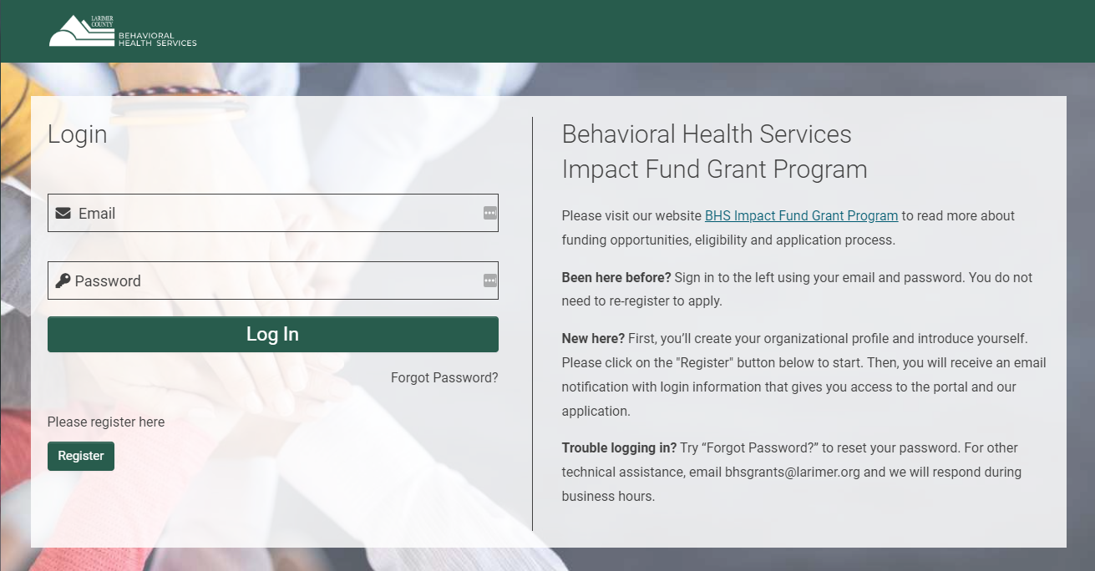

Follow the instructions

on the landing page

If you are a New applicant, please Register.

If you are a Returning applicant, please Log In.

If you have forgotten your password, click “Forgot Password” to reset your password.

If your organization is already registered and has a new Primary Contact, contact bhsgrants@larimer.org to set up a new login and password for the organization. There is no need to re-register the organization.

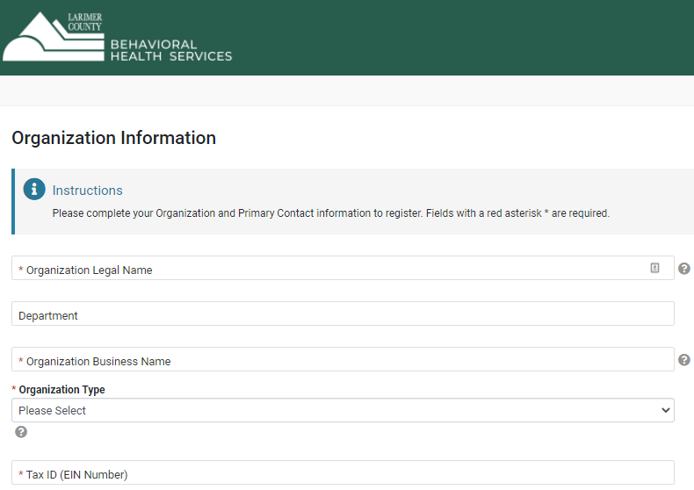
Registration

Tool Tip: The legal name is used for populating

grant agreements, payments, and verifying documents.

Tool Tip: The Business Name is used when
referring to your organization in publications and reports.

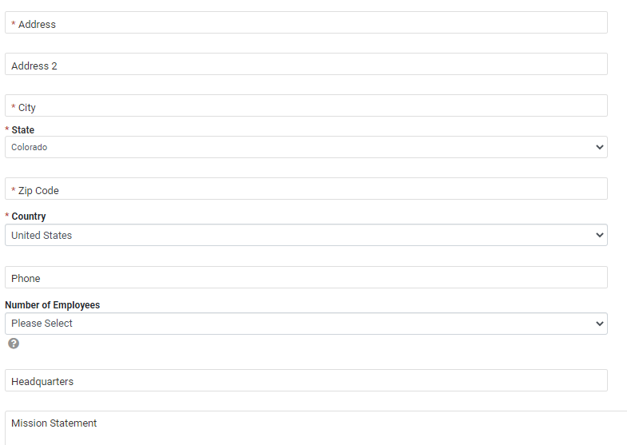

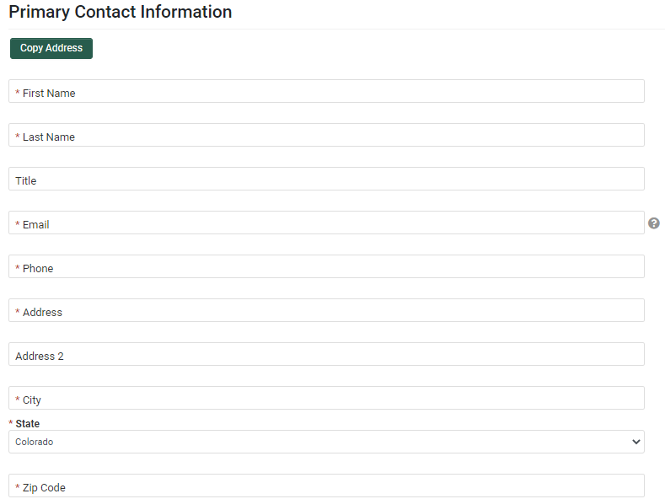

Tool Tip: If your organization has multiple
individuals (or collaborators) that need
to receive email notifications relating to the application
and grant, if awarded, then we recommend
creating/using a shared email address
when registering your account.


Click the “Submit” button

Within 5 minutes you will receive an email with the subject, “Login to Account” that will provide your username and a link to create your password. If you do not see this in 5 minutes, please check you Spam folder.

Once you have set your password you will receive an email with the subject, “Successful Password Change” with the reminder to login at https://larimerbhs.smartsimple.com/ with your new credentials.

Please save your username (email) and password to login in the future.
Additional Instructions for:

Organizations with Fiscal Sponsors. If you are an organization with a Fiscal Sponsor, please register with your organization information. Any Fiscal Sponsor documents will be required separately within your Organizational Profile.

Large Organizations/Higher Education Institutions (e.g. Colorado State University, UCHealth). Please register with specifics regarding your organization’s hierarchy including the particular business unit, school, college or department that is associated with your application in the “Organization Business Name”. Examples are provided below.

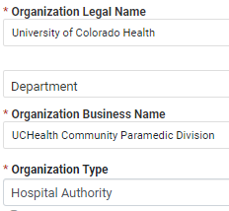
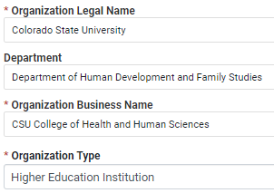

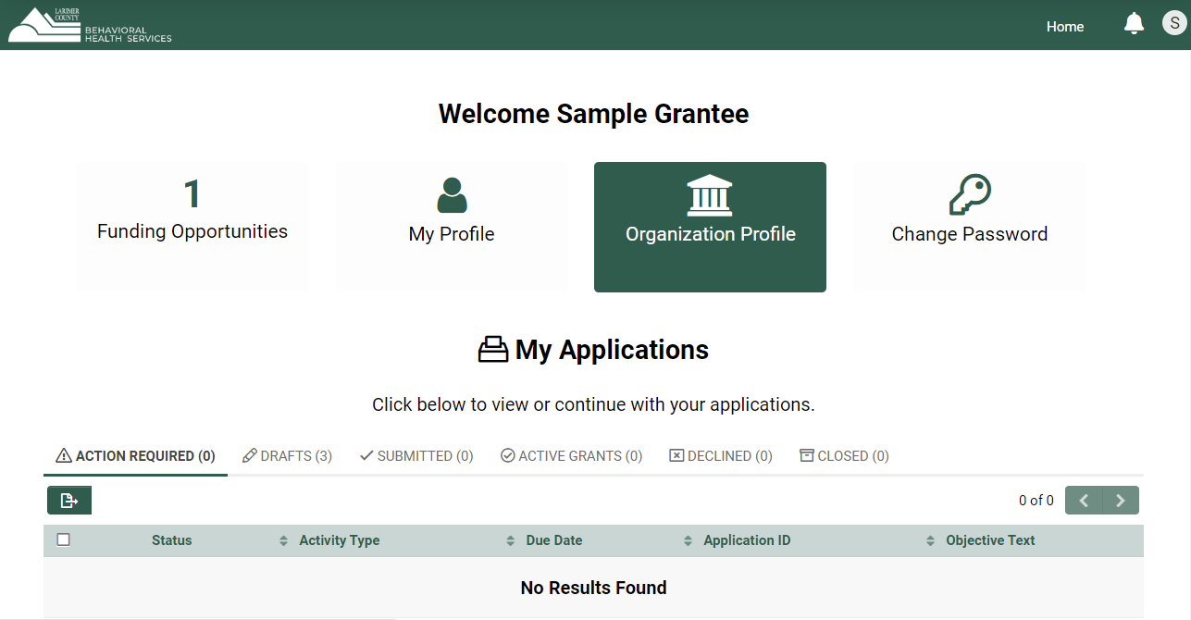
Add/Update your Organization Profile

Confirm that your Organization's Information is correct
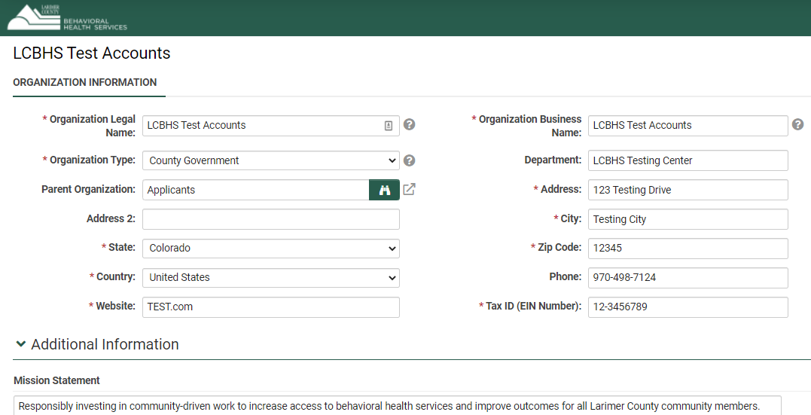
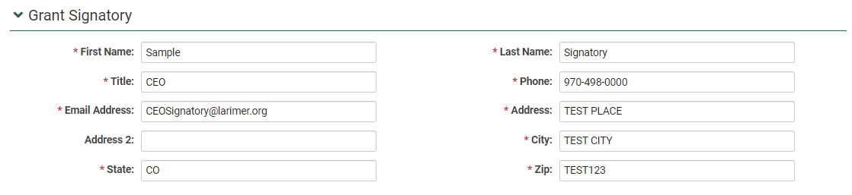
Add your Organization’s
Signatory Contact Information

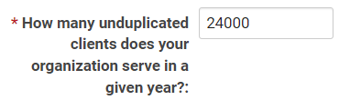
*Add the number of clients

the organization serves in a given year

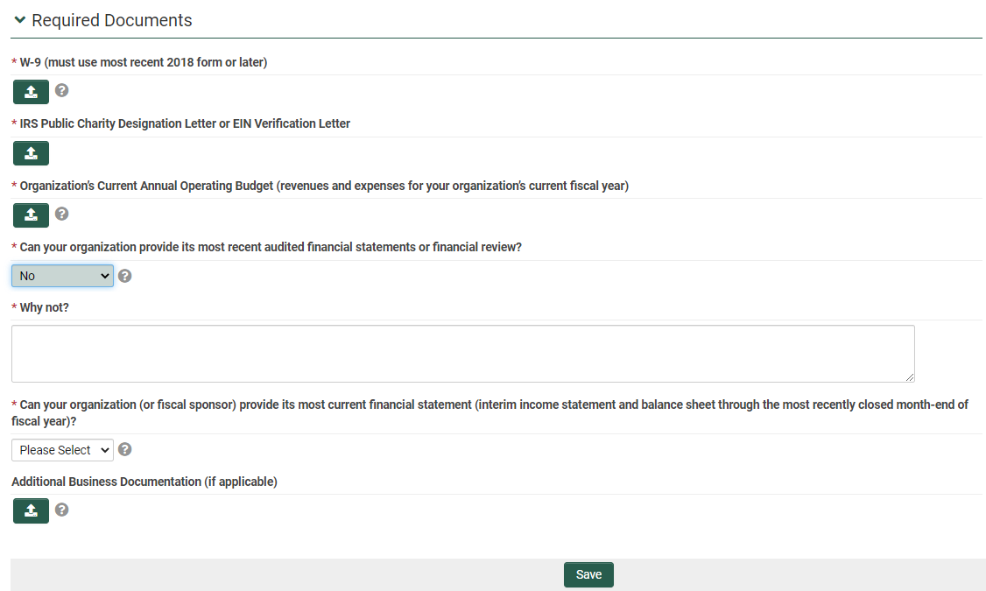

Upload your Required Documents

Tool Tip: If you cannot provide audited financials
or the most recent financial statement

please explain why not.

If you need to come back later, click “Save” and “Home” in the upper right corner to return to the Applicant Home page.

For returning applicants, your W9 and IRS letter may be uploaded. You do not need to reupload those documents if they have not changed. Financial documents must be updated with the current year’s financial information.

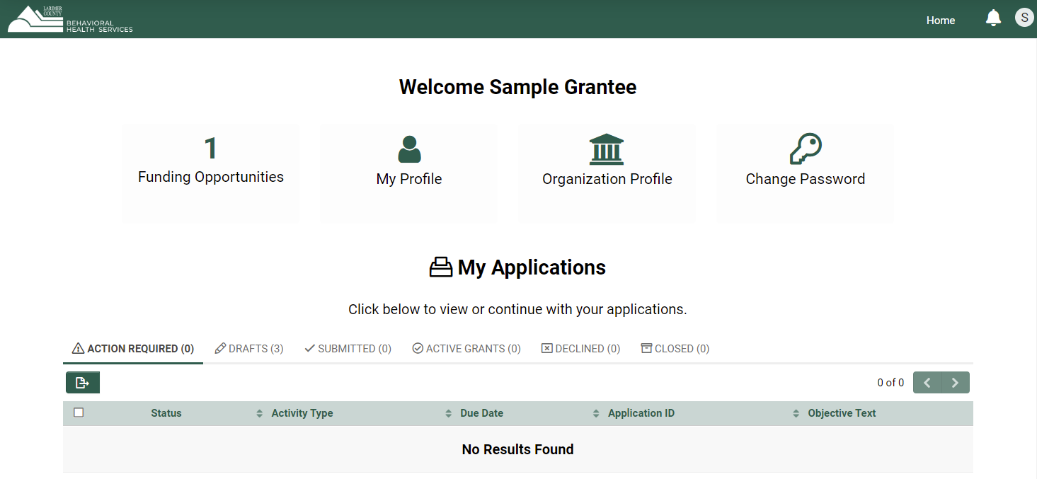
Starting a new Application

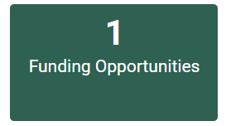

On the Applicant Home Page
Click “Funding Opportunities”

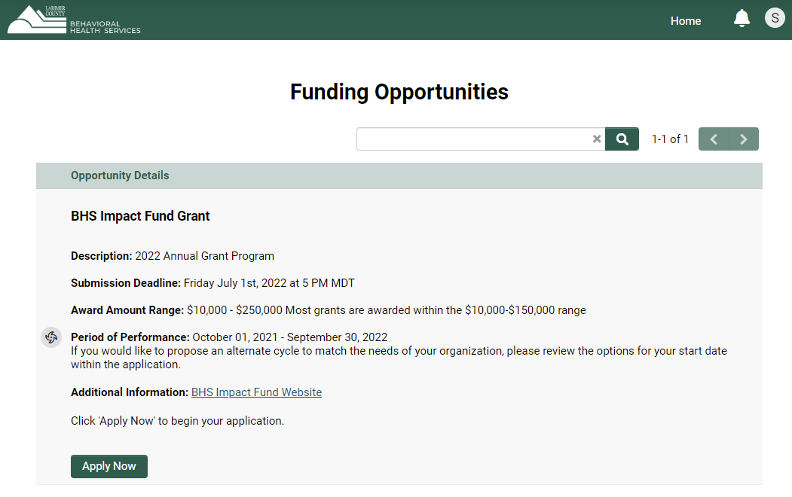

Click “Apply Now”

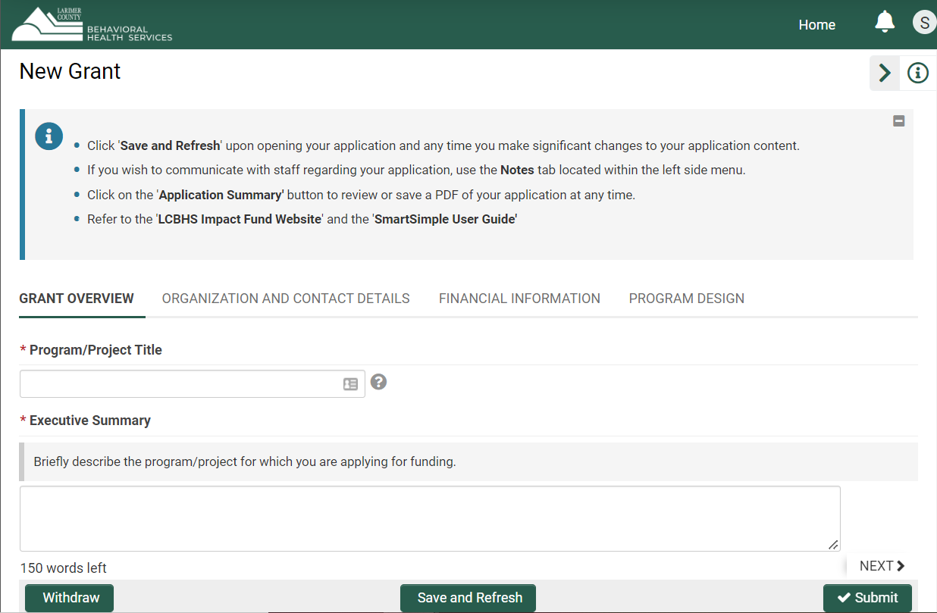

Read the instructions

Click “Save and Refresh”

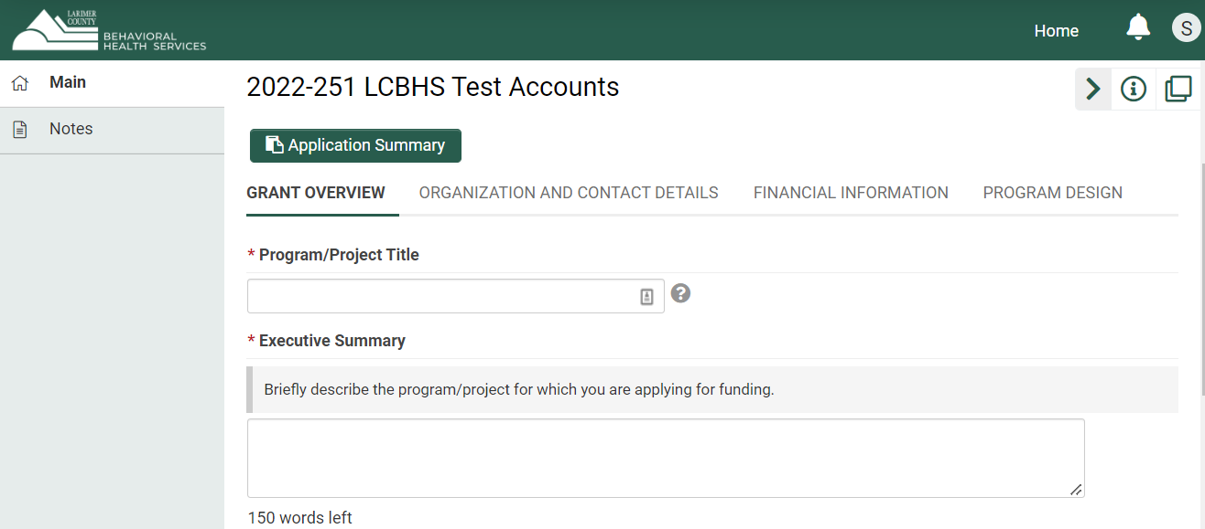
Application ID

Clicking Save and Refresh will
populate your “Application ID”
and ensure all questions in the application
are available.

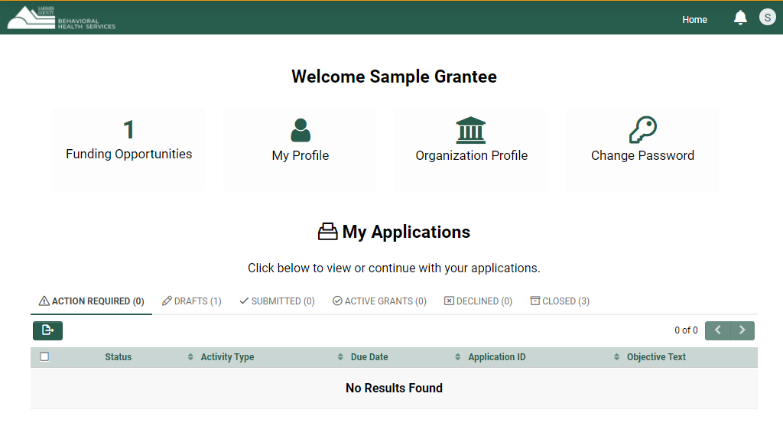
To Exit the Application and return later

Click “Save and Refresh” then
Click “Home” in the top right corner

To get back to your drafted application
Under “My Applications”
Click on the “Drafts” tab

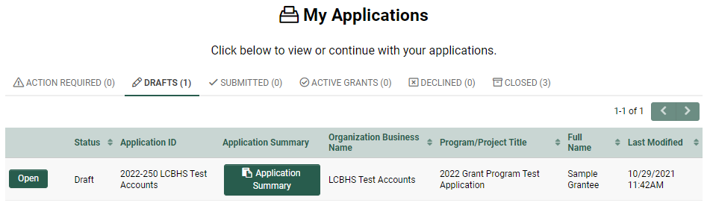
Click “Open”

If you need to communicate with BHS staff:
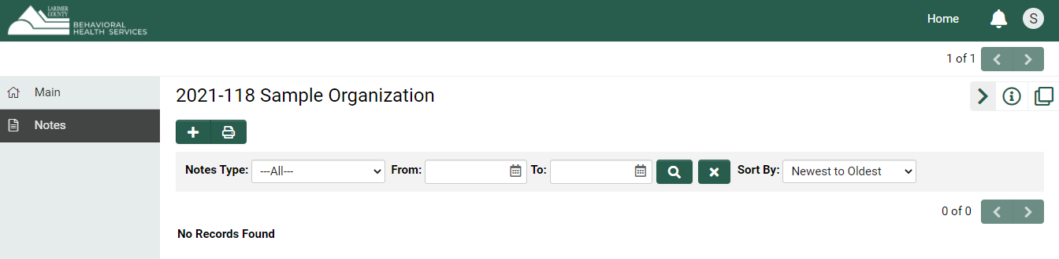

Click the “+” button

to send a “Note” to BHS Staff

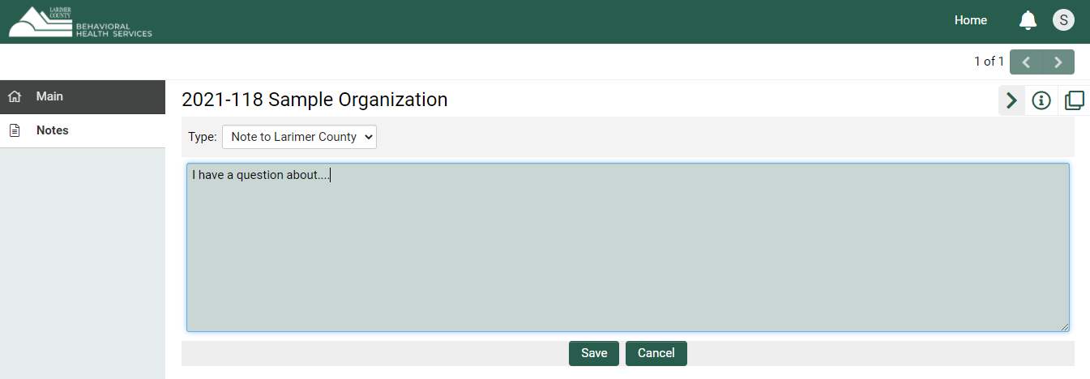

Type in your question/comment

Click “Save”

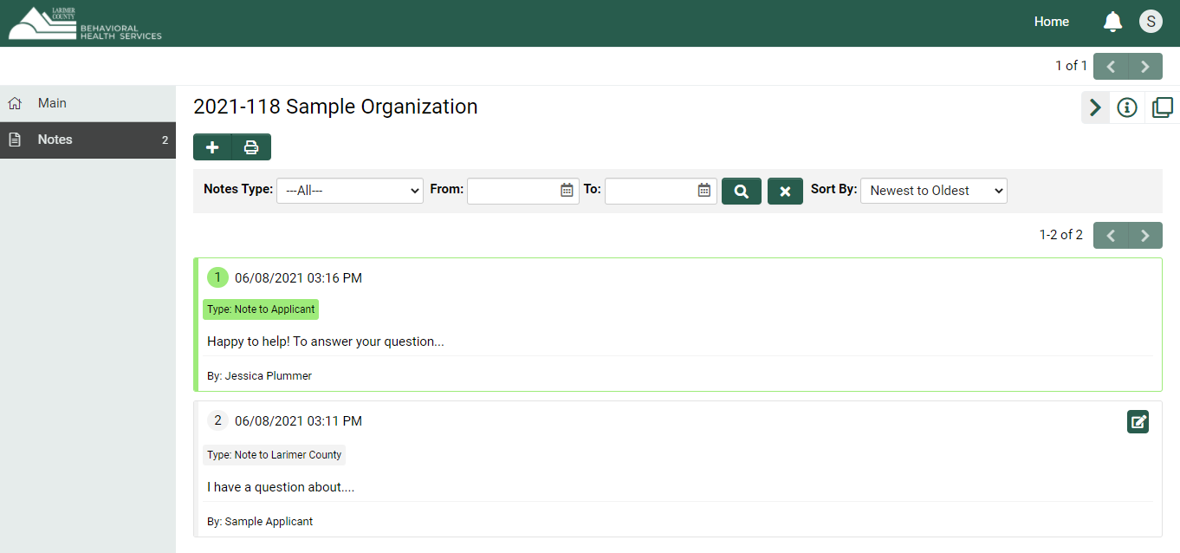

A member of the BHS team will respond

Applicants will receive notification via email

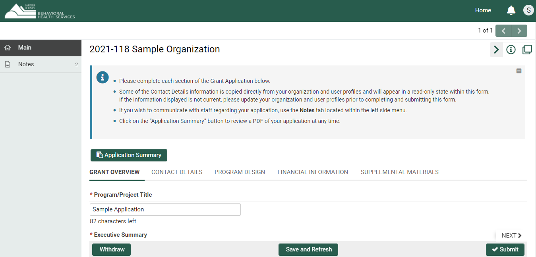

Click “Application Summary”
to download a PDF of your application

for review at any time



At the bottom you have three options:



Withdraw anytime before you Submit

Save and Refresh anytime

Submit before the due date/time

Clicking Submit will prompt you with the following message before confirming:

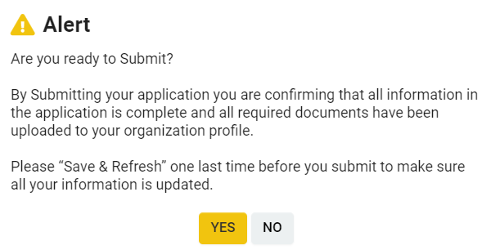

Application Navigation & Tips

To navigate through the Application it is easiest to click the Heading you want to navigate to that section of the application. You do not need to complete the previous section in order to move forward. You can complete any section at any time. Just remember to click “Save and Refresh” as you work on different parts of the application.

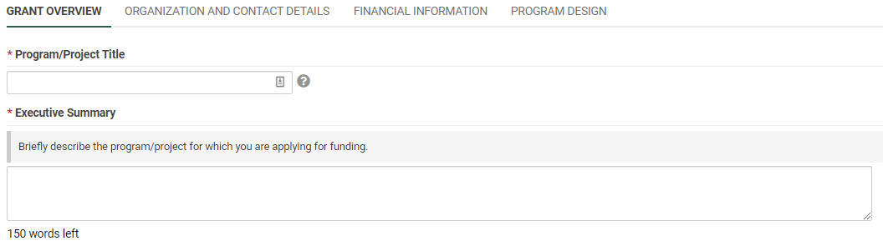

Hover over the “Tool Tips” to get guidance to those questions

Note that these two questions have word/character limits.

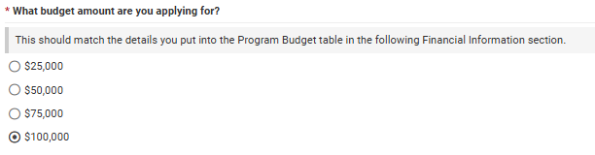

(Please read the instructions in the gray text box)

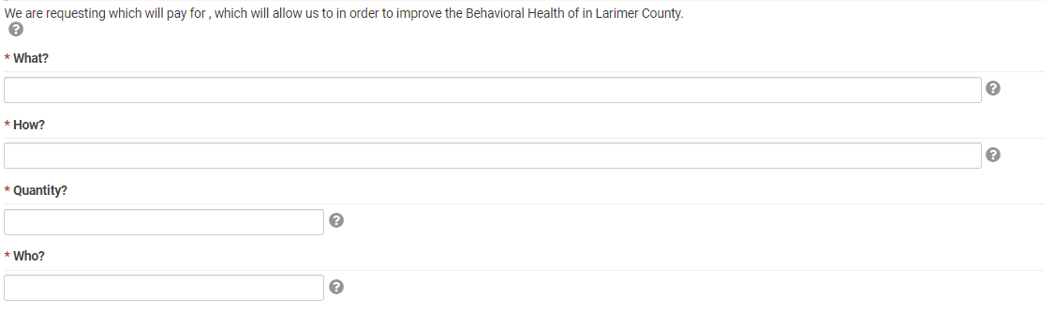
Example: We are requesting (Amount) $98,750, to pay for (What) a Social Emotional Learning Coordinator and their professional development training, which will allow us to (How) set district plans for a tiered mental health support and referral system in order to improve the Behavioral Health of (Quantity) 1100 (Who) Estes Park students and families in Larimer County.

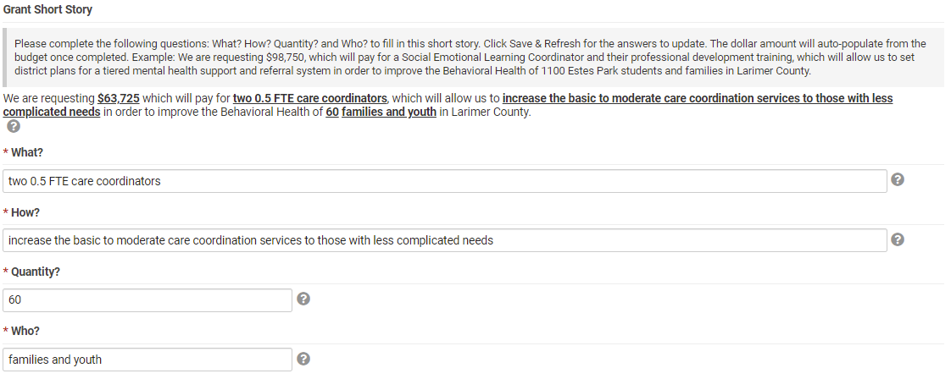
(Example)

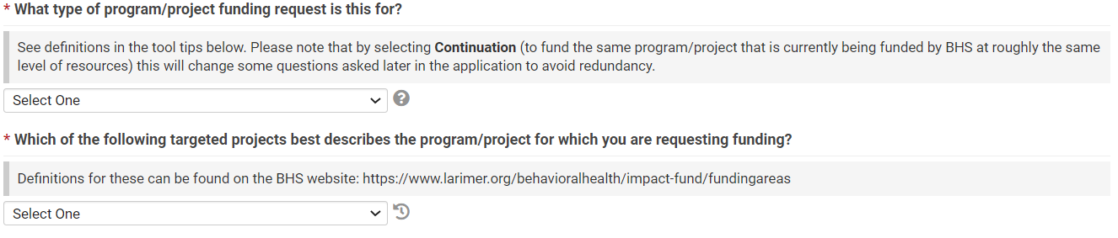
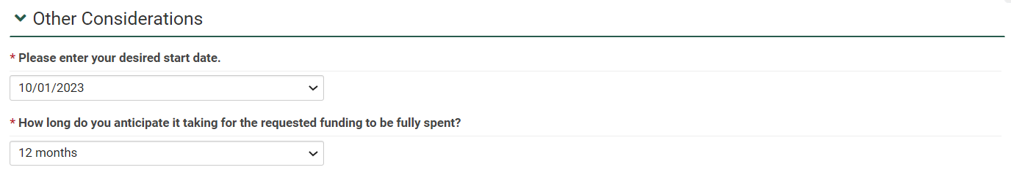

(Options are 12 months, 9 months, 6 months, 3 months)
(Default is 10/01 of the current year)
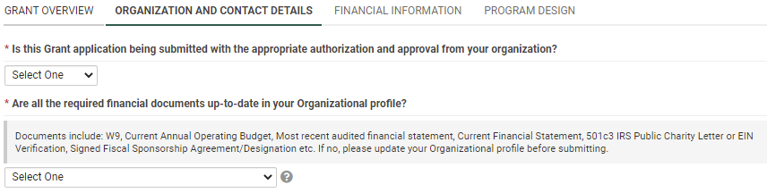
(Yes/No)
(Yes/No)

Contact information for each of the three Roles (Primary Contact, Program/Project Director and Grant Signatory) are required.

Some of the Contact Details (Organization Information and Primary Contact) appear in read-only form because the information is copied directly from your Organization and user Profiles and will appear uneditable within the application form. If the information displayed is not correct, please update your Organization and user Profiles prior to submitting your application.

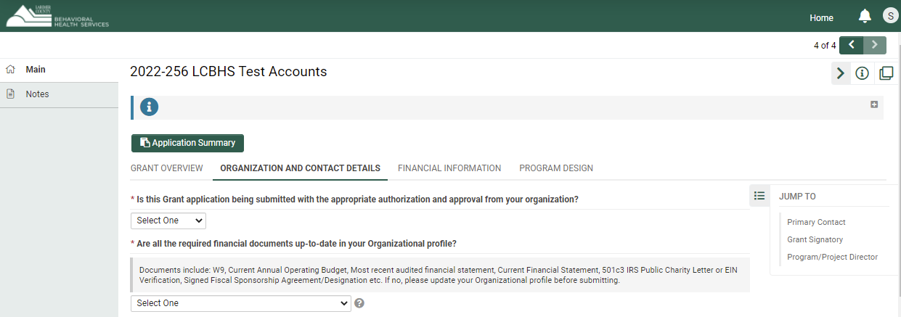

To navigate to your Profile, click “Home”
located in the top right-hand corner.

To update your Organization Details
Click on “Organization Profile”
Update or upload your information, click “Save”

To update your Primary Contact Information
Click “My Profile”
Update your information, click “Save”
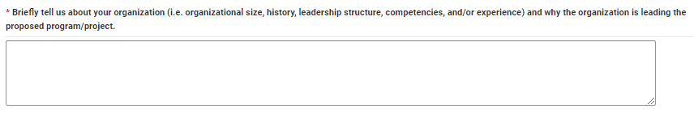

For “Continuation” requests, you will have this question instead:
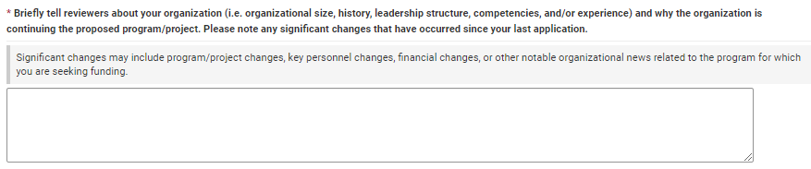

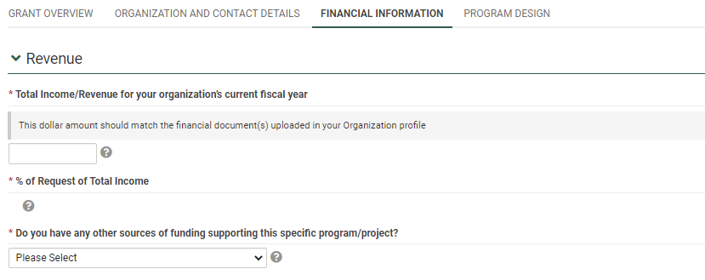
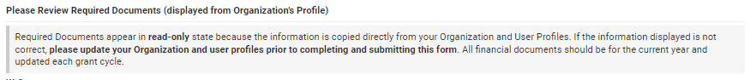

(Enter the total revenue your organization expects from all endeavors for the current fiscal year (a full 12 months)

(This will auto-calculate once the Budget and total income/revenue are completed. Funding should be less than 25% of the Organization’s total Income/Revenue)

(Yes/No)

If “Yes” add in the Amounts for Secured or Pending Funding. Add any narrative you have to support that information.
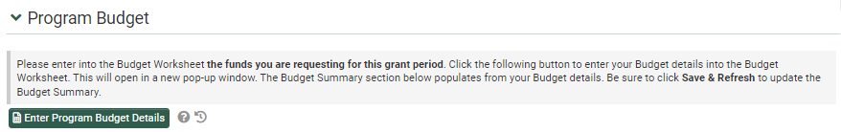

Tool Tip: Once you complete the Budget Worksheet, click "Save” in the pop-up window

Click the “Save and Refresh” button after your “Close” the Budget Worksheet window. This will allow the system to perform necessary autocalculations for the Budget Summary.

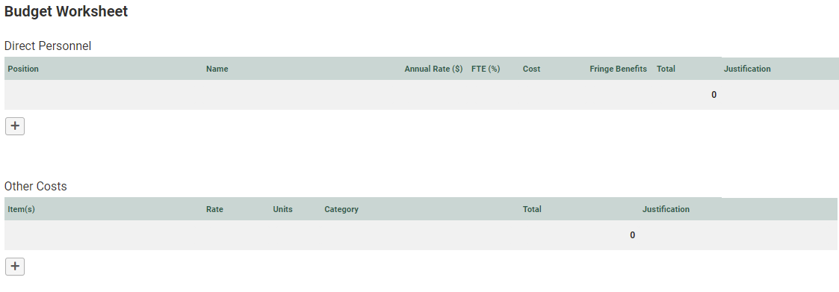

Use the “+” button to add your line items

Use the “+” button to add your line items

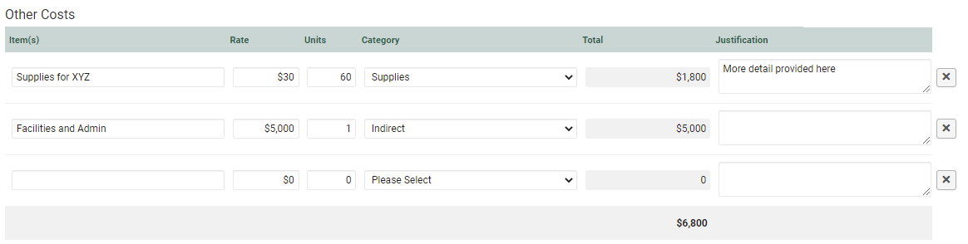
To delete an extra line, click the “X” button the right.

When you are done. Click “Save” and close the pop-ip window.

Click “Save & Refresh” on the main application to update the budget summary display on the application.

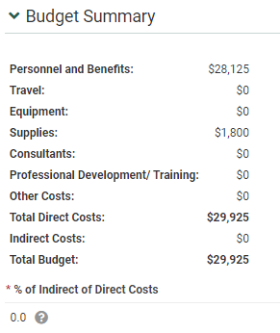

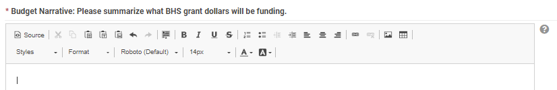

This is an auto-calculated field. Indirects should be 20% or less of Direct Costs
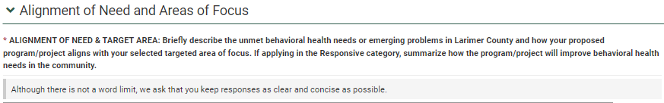

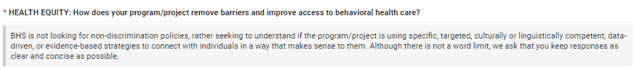

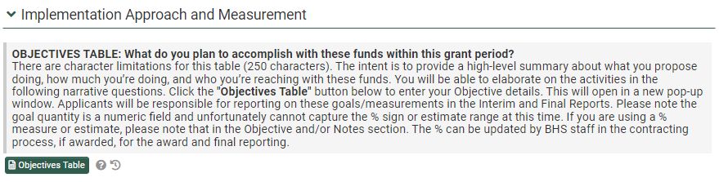
Click the following button to enter your Objective details into the objectives table. This will open in a new pop-up window.

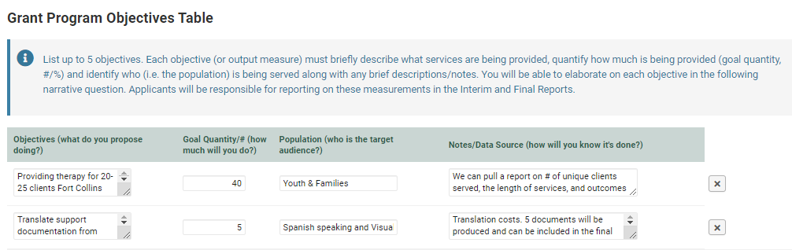

Use the “+” button to add your line items


Examples of objectives are provided in the Application Outline.
When you are done. Click “Save” and close the pop-up window
Click “Save & Refresh” on the main application to update the objective table display on the application

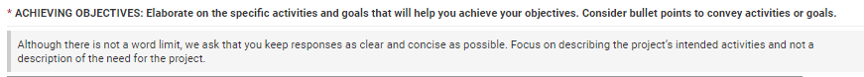

For “Continuation” only

Examples may include, letters of support, photos, infographics, strategic plan documents, etc.

Submitting Your Application
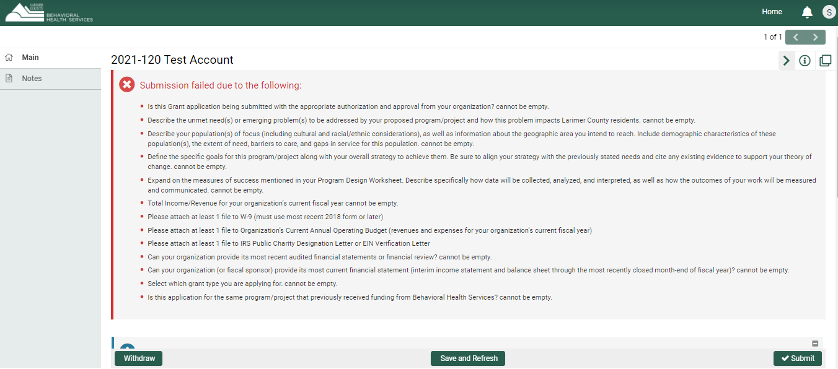

If you receive any “Submission Failed due to the following:” message, go back to that part of the application to fix the information before resubmitting. Anything with a red asterisk * is required.

You will receive a confirmation email with the subject: “LCBHS Application Received” with a PDF summary of the application for your records. Please note the email will come automatically from larimerbhs@smartsimple.com.

If you have any questions or experience other technical issues contact the BHS team directly through the Notes section or email bhsgrants@larimer.org.
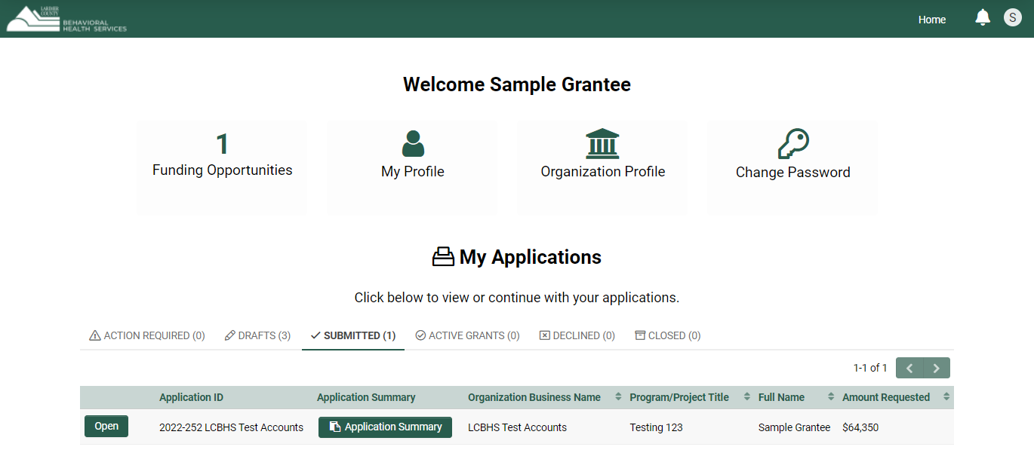
Submitted

Revisions Requested

If the LCBHS staff has questions and needs to request revisions on the application you will receive an email with the subject: “LCBHS: Revisions Requested to your Application” and an email that instructs you to login to modify the report in the “Drafts” tab.

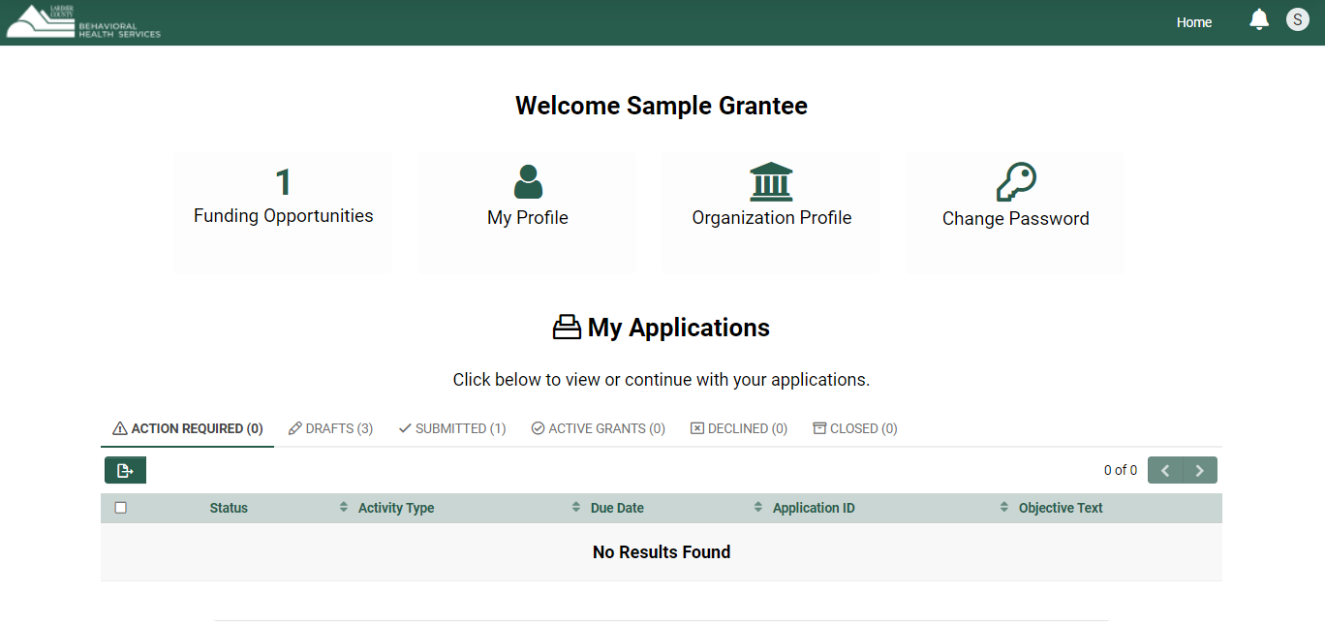

Once logged back into your application, read the instructions at the top which will specify what in the application need revisions.

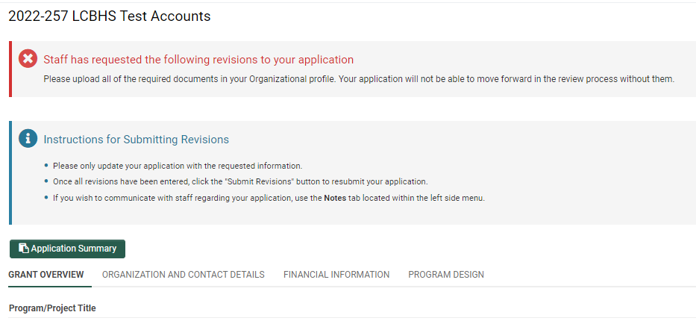

Address the area of concern, then click “Save and Refresh” and resubmit using the “Submit Revisions” button.

