Synergy Fund Application

The goal of this application is to capture the core of your collaborative idea without requiring a lengthy proposal. All questions are required and need to be completed in our online portal.

Section 1: Summary

*Please confirm your eligibility by selecting all the statements below: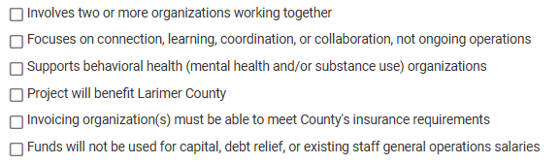

*Program/Project Title (15 words or less)

*In a few words, tell us your idea. (75 words or less)

*Total Amount Requested (Must be $10,000 or less, rounded to the nearest dollar)

*How many organizations will participate? (Select one)

*How many organizations are new to working together? (Select one)

*What collaborative area(s) are the focus of this work? (Select all that apply) 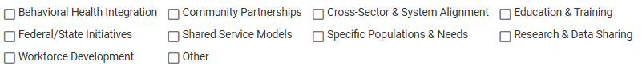

*Please provide the main contact information for your partner organization(s)

Section 2: Details
All answers must be 200 words or less.

*PARTNERSHIP OVERVIEW: Who are you partnering with, and why are you partnering on this project now?

*COLLABORATION DESIGN: What community need or challenge are you hoping to address together and how will your organizations work together throughout the project?

*SYNERGISTIC IMPACT: Explain what you can accomplish together that you could not accomplish alone. How will your collaboration improve efficiency, expand reach, or deepen impact?

*LEARNING: How will you capture lessons learned and share them with your partners or community? What signs or indicators will show progress, even if there’s no tangible product?

*VISION: If this collaboration goes well, what might it spark next?

*BUDGET: Please list how the funds requested will be used.

Section 3: Other Considerations

*If approved, are you able to submit an invoice for these services on behalf of your organization as well as any partner organization, if applicable? Yes/No

*ATTESTATION: I certify that the information provided in this application is true, accurate, and complete to the best of my knowledge with the approval from my organization. I understand that submission of this application does not guarantee funding, and that any approved funds must be used solely for the approved project purposes.

