Staff Report 

TITLE: River of Return Special Review

REQUEST: Special Review approval for a Retreat to instruct wounded military veterans in fly fishing as part of their recovery program.

LOCATION: 5678 River Road, Loveland

APPLICANT: Veteran’s Fly-Fishing Association
1234 A Road Somewhere
Loveland, CO

PROPERTY OWNER: John and Joan Adams
5678 River Road
Loveland, CO

STAFF CONTACTS: Pat Smith, Planning Dept.
Chris Jones, Engineering Dept.
Jo Johnson, Health Dept.
Joe Friday, Building & Code Compliance

NOTICE GIVEN: Notice given per legal requirements.
_____________________________________________________________________________________

SITE DATA:
Total Development Area: 5 Acres
Proposed Land Use: Fly Fishing Retreat
Existing Zoning: O-Open
Adjacent Land Uses: Single Family Residential
Services:
Access: River Road
Water: Well
Sewer: Septic
Fire Protection: Estes Park VFD
_____________________________________________________________________________________

PROJECT DESCRIPTION/BACKGROUND:
- The Veteran’s Fly-Fishing Association is a national organization that helps with the physical & emotional rehabilitation of disabled military veterans. The organization teaches wounded veterans about fly fishing as part of their recovery program. The proposal would allow a fly fishing retreat for veterans, to hold two events per month from May to September, no more than 10 events total, with up to 60 people on site per event and up to 30 people camping on site per event.

- The site for the retreat is a 5-acre residential lot along the Big Thompson River. The property is large enough to accommodate the use, including parking, lunch, and a permanent restroom.

- In 2005 the group started with 15 volunteers and eight veterans, meeting once per year. The program has grown from one event per year to at least one event per month from May through September. Each event currently involves approximately 20 veterans and 40 volunteers. This frequency of events and number of participants has raised neighborhood concerns, especially since some group members are camping on the site.

REVIEW CRITERIA AND ANALYSIS:
The role of the Planning Commission is to review applications for development, and to advise the Board of County Commissioners on approval or denial of the request. The Planning Commission shall consider the following review criteria and find that each has been met, or that it does not apply. The review criteria are shown in bold, with assessment by staff following each.
- The proposed use will be compatible with existing and allowed uses in the surrounding area and be in harmony with the neighborhood.
When the group held a single event once a year it did not generate any neighborhood concerns. Now events take place at least once a month with approximately 60 participants. Neighbors have raised concerns about additional traffic, noise, crowding on the river and participants camping on the site. Neighbors indicate that this level of use is not compatible with their residential zoning.
- The applicant has demonstrated that this project can and will comply with all applicable requirements o/the County Land Use Code.
The Development Services Team has reviewed the project and notes the following issues:
Planning Department:
The program has grown to a size that now meets the definition of a "retreat". This requires approval from the Board of County Commissioners. The use has raised concerns from neighboring property owners. Code Compliance staff have received complaints about noise, traffic, crowding on the river and on-site camping. In addition, a setback variance is required for the pavilion because it was built too close to the river. The setback from the river is 100 feet, and the pavilion is located at 40 feet from the river. The proposed outbuilding under construction is also too close to the river, and should be removed and built to meet setbacks as required by the Health Department.
Health Department:
The Health Department has raised concern about the proposed kitchen used to prepare food for the veterans. The kitchen will need to be inspected by the Health Department to ensure that the kitchen meets health codes for food preparation. There are also two concerns about environmental impacts from the permanent restroom within the outbuilding that is on a vault system. The foundation was built without a permit, and it is set back 85-feet from the river's edge where the Code requires a 100-foot setback. The Health Department recommends the structure be removed and constructed to meet setback and permit requirements.
Engineering Department:
The Engineering Department noted the use has increased traffic on a busy two-lane road. They recommend the applicant construct an acceleration / deceleration lane to mitigate the impact. The Engineering Department is also concerned about an unimproved meadow being used for parking. They recommend the parking area be improved with an all-weather surface. Finally, the Engineering Department asks for a drainage report to assess impacts caused by the pavilion and restroom because the structures are in the FEMA designated floodplain.
Non-County Review Agencies:
The Colorado Department of Transportation (CDOT) provided comments and indicated they are concerned about traffic impacts on Highway 33, a road that provides some access to the site. River Road connects to Highway 33, the highway is a major route into the Town of Estes Park. CDOT recommends construction of an acceleration / deceleration lane to mitigate impacts.
The State Division of Wildlife (DOW) contacted the County to express concerns about impacts to the river from the high number of fly fisherman. The DOW also warned about problems with bears and campers.
3 The proposed use will not result in a substantial adverse impact on property in the vicinity of the subject property.
Some neighbors have contacted Staff to stress that they are not able to sell their homes because potential buyers are troubled by the large crowd and traffic.
_____________________________________________________________________________________

ISSUES AND CONCERNS:
The issues and concerns are outlined above. Compatibility concerns, environmental concerns, traffic impacts, and health and safety concerns about structures built or under construction without permits and in the flood plain are the primary concerns of staff, referral agencies, and neighbors. Additional concerns include conflicts between people and wildlife and illegal camping along the river. Some surrounding property owners have stated the level of this use is having a negative impact on their property values.
_____________________________________________________________________________________

DEVELOPMENT SERVICES TEAM FINDINGS:
The Development Services team finds that the proposed use can meet the Review Criteria under certain conditions. Staff recommends reducing the number of events to one event every 45 days with no camping allowed along the river. The applicant must obtain a variance and building permit for the pavilion. The outbuilding shall be removed and constructed to meet required setbacks from the river, and it will be subject to building permit and inspection requirements. The applicant shall also provide a drainage report, and make the site improvements required by the County Engineer.
_____________________________________________________________________________________

DEVELOPMENT SERVICES TEAM RECOMMENDATION:
The Development Services Team recommends approval of the River of Return Special Review, subject to the following conditions:
1. The number of events shall be limited to a total of four from May through September, to be scheduled at least 45 days apart.
2. The applicant shall obtain a building permit and variance for the pavilion along with all required inspections.
3. The applicant shall remove the foundation for outbuilding containing the vault restroom, and shall obtain a building permit for any new buildings, subject to setback and inspection requirements during construction.
4. No overnight camping or lodging is allowed on the site.
5. The proposed kitchen shall be inspected by the Larimer County Health Department before occupancy of the building.
6. The applicant shall provide for improvements to the State Highway to include an acceleration / deceleration lane for access. A Colorado Department of Transportation construction permit is required.
7. The applicant shall provide an improved parking area with a gravel surface.
8. The applicant shall provide a drainage report for review and approval by the County Engineer.
_____________________________________________________________________________________

SUGGESTED MOTION:
I recommend the Planning Commission support approval for the River of Return Special Review, by the Board of County Commissioners, subject to conditions 1 through 7 as recommended.
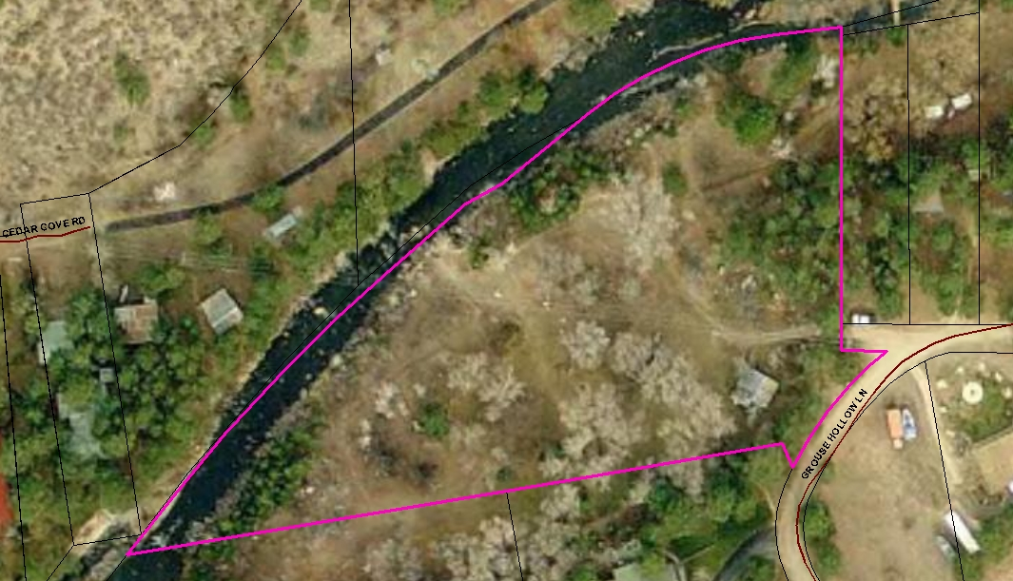
General Overview of the Site

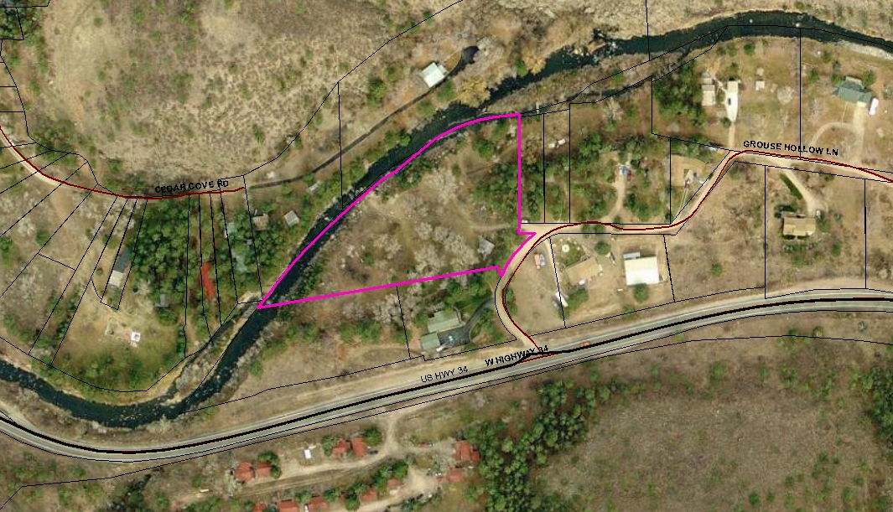
Site showing nearby structures in the area
Legend

Residential Structures

Camping area generally

Outbuilding

Pavilion

Site showing nearby residences and improvements.

